Unit name: Macbeth Text Study* | EAL level: C3-C4 | Year level: 10 | Duration: 5-6 weeks
Topic focus  By the end of this unit, students will understand:  - the characters, settings, plot, and themes of the text  - the ways authors create meaning and build the world of the text  - the features of a range of literary texts, including structures and language. | Victorian Curriculum F-10 EAL (C3)  By the end of this unit, students will be able to:  - Respond to imaginative texts, showing an understanding of key events, characters and issues (VCEALC700)  - Experiment with reading long, complex texts with support from the teacher (VCEALA703)  - Plan and draft text with support from peers and teacher (VCEALA719)  - Revise text and proofread for accuracy of expression (VCEALA720) |  | Victorian Curriculum F-10 EAL (C4)  By the end of this unit, students will be able to:  - Read a sustained, complex text (VCEALA765)  - Interpret a text at literal and inferential levels (VCEALC762)  - Plan and draft text independently and through group activities (VCEALA781)  - Revise and refine writing in response to feedback from a teacher or peer (VCEALA782)
Topic-specific vocabulary  - Vocabulary specific to Macbeth (ambition, guilt, dagger, murder…)  - Vocabulary for plays (scene, act, stage directions…)  - Vocabulary for text analysis (theme, symbol, metaphor, repetition, emphasise, suggest, depict…) | Linguistic structures and features  - Active and passive voice (Macbeth kills Duncan – Duncan is killed by Macbeth)  - Analysing verbs (suggest, emphasise, highlight, depict…)  - Nominalisation (ambitious – ambition)  Select structures suitable for your class. It may not be possible to teach all structures in the given time frame. |  | Summative assessment  - text response essay

* This unit can be used with an adapted version of the text or with the original. If studying the original text, consider investing in an edition that contains a side-by-side modern English translation.
Teaching and learning activities
The time taken to achieve each learning intention will vary. Learning intentions do not necessarily correspond to single lessons.
Learning intention: We are learning about William Shakespeare.
Success criteria: I can describe some key facts about Shakespeare’s life and works.
Teaching and learning activities:
- Show students some pictures of Shakespeare, the Globe Theatre, and actors performing in Macbeth. Ask them to guess what they are studying next.
- To hook students’ interest in the themes of the play, project a series of statements on a PowerPoint and ask students to line up alongside a classroom wall depending on how strongly they agree.
Statements could include:
If someone commits a crime, they are a very bad person.
It is good to be ambitious.
I would like to be a king or queen.
Powerful people are always happy.
After each statement, ask students to turn to the person next to them and explain why they chose their position. Then, call on students to share their thoughts with the whole class.
- Activate students’ prior knowledge with the Shakespeare quiz.
- Students work in pairs to complete the information gap activity. Model how to create questions to find the missing information.
- If students are studying the original text rather than an EAL adapted version, they may feel overwhelmed by the language. Help to make the language feel more accessible by conducting a short activity where students match Shakespearean phrases to their modern English meanings. View Page 2 of this worksheet for an example.
- Students demonstrate what they have learned about Shakespeare by providing written answers to two or three questions, such as “What is Shakespeare famous for?” Collect students’ responses at the end of the lesson.

Learning intention: We are learning how to study a play. We are learning about the plot, characters, and themes of Act I of Macbeth.
Success criteria: I can write a journal entry from Lady Macbeth’s point of view (or other similar creative writing task).
Teaching and learning activities:
- Introduce the final assessment task to students so that they know what they are working towards. Providing the final essay topic at the beginning of the unit helps students focus on the relevant themes and collect relevant evidence.
- Show students how to set up a Play journal and teach key vocabulary for understanding the structure of a play (‘act’/ ‘scene’). Students add to this journal regularly, summarising each scene they read and recording questions they have. Establish the expectation that students should keep track of important quotes, for example by underlining them in pencil and adding a coloured flag to the page.
- Read the witches’ speech in Act I, Scene I, together as a class. Show students YouTube videos of two or three adaptations of this scene. Make sure to watch the videos first and select versions that are appropriate for your class: be mindful that some adaptations are graphic. Ask students to discuss which version they prefer, and why.
- Provide students with an example of how to fill in their journal for Act I, Scene I, and point out any important quotes for students to underline. Eventually students should decide for themselves which quotes to keep track of.
- Select key sections from the first few scenes to read aloud as a whole class. Do not read aloud every line: focus on sections that are particularly pertinent for the plot, characters, and themes.
- After each scene, write some questions on the board for students to discuss in small groups. Use a range of closed questions to check basic knowledge (“What did Macbeth do in the battle?”) and questions that encourage students to probe more deeply (“What does Duncan think about Macbeth?”). Circulate while students are talking and use their answers to gauge their understanding. Provide more scaffolding—for example, scene summaries in simple language—if students are struggling to understand.
- After reading a few scenes (for example, at the end of Act I), give students the opportunity to complete a short creative response about the text such as a diary entry from a character’s point of view. Collect students’ play journals regularly and use them to assess and give feedback on students’ writing, as well as their understanding of the play.
Learning intention: We are learning how to discuss a text with classmates.
Success criteria: I can participate in ‘Literature Circles’ with my group.
Teaching and learning activities:
- Introduce students to Literature Circles and explain the benefits of this approach. Please note that an adapted version of Literature Circles is used in this unit.
- Divide students into groups of 4. Distribute the Literature Circles sheets and assign each student a scene they will be responsible for. Students fill out this sheet about their scene and then use it to guide a group discussion.
- Model how to prepare for a scene by providing students with a worked example of a Literature Circles sheet and using it to lead a whole-class discussion about that scene.
- For the first round of Literature Circles, students should prepare their scene in class to facilitate teacher support and feedback. However, this will eventually be done for homework.
- Establish the expectation that students should read the whole play at home (if this is appropriate for their language level).
- Distribute the Sample Literature Circles discussion. In groups, students read the roles aloud and then answer the questions. Point out key features of the discussion that should appear in students’ own discussions: everybody contributes; detailed answers are provided to all questions; and ideas are supported with evidence.
Ongoing study of the play
- Use Literature Circles to study as much of the text as possible. However, it can be beneficial to also include some teacher-led discussions of especially significant scenes, such as Lady Macbeth’s “Unsex me here” speech, and the banquet scene in which Banquo’s ghost appears. Show performances of these scenes on YouTube and discuss. Choose at least one scene for students to act out as a group.
- Students regularly complete entries in their play journals.
- Lessons on grammar should be interwoven with literary study of the play. It is not necessary to finish reading the whole play before beginning grammar teaching.
- It is not necessary to study every scene.
Learning intention: We are learning when and how to use active and passive voice.
Success criteria: I can write sentences about ‘Macbeth’ using active and passive voice.
Teaching and learning activities:
- Explicitly teach active and passive voice, including how to make them and when to use them. Refer to Sample passive voice lesson plan.
- Students apply their knowledge of passive to Macbeth. See Macbeth active/passive sentences and Writing in the passive voice about Macbeth. Note: the second resource includes some more advanced passive sentences such as the continuous and perfect passive. Adjust the resource as necessary if students have not learned these structures.
- Play some speaking games to build fluency with the passive. For example, write the names of characters, places, and objects from Macbeth on cards. Divide students into small groups and place the deck of cards face down in the middle of each group. Students take turns picking up a card and using passive sentences to describe the character, place, or object on the card (e.g. “His future was foretold by the witches.” “They are used by Macbeth to kill Duncan.”) The first student to guess correctly wins the card.
- Look at a paragraph of a text (for example, a paragraph from the sample essay) and highlight where the author has used active or passive voice. Discuss why that voice was chosen and what the effect would be of using the other voice.
- Continue to reinforce the active and passive voice throughout subsequent lessons, for example, by providing feedback focused on students’ use of active or passive voice in their play journals and other writing tasks.
Learning intention: We are learning about literary techniques.
Success criteria: I can identify literary techniques in Macbeth.
Teaching and learning activities:
- Choose a passage from the play you have already studied (for example, the ‘Sleep’ speech from Act 2 Scene 3). Point out features such as metaphors and alliteration. Explain that these are all types of literary techniques.
- Explicitly teach what similes, metaphors, personification, and alliteration are, using examples and supporting images. Refer to Literary techniques.
- Students complete Activities A and B in the Literary techniques booklet. Activity B is best done with the whole class. Please note that the quotations in this resource come from an adapted version of Macbeth: replace with quotations from the version you are using.
Learning intention: We are learning about literary techniques. We are learning to read aloud with expression.
Success criteria: I can identify literary techniques in a speech from Macbeth. I can perform a speech from Macbeth.
Teaching and learning activities:
- If students are studying an adapted version of the play, give them the opportunity to experience the richness of Shakespeare’s language by analysing one or two famous speeches from the original. Good examples include the ‘Sleep’ speech from Act 2 Scene 3 and the ‘Tomorrow’ speech from Act 5 Scene 5.
- Project the speech on the board and give students their own copies to annotate. Highlight and discuss literary devices such as metaphor and symbolism.
- Read each line aloud and have students recite after you. Model pronunciation of difficult words.
- Watch and discuss at least two different interpretations of the speech on YouTube.
- Give students the opportunity to practise reciting the speech in pairs. If appropriate, have each student present their speech to the whole class. Have the rest of the students vote on who gets the ‘Oscar’ for the best performance.
Learning intention: We are learning to analyse literary techniques.
Success criteria: I can analyse the effect of literary techniques in Macbeth on the reader/audience.
Note: if students have not already been introduced to the sample essay, it would be advisable to show them at least one paragraph, so that they can see what they are working towards and why it is important to learn about analysing literary techniques.
Teaching and learning activities:
- Begin the lesson with a quick revision of the literary techniques learned, such as through a short Kahoot quiz.
- Explicitly teach analysing verbs such as suggest, emphasise, depict and symbolise. Provide examples of how each verb is used and circulate to check if students can use the verbs in their own sentences.
- Cut up sentence parts and distribute to pairs of students. Students arrange them to create sentences analysing Macbeth. Refer to Macbeth sentence structure practice.
- Model how to use these verbs in different sentence structures. Connect with prior learning by drawing students’ attention to the structures that use the passive voice.
- Students apply their knowledge of analysing verbs by writing a paragraph about a short excerpt from the play. Refer to Activity E Annotation and Activity F Analysis. Students share their paragraphs with a partner and suggest one thing done well and one area for improvement. They then redraft their work before submitting it to the teacher.
- Analyse students’ paragraphs to plan subsequent teaching. For example, some students may be misusing some of the analysing verbs and require their meaning to be clarified.
Learning intention: We are learning about nominalisation.
Success criteria: I can use nominalised forms of words to write about Macbeth.
Teaching and learning activities:
- Review the different sentence structures studied in the previous lesson. Demonstrate how it is sometimes useful to write a verb or an adjective as a noun, so that you can make it the subject of a sentence. For example:
Macbeth repeats “Tomorrow” three times, emphasising…
The repetition of the word “Tomorrow” emphasises…
This can be useful for making a complex idea more compact, or for connecting ideas in our writing:
Macbeth’s bloody hands symbolise his guilt. This symbolism is seen again when Lady Macbeth is sleepwalking, trying desperately to “get [her] hands clean”.
- Students work in pairs to fill out the Word families. Go through the meanings and encourage students to translate the words into their home language.
- Students practise re-writing sentences using nominalisation. See the activities at the end of the Word families resource.
- Use students’ sentences to determine how well they can include nominalisation in their writing and what kind of further teaching is required.
Learning intention: We are learning how to structure a text response essay.
Success criteria: I can answer questions about the sample essay.
Teaching and learning activities:
- Distribute the sample plan and essay. Read through and discuss as a class, pointing out how the plan informs the structure of the essay. Highlight and discuss the language features that students have been learning (passive, nominalisation, etc.).
- Students work in pairs or independently to answer the questions about the sample essay.
Learning intention: We are learning how to write a text response essay.
Success criteria: I can work in pairs to write a text response essay about Macbeth.
Teaching and learning activities:
- Distribute the booklet Constructing an essay together. Explain that this booklet contains the same sample plan students saw in the previous lesson, but the essay has been removed. Explain that students will work in pairs to re-construct the essay using the plan, without looking at the original sample essay.
- Construct Paragraph 1 together as a whole class, with the teacher leading the discussion. Verbalise your thinking processes (“Hmm, I think we should make this sentence active, because that emphasises Macbeth as the subject of the sentence”).
- Students work in pairs to write paragraphs 2 and 3, using the scaffold provided. Remind students to use the verbs and sentence structures taught.
- Students reflect on the process of writing an essay in pairs.
Learning intention: We are learning what a good essay looks like.
Success criteria: I can use the rubric to assess an essay about Macbeth.
Teaching and learning activities:
- Take students through the Macbeth text response essay rubric, explaining key vocabulary such as “identifies”, “main contention” etc.
- Model using the rubric to assess the sample essay.
- Working in pairs, students use the rubric to assess their jointly constructed essay and reflect on how they could improve it.
Learning intention: We are learning how to draft, edit, and self-assess our work.
Success criteria: I can improve my draft three times using feedback from myself, a friend, and the teacher.
Teaching and learning activities:
- Introduce the final essay topic: “Who is the real villain of Macbeth?” Discuss the concept of a villain using well-known examples, such as from Harry Potter. Ask students to discuss the topic in small groups, and then report back to the class.
- Students plan their essay using the blank planning template. Check their plans before they begin their draft.
- Students complete the first draft of their essay. Provide the essay scaffold or a similar resource if required.
- Explicitly teach proofreading. Write a sentence on the board containing a common mistake and see if students can identify it. Give students practice at this skill by providing a number of sentences and asking students to identify and correct the mistakes. Use mistakes that you have frequently identified in students’ writing.
- Students proofread their first draft and self-assess. Refer to Self-assessment.
- They then swap with a partner and complete Peer assessment. They use this feedback to improve their draft a second time. On the board, brainstorm useful phrases for peer feedback, for example:
- I like…
- You supported this argument with strong examples, such as…
- You used… several different conjunctions to join your ideas.
- I think you should…
- This paragraph would be even better if…
- Students submit this third draft to the teacher for feedback.
- Students use teacher feedback to produce the final copy of their essay.
- Elicit feedback from the students about the unit, for example, by asking questions such as:
  - What are the most important things I learned from this unit (e.g. grammar, writing, speaking skills)?
  - What parts of the unit did I enjoy the most, and why?
  - What parts of the unit did I not enjoy, and why?
  - Which activities helped me learn the most?

End of unit

References
British Council (no date). Teaching English: Macbeth. https://www.teachingenglish.org.uk/article/macbeth
Murphy, R. (2019). English Grammar in Use (5th ed.). Cambridge: Cambridge University Press.
Tarner, M. (2010). Macbeth by William Shakespeare (abridged version retold by Margaret Tarner). Oxford: Macmillan Heinemann ELT.

Images
"Shakespeare's birth place. Stratford upon Avon" by elvis_payne is licensed under CC BY-NC-ND 2.0
"Shakespeare's - Globe Theatre" by Cyberslayer is licensed under CC BY-NC-SA 2.0
"William Shakespeare" by tonynetone is licensed under CC BY 2.0

Model text: Text response essay on Macbeth
Topic: Does Macbeth have a moral message?
On the surface, Macbeth is a play with a clear moral message: if you upset the natural order of things, you will be punished. However, this moral message is less straightforward than it initially seems. Macbeth and Lady Macbeth are both punished for their evil deeds, but it is unclear whether they are fully in control of their fate and therefore responsible for their actions.
Macbeth upsets the natural order of things by murdering King Duncan and is eventually punished. This “unnatural deed” upsets the balance of nature: after Duncan’s death, “the wind… blew down trees… and some men said they felt the earth shake.” Macbeth immediately regrets his actions, saying that “if [he] had died an hour before this moment, [he] would have died happy.” He also loses the ability to sleep properly, which symbolises his lost peace of mind. Becoming king brings him no happiness: on the contrary, his “kingly clothes… weigh him down”. Towards the end of the play, Macbeth compares himself to a “dry and yellow leaf”, suggesting that his life is devoid of beauty. He is finally killed by Macduff, and everybody celebrates his death. Macbeth’s tragedy seems to have a clear moral message: people who commit evil deeds will be punished.
Lady Macbeth is also punished for her evil deeds. Becoming the queen “brings no delight”, and she laments that “guilt and horror” have destroyed their lives. Eventually, the guilt drives her to insanity. When she is sleepwalking at the beginning of Act 5, her language is written in disjointed prose rather than blank verse, evoking her degraded state of mind. The imaginary spot of blood on her hand symbolises her guilt, which she will never be able to overcome. At the end of the play, she “[dies] by her own hand.” Her doctor says that “unnatural deeds lead to unnatural troubles”, which suggests that Lady Macbeth gets what she deserves. As such, her decline into insanity and death seems to carry a moral lesson.
On the other hand, this moral lesson is not as clear as it seems. Macbeth and Lady Macbeth are spurred to commit murder by the prophesy of the three witches, which predicts that Macbeth will be king. The “terrible idea” first occurs to Macbeth after meeting the witches, suggesting that he would not have thought of it otherwise. Lady Macbeth is also influenced by the prophesy, but her reaction to it is confused. She believes that Macbeth “must commit a murder… to get the crown”, but she also believes that “fate says [the crown] shall be [his]”. As such, it is unclear whether the husband and wife are truly in control of their own fate. Although at the beginning of Act 3, Macbeth claims that his “fate is in [his] hands”, by the end of Act 5 he realises that “those double-dealing spirits made a fool of [him] with their dishonest words”. When he learns about his wife’s death, Macbeth laments that “all our yesterdays have lighted fools the way to dusty death”. The personification of time as guiding humans towards their death suggests that time itself is truly in control. If humans are not in control of their fate, it is then unclear whether they can take responsibility for their actions.
On the surface, Macbeth is a play with a moral lesson: those who commit evil deeds will be duly punished. This is suggested by the decline of both Macbeth and Lady Macbeth. However, it is never certain that the characters are truly in control of their fate, and therefore deserve their punishment. This ambiguity undermines any clear moral message in Macbeth.

Shakespeare Quiz
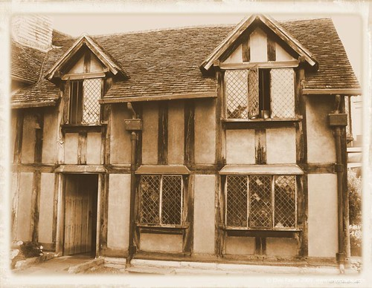
1. When was Shakespeare born?
a) 1498
b) 1564
c) 1895

2. What did Shakespeare NOT write?
a) plays
b) poems
c) novels

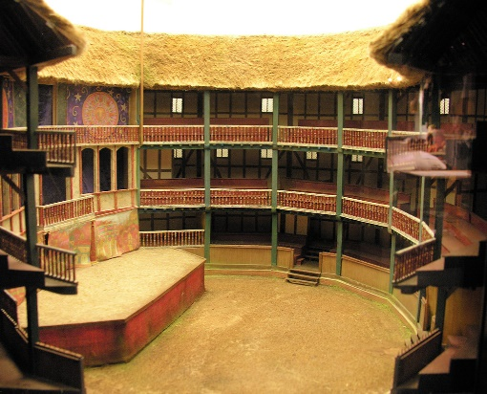
3. What’s the name of Shakespeare’s theatre in London?
a) The Old Shakespeare Theatre
b) The World Theatre
c) The Globe Theatre

4. What kind of play is Macbeth?
a) tragedy
b) comedy
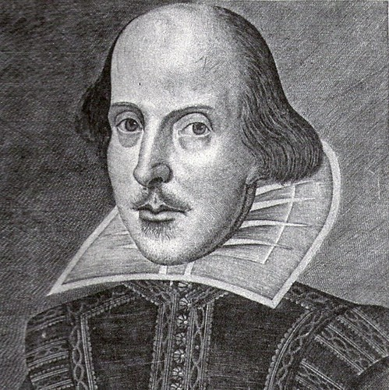
c) musical

5. Where is Macbeth set?
a) England
b) Scotland
c) Ireland

Answers: 1. 1564 2. Novels 3. The Globe Theatre 4. Tragedy 5. Scotland

Play journal
Act and scene | Summary | Questions
Act 1, Scene 1 | Three witches come together. They say they will meet with Macbeth after the battle. Before they leave, they say “fair is foul and foul is fair.” | How do the witches know what will happen in the future? What battle are they talking about?  I still don’t understand what “fair is foul and foul is fair” means.

Literature Circles
Name:
Scene:

- What happened in this scene? Why is this scene important?
______________________________________________________________________________________________________________________________________________________________________________________________________________________________________________________________________________________________________________________________________________________________________________________________________________________________________________________________________________________________________________________________________________________________________________________________________________________________________________________________________________________________

- List some difficult words and their meanings.
Word | Meaning

C. Discussion questions
Write at least five questions to start a discussion with your group.
These must be open questions that lead to an interesting conversation.
Examples of good open questions:
What is the significance of the symbol of “sleep” in this scene?
Why does Macbeth feel that he is unable to say “Amen”?

Do not use closed questions (questions with very short, simple answers).
Examples of closed questions:
Who does Macbeth kill?
Does Macbeth feel bad about what he has done?

- ______________________________________________________________________________________________________________________________
- ______________________________________________________________________________________________________________________________
- ______________________________________________________________________________________________________________________________
- ______________________________________________________________________________________________________________________________
- ______________________________________________________________________________________________________________________________
______________________________________________________________________________________________________________________________________________________________________________________________________________________________________________________________________________________________________________________________________________________________________________________________________________________________________________________________________________________________________________________________________________________________________________________________________________________________________________________

Sample Literature Circles discussion
Name:
The students have just finished reading aloud Act 2, Scene 2.
Student A is the leader for this scene.

Student A: Let’s start by summarising what happened in this scene. At the start, Macbeth goes off stage to murder Duncan. He comes back on stage covered in blood, still holding the daggers he used to kill the king. It is very clear that Macbeth regrets what he has done. He thinks he will never be able to sleep again. Lady Macbeth tells him he is being silly. Then she notices that he is holding the daggers, and tells him to take them back to the room and leave them next to the king’s servants, so that people will think that they killed him. But Macbeth refuses to go back to the room, so Lady Macbeth tells him he is a coward, and takes the daggers back herself. The scene ends with Macbeth wishing he had never killed Duncan. Does anyone have any questions about what happened in the scene?
Student B: Why did Macbeth bring the daggers out of the room?
Student A: Good question. I think he was very afraid and anxious when he was killing Duncan. So he wasn’t thinking straight.
Student C: How did the servants not wake up when Macbeth went into the room?
Student A: Lady Macbeth had drugged their drinks so that they would fall into a very deep sleep. Any other questions?
Student C: No, I think I understand what happened.
Student A: Great. Are there any words you didn’t understand?
Student B: What’s an owl?
Student A: It’s a type of bird that is awake at night. It has a round face and large eyes.
Student C: And what does “courage” mean?
Student A: It is like “bravery”, which is the noun of “brave”. If someone has courage, they are very brave and strong. They are not afraid.
Student B: At the end of the scene, it says there is “loud knocking”. What does that mean?
Student A: Knocking is the sound you make with your hand on a door. Like this.
Student B: I see.
Student A: Any other words?
Student C: No, I think I understand them all.
Student B: Same here.
Student A: Okay, let’s start our discussion. First question: according to Lady Macbeth, why couldn’t she kill King Duncan? What does that tell us about her?
Student B: It says here that she would have murdered him if he hadn’t looked like her father.
Student A: And what does that tell us about her?
Student B: It’s interesting because she seems like a really horrible person, but this line makes me think that she loved her father.
Student A: What do you think?
Student C: I agree. It’s like she can be a little bit kind. It reminds me of Act 1, Scene 5, when she asks the spirits to take away her kindness. If she was 100% bad, she wouldn’t need to do that. It seems like she is a little bit good.
Student B: But then she calls Macbeth a weak-minded coward! It seems like she doesn’t regret the murder, while Macbeth really does.
Student C: True, but maybe she will regret it later.
Student B: Maybe. I still think she’s a very bad person.
Student C: Maybe the point is that characters aren’t completely good or completely bad. Maybe all humans are a little bit good and a little bit bad.
Student B: I definitely feel that way about Macbeth. He has just committed a horrible crime, but I feel sorry for him. He seems to regret his actions really badly.
Student A: How do we know that?
Student C: At the bottom of page 36, he says: “Will all the water of the world’s great oceans wash this blood from my hands?” That’s a symbol for his guilt, which can never be washed away.
The students continue to talk, until they have discussed all of Student A’s questions and have a good understanding of the scene. Then, they move to the next scene.
True or False?
- Student A does almost all of the talking. T / F
- Student A gives the other students all of the answers. T / F
- Student A checks to make sure the other students understand the scene. T / F
- The students only discuss the questions that Student A has prepared. T / F
- The students sometimes talk about how this scene connects to other scenes. T / F
- The students read aloud all of their scenes first, and then do the discussions. T / F
- Student A makes sure that the other students understand difficult words in the scene before they begin their discussion. T / F
- The students give quick, short answers to each question. T / F
- The other students ask questions when they don’t understand. T / F
- Student A has prepared well and has a good understanding of the scene. T / F

Sample lesson plan
Learning intention: We are learning how and when to use active and passive voice.
Success criteria: I can write sentences about Macbeth using active and passive voice.
Teaching and learning activities | High Impact Teaching Strategies (HITS)
Pre-test  1. Give students a quick diagnostic test to gauge their understanding of active and passive voice and adjust your teaching accordingly. For example, provide fill-in-the-blanks exercises such as the following:  Write the correct form of the verb. Use active (wrote) or passive (written).  When I was a child, I _____ (live) in an old house that _____ (build) in the 1920s. However, it always _____ (look) new because it _____ (paint) every year.  Share the results of the pre-test with students to help them understand where the gaps in their learning are.  The following lesson plan assumes that students require explicit teaching of the passive voice in simple present and past. However, some students may be ready to learn more advanced forms, such as continuous (It’s still being fixed) and perfect (The bins have already been emptied).  Introduction  - Write some sentences in active voice on the board, for example:  My sister plays computer games.  Leo missed the bus.  J.K. Rowling wrote ‘Harry Potter’.  - Ask students if they can identify the verb in the sentence (this will require pre-teaching if students are not familiar with the concept of a verb). Highlight the verb in green. Ask students: Who/what plays computer games / missed the bus? Point out that the subject of the sentence is the person/thing who does the verb.  - Explain that this is not the only way to make a sentence. Sometimes, we are less interested in who/what is doing the verb. Show a picture of a house and write the sentence: Someone built this house in 1961. Ask students: what is important in this sentence? Guide students towards understanding that we are not really worried about who built the house: the important thing in this sentence is the house itself. So, we can put it at the front of the sentence to show its importance. See if any students know how to do this already.  - Write the sentence: This house was built in 1961. See if students can identify the verb group here (‘was built’). Explain that in this sentence, the subject does not do the verb (houses cannot build!). The verb shows what happens to the subject, which is called passive voice. Refer to the learning intentions and success criteria.  Explicit Teaching  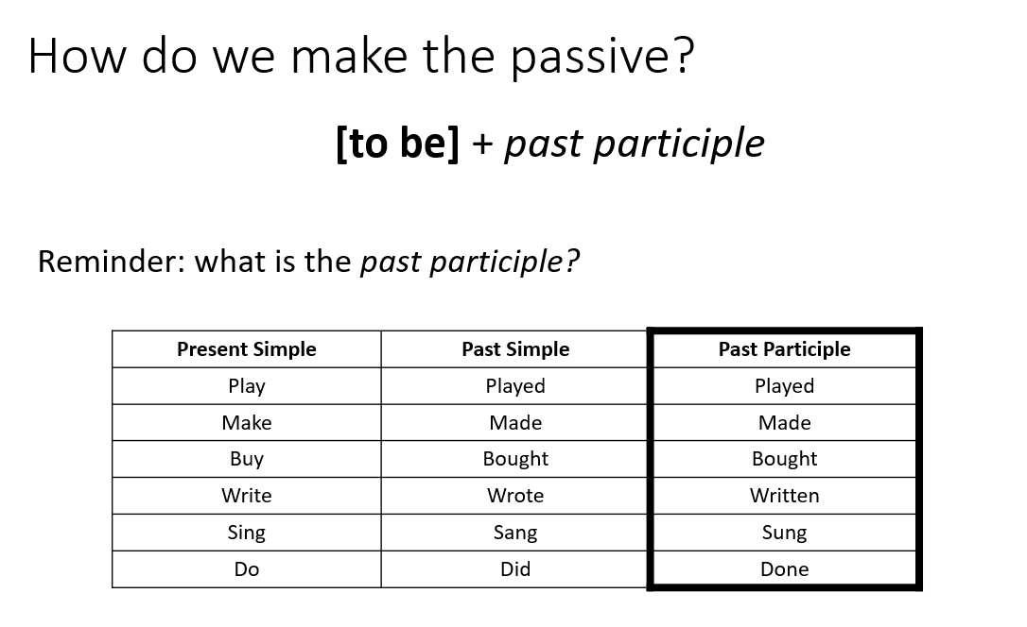  - Use the whiteboard or a PowerPoint to explicitly teach how we make the passive and when we use it. For example:  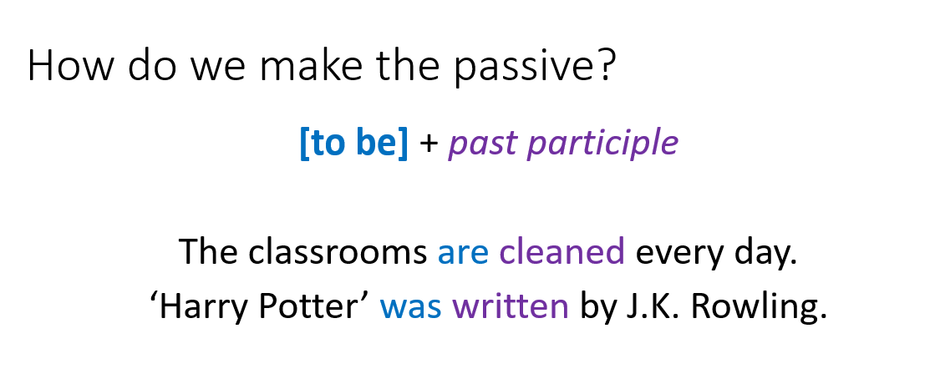  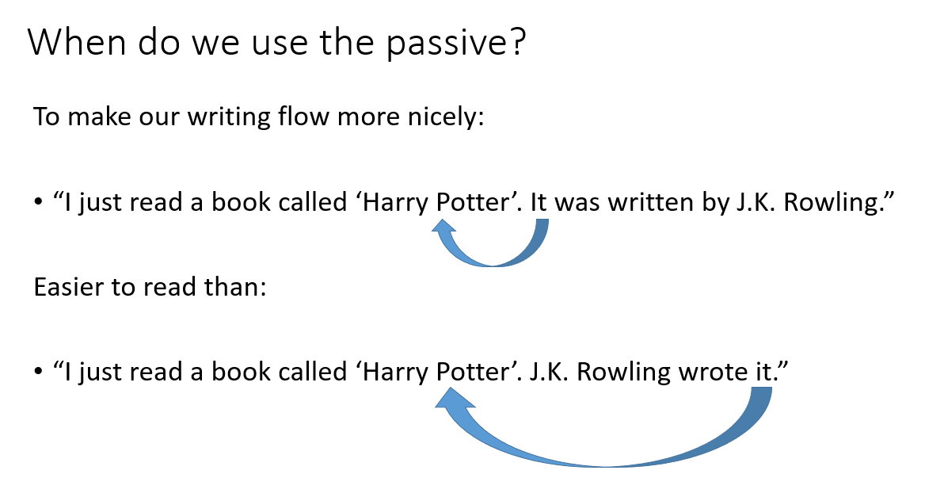  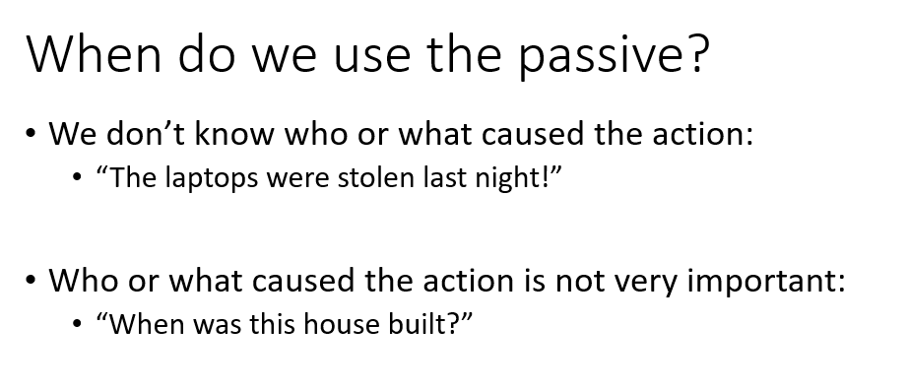  - Make it clear that passive voice is not “better” than active voice: indeed, the active voice is often preferable. However, there are some situations where it is helpful to use passive.  - Check for understanding before moving on. For example, put two sentences on the board and see if students can identify the correct one. Give students time to think individually and discuss in pairs before you call on them.  Guided practice  - Give students plenty of opportunity to practise the skill of using the passive voice through exercises such as those in Raymond Murphy’s English Grammar in Use. Students should do the exercises individually but should be encouraged to discuss their answers in pairs or small groups. Students who have already learned the simple passive can work together on more advanced structures, such as the continuous passive (“The house is still being built”) or perfect passive (“Have the bins been emptied?”).  - Correct exercises as a whole class, identifying and addressing any common misconceptions. If students make a mistake when sharing an answer, frame this in a positive light (“I’m glad you shared that answer, because we can all learn from it.”).  - Develop students’ fluency and automaticity with using the passive through speaking activities. For example, project on the board a picture of a very messy room where many things have been broken, turned upside-down etc. Students work in pairs to brainstorm passive sentences to describe the room: for example, The window was broken. The table was tipped over. Rubbish was left on the floor.  - Bring students back to the topic by writing about Macbeth using both the active and passive voice (see below resources for ideas).  Independent practice  - Students write a short plot summary of the Macbeth scenes they have read so far, using the active and passive voices as appropriate. Alternatively, they could do a creative writing task, such as a journal entry from the point of view of one character. Provide feedback on students’ writing and give them time in class to set goals using their feedback.  Conclusion  - Students submit their paragraphs and complete an exit slip. The exit slip should contain an activity similar to the pre-test: a short fill-in-the-blanks exercise where they have to choose between active and passive voice.  - Use these exit slips and students’ paragraphs to evaluate how well they have learned the passive voice (how to make it and when to use it) and to plan for the following lessons. | Feedback  Differentiated teaching  Structuring lessons  Setting goals  Explicit teaching  Worked examples  Questioning  Multiple exposures  Collaborative learning  Differentiated teaching  Feedback  Multiple exposures  Collaborative learning  Multiple exposures  Feedback

Macbeth active/passive sentences
Acts 1-3
Please write in full sentences in your workbook.
Fill in the blanks with the correct form of the verb, active or passive. Use present tense.
Example:
Macbeth is told (tell) by the witches that he will be king.
- The Thane of Cawdor _________ (betray) Duncan by helping the King of Norway.
- The witches _________ (tell) Macbeth and Banquo about their futures.
- When Lady Macbeth receives a letter from her husband, she _______ (begin) to plan Duncan’s murder.
- Duncan ________ (welcome) to Macbeth’s castle by Lady Macbeth.
- Macbeth _________ (persuade) by Lady Macbeth to go ahead with their plan.
- Macbeth ______ (imagine) a dagger floating in the air.
- Macduff comes to Macbeth’s castle and sees that Duncan ________ (murder).
- The servants sleeping in Duncan’s room ______ (kill) by Macbeth.
- Malcolm and Donalbain _______ (feel) they are not safe and so they _______ (decide) to leave Scotland.
- The murderers ________ (instruct) to kill Banquo and his son Fleance.
- Banquo ______ (kill) by the murderers but Fleance ________ (escape).
- Macbeth _________ (frighten) by the ghost of Banquo.

Writing in the passive voice about Macbeth
Name:
Change the sentences from active to passive. Use present tense only.
For example:
Macbeth kills Duncan. Duncan is killed by Macbeth.

- The Thane of Cawdor betrays Duncan.
_______________________________________________________________

- The witches foretell Macbeth’s future.
_______________________________________________________________

- Lady Macbeth persuades Macbeth to go ahead with their plan.
______________________________________________________________________________________________________________________________

- Two servants are guarding King Duncan as he sleeps.
_______________________________________________________________

Complete the sentences below, using the passive voice.
- Macbeth kills Duncan with the daggers that Lady Macbeth has left out.
Macbeth kills Duncan with the daggers that________________________________ ______________________________________________________________

- Macduff learns that someone has murdered King Duncan.
Macduff learns that_________________________________________________

- Ross tells Macduff that someone has killed his family.
Ross tells Macduff that_______________________________________________

- The witches tell Macbeth that nobody will defeat him until the forest moves.
The witches tell Macbeth that__________________________________________ ______________________________________________________________

- Macbeth believes that nobody born of woman can kill him.
Macbeth believes that ______________________________________________

- Macbeth realises that the witches have deceived him.
Macbeth realises that_______________________________________________

For each pair of sentences, decide which one you prefer—the active or the passive—and why. Share your answers with a friend.
Literary techniques
Name:
- Literary techniques
The following excerpts from Macbeth are examples of literary techniques. Place the number of each excerpt in the correct column (sometimes they can go in more than one column).
- “Pity, helpless as a new-born child, will take on Heaven’s power.”
- “His noble deeds will plead with angelic voices…”
- “Your face is like a book… where men can read strange things.”
- “Every wound was like a door through which death entered.”
- “Sleep that knits up the ravell’d sleeve of care”
- “Sleep… balm of hurt minds, great nature’s second course, chief nourisher in life’s feast.”
- “He’s like a child, wearing a giant’s clothes.”
- “I am like a dry and yellow leaf, ready to fall.”
- “Tomorrow…. creeps in this petty pace from day to day...”
- “Out, out, brief candle!”
- “Life’s… a poor player, who struts and frets his hour upon the stage, then is heard no more.”
- “It is a tale told by an idiot”
- “All our yesterdays have lighted fools the way to dusty death.”
Simile | Metaphor | Personification | Alliteration
1 |  | 1

- Symbols and motifs
A symbol is an object that represents a complex idea. For example, the raven (a black bird) is a symbol of death.
A motif is a symbol, image, or idea that recurs in a text. For example, ‘sleep’ is a motif in Macbeth. Important things happen when characters are asleep, and characters often talk about it. It is also a symbol (for peace of mind) and there are many metaphors for sleep (for example, Macbeth describes it as “sore labour’s bath”).
Think of some other symbols and motifs in Macbeth:
- sleep

- Analysing verbs
It is not enough to just point out a literary technique: you need to analyse its effect on the audience.
For example: “The comparison of life to a “brief candle” suggests that it is short and meaningless.”
Here are five verbs that are useful for analysing literary techniques. Match the word to its definition.
suggest  emphasise  depict  symbolise  evoke | how an object represents an idea  to show an idea indirectly (not actually say it)  to draw attention to something or show how important it is  to bring something to mind  to show or describe something

How do you use each word?
- Suggest
suggest + that + clause
The comparison of life to a “brief candle” suggests that it is short and meaningless.
Your turn: ______________________________________________________________________________________________________________________________________ ___________________________________________________________________
- Emphasise
emphasise + that + clause
By ending Macbeth’s speech halfway through the line, Shakespeare emphasises that death arrives abruptly.
or
emphasise + noun group
By ending Macbeth’s speech halfway through the line, Shakespeare emphasises the abruptness of death.
Your turn: _________________________________________________________________________________________________________________________________________________________________________________________________________
- Depict
depict + noun group + as + noun group
By describing sleep as a “balm of hurt minds”, Shakespeare depicts it as a calm and soothing antidote to worry.
or
depict + noun group + as + adjective
By describing sleep as a “balm of hurt minds”, Shakespeare depicts it as calming and soothing.
Your turn: ______________________________________________________________________________________________________________________________________ ___________________________________________________________________
- Symbolise
symbolise + noun group
The “spot” that Lady Macbeth cannot clean from her hands symbolises her guilt.
Your turn: ______________________________________________________________________________________________________________________________________
- Evoke
evoke + noun group
Lady Macbeth’s disjointed language evokes her degraded state of mind.
Your turn: ______________________________________________________________________________________________________________________________________
- Different sentence structures
The analysing verbs can be used in different ways. Read each example, then try writing a similar sentence yourself using a different verb.
- The comparison of life to a “brief candle” suggests that it is short and meaningless.
______________________________________________________________________________________________________________________________________

- Macbeth compares life to a “brief candle”. This suggests that life is short and meaningless.
______________________________________________________________________________________________________________________________________

- Macbeth compares life to a “brief candle”, which suggests that it is short and meaningless.
______________________________________________________________________________________________________________________________________

- Macbeth compares life to a “brief candle”, suggesting that it is short and meaningless.
______________________________________________________________________________________________________________________________________

- Lady Macbeth’s guilt is symbolised by the spot of blood on her hands.
______________________________________________________________________________________________________________________________________

- By comparing life to a “brief candle”, Macbeth depicts it as short and meaningless.
______________________________________________________________________________________________________________________________________

- Annotation
Annotate literary techniques and other interesting language features in the ‘Tomorrow’ speech.

Tomorrow, and tomorrow, and tomorrow,
Creeps in this petty pace from day to day,
To the last syllable of recorded time;
And all our yesterdays have lighted fools
The way to dusty death. Out, out, brief candle!
Life's but a walking shadow, a poor player,
That struts and frets his hour upon the stage,
And then is heard no more. It is a tale
Told by an idiot, full of sound and fury,
Signifying nothing.

- Analysis
Finish writing the analysis.
The repetition of the word “tomorrow” emphasises that life has become monotonous and meaningless for Macbeth. Each day “creeps in this petty pace”, the alliteration of the plosive “p” sound evoking the bitterness that Macbeth feels. Life is compared to a “brief candle”, suggesting that…_______________________________________________________________ ________________________________________________________________________________________________________________________________________________________________________________________________________________________________________________________________________________________________________________________________________________________________________________________________________________________________________________________________________________________________________________________________________________________

‘Sleep’ speech (Act 2, Scene 3)
Methought I heard a voice cry 'Sleep no more!
Macbeth does murder sleep', the innocent sleep,
Sleep that knits up the ravell'd sleeve of care,
The death of each day's life, sore labour's bath,
Balm of hurt minds, great nature's second course,
Chief nourisher in life's feast.

‘Tomorrow’ speech (Act 5, Scene 5)
Tomorrow, and tomorrow, and tomorrow,
Creeps in this petty pace from day to day,
To the last syllable of recorded time;
And all our yesterdays have lighted fools
The way to dusty death. Out, out, brief candle!
Life's but a walking shadow, a poor player,
That struts and frets his hour upon the stage,
And then is heard no more. It is a tale
Told by an idiot, full of sound and fury,
Signifying nothing.

Macbeth sentence structure practice
Cut up the sentence parts and distribute to pairs of students. Students arrange them to create sentences analysing Macbeth.
suggests | depicts | emphasises
symbolises | evokes
suggests | depicts | emphasises
symbolises | evokes
suggests | depicts | emphasises
symbolises | evokes

The repetition of the word “Tomorrow” |  | the motif of sleep
The spot of blood on Lady Macbeth’s hand |  | her guilt. |  | it
Shakespeare’s description of sleep as a “balm for hurt minds”
the meaninglessness of life.
The symbol of light and dark
the contrast between good and evil.
The description of life as “like a brief candle”
its brevity and meaninglessness. | Shakespeare
Lady Macbeth’s disjointed language
her insanity. | life |  | him
Macbeth’s bitterness.
Macbeth’s description of himself as like a “dry and yellow leaf”
The metaphor of life as a “poor player”

as calming and soothing. | as meaningless.
as short and meaningless. | as old and tired.
Through his comparison of Macbeth to a “dry and yellow leaf”,
Through his description of life as a “brief candle”,

Word families in Macbeth
Name:
- Fill in the blank columns and translate words into your home language.
Noun | Verb | Adjective
ambition |  | ambitious
 |  | violent
flattery |  | flattering
 |  | guilty
confession
 | repeat
 | emphasise
symbol / symbolism
 | compare
 |  | abrupt
description
 | depict
 | suggest
 |  | meaningful
 | evoke
 | Use
bitterness
 |  | brave
 |  | greedy
blood

Knowing the different members of a word family can help us structure our sentences in different ways. For example:
Macbeth repeats “Tomorrow” three times, emphasising the meaninglessness of life.
The repetition of the word “Tomorrow” emphasises the meaninglessness of life.
It can also help us to connect our ideas together when we are writing. For example:
Macbeth’s bloody hands symbolise his guilt. This symbolism is seen again when Lady Macbeth is sleepwalking, trying desperately to “get [her] hands clean”.

Re-write each sentence by transforming the verb or adjective into a noun.
You might need to change the sentence from active into passive, or vice versa.
Example:
Macbeth repeats “Tomorrow” three times, emphasising the meaninglessness of life.
The repetition of the word “Tomorrow” emphasises the meaninglessness of life.

- The alliteration of the [p] sound suggests that Macbeth feels bitter.

Macbeth’s bitterness is suggested by_____________________________________ ______________________________________________________________
- Macbeth is ambitious, which causes his downfall.
______________________________________________________________________________________________________________________________
- Macbeth compares life to a “brief candle”, suggesting that it is short and meaningless.
______________________________________________________________________________________________________________________________
- By ending the Macbeth’s speech halfway through the line, Shakespeare suggests that death is abrupt.
______________________________________________________________________________________________________________________________
- Shakespeare uses the symbol of light and dark to suggest the contrast between good and evil.
______________________________________________________________________________________________________________________________
- Macbeth is described as “like a child, wearing a giant’s clothes.” This suggests that he is not suited to the role of king.
______________________________________________________________________________________________________________________________
- When Macbeth kills the rebels’ leader in battle, Duncan celebrates how brave he is.
______________________________________________________________________________________________________________________________
If you finish early, try making up your own pairs of sentences.

Macbeth Sample plan and essay
Topic: Does Macbeth have a moral message?
Word Length: 500-600 words

Plan
Main contention: On the surface, Macbeth is a play with a clear moral message: if you upset the natural order of things, you will be punished. However, this message is less straightforward than it initially seems.
Paragraph #3:
However, it is not clear that characters have full responsibility for their actions.

Evidence:
- It seems like characters are not fully in control of their fate– can they therefore be held responsible?
- the motif of fog: moral ambiguity
- Macbeth says “my fate is in my hands” – but we know that’s not true (dramatic irony)
- “Those double-dealing spirits made a fool of me with their dishonest words”
- “All our yesterdays have lighted fools…” – personification implies that humans are not in control

Paragraph #2:
Lady Macbeth is also punished for her evil deeds.

Evidence:
- Lady Macbeth asks spirits to make her full of cruelty so she can kill Duncan – but becoming queen brings her no happiness
- “what we have now, brings no delight”
- “guilt and horror our own lives destroy”
- the disjointed language of Lady Macbeth’s sleepwalking scene – evokes her madness
- “unnatural deeds lead to unnatural troubles”
- the symbol of blood – the guilt that she can’t wash away

Paragraph #1:
Macbeth commits evil deeds, and in the end is punished.

Evidence:
- After murdering Duncan, Macbeth’s life has no happiness, and eventually he is killed himself
- “If I had died an hour before this moment, I would have died happy”
- Macbeth can’t sleep - represents the loss of his peace of mind
- an “unnatural deed” – the natural order of things has been upset
- “the kingly clothes he wears all weigh him down” – Macbeth got what he wants, but isn’t happy
- Macbeth like “a dry and yellow leaf”

Essay

On the surface, Macbeth is a play with a clear moral message: if you upset the natural order of things, you will be punished. However, this moral message is less straightforward than it initially seems. Macbeth and Lady Macbeth are both punished for their evil deeds, but it is unclear whether they are fully in control of their fate and therefore responsible for their actions.
Macbeth upsets the natural order of things by murdering King Duncan and is eventually punished. This “unnatural deed” upsets the balance of nature: after Duncan’s death, “the wind… blew down trees… and some men said they felt the earth shake.” Macbeth immediately regrets his actions, saying that “if [he] had died an hour before this moment, [he] would have died happy.” He also loses the ability to sleep properly, which symbolises his lost peace of mind. Becoming king brings him no happiness: on the contrary, his “kingly clothes… weigh him down”. Towards the end of the play, Macbeth compares himself to a “dry and yellow leaf”, suggesting that his life is devoid of beauty. He is finally killed by Macduff, and everybody celebrates his death. Macbeth’s tragedy seems to have a clear moral message: people who commit evil deeds will be punished.
Lady Macbeth is also punished for her evil deeds. Becoming the queen “brings no delight”, and she laments that “guilt and horror” have destroyed their lives. Eventually, the guilt drives her to insanity. When she is sleepwalking at the beginning of Act 5, her language is written in disjointed prose rather than blank verse, evoking her degraded state of mind. The imaginary spot of blood on her hand symbolises her guilt, which she will never be able to overcome. At the end of the play, she “[dies] by her own hand.” Her doctor says that “unnatural deeds lead to unnatural troubles”, which suggests that Lady Macbeth gets what she deserves. As such, her decline into insanity and death seems to carry a moral lesson.
On the other hand, this moral lesson is not as clear as it seems. Macbeth and Lady Macbeth are spurred to commit murder by the prophesy of the three witches, which predicts that Macbeth will be king. The “terrible idea” first occurs to Macbeth after meeting the witches, suggesting that he would not have thought of it otherwise. Lady Macbeth is also influenced by the prophesy, but her reaction to it is confused. She believes that Macbeth “must commit a murder… to get the crown”, but she also believes that “fate says [the crown] shall be [his]”. As such, it is unclear whether the husband and wife are truly in control of their own fate. Although at the beginning of Act 3, Macbeth claims that his “fate is in [his] hands”, by the end of Act 5 he realises that “those double-dealing spirits made a fool of [him] with their dishonest words”. When he learns about his wife’s death, Macbeth laments that “all our yesterdays have lighted fools the way to dusty death”. The personification of time as guiding humans towards their death suggests that time itself is truly in control. If humans are not in control of their fate, it is then unclear whether they can take responsibility for their actions.
On the surface, Macbeth is a play with a moral lesson: those who commit evil deeds will be duly punished. This is suggested by the decline of both Macbeth and Lady Macbeth. However, it is never certain that the characters are truly in control of their fate, and therefore deserve their punishment. This ambiguity undermines any clear moral message in Macbeth.

Questions
- What does the student do in their introduction? _______________________________________________________________________________________________________________________________________________________________
- What do they do in the first sentence of each body paragraph? _______________________________________________________________________________________________________________________________________________________________
- What do they do in the last sentence of each body paragraph? _______________________________________________________________________________________________________________________________________________________________
- How does the first sentence of each body paragraph connect back to the previous paragraph? __________________________________________________________________________________________________________
- How many quotes are in each body paragraph? _____________________
- How many times does the student analyse literary techniques? __________
- When does the student use [square brackets]? _____________________________________________________
- Underline sentences where the student has used the passive voice. Why do you think they’ve used the passive voice there? __________________________________________________________________________________________________________
- What does the student do in their conclusion? _____________________________________________________ __________________________________________________________________________________________________________
- Look at the student’s plan. Do they use all of their evidence in the essay? Why or why not? _______________________________________________________________________________________________________________________________________________________________
Constructing an essay together
Name:
For this activity, please do not look at the sample essay that you have been given!
Working in pairs, use the plan below to help you re-construct the sample essay.
Plan
Main Contention: On the surface, ‘Macbeth’ is a play with a clear moral message: if you upset the natural order of things, you will be punished. However, this message is less straightforward than it initially seems.
Paragraph #3:
However, it is not clear that characters have full responsibility for their actions.

Evidence:
- It seems like characters are not fully in control of their fate– can they therefore be held responsible?
- the motif of fog: moral ambiguity
- Macbeth says “my fate is in my hands” – but we know that’s not true (dramatic irony)
- “Those double-dealing spirits made a fool of me with their dishonest words”
- “All our yesterdays have lighted fools…” – personification implies that humans are not in control

Paragraph #2:
Lady Macbeth is also punished for her evil deeds.

Evidence:
- Lady Macbeth asks spirits to make her full of cruelty so she can kill Duncan – but becoming queen brings her no happiness
- “what we have now, brings no delight”
- “guilt and horror our own lives destroy”
- the disjointed language of Lady Macbeth’s sleepwalking scene – evokes her madness
- “unnatural deeds lead to unnatural troubles”
- the symbol of blood – the guilt that she can’t wash away

Paragraph #1:
Macbeth commits evil deeds, and in the end is punished.

Evidence:
- After murdering Duncan, Macbeth’s life has no happiness, and eventually he is killed himself
- “If I had died an hour before this moment, I would have died happy”
- Macbeth can’t sleep - represents the loss of his peace of mind
- an “unnatural deed” – the natural order of things has been upset
- “the kingly clothes he wears all weigh him down” – Macbeth got what he wants, but isn’t happy
- Macbeth like “a dry and yellow leaf”

Introduction:
State the first part of the main contention | On the surface, ‘Macbeth’ is a play with a clear moral message: if you upset the natural order of things, you will be punished.
State the second part of the main contention | However, this moral message is less straightforward than it initially seems.
Outline the three body paragraphs | Macbeth and Lady Macbeth are both punished for their evil deeds, but it is unclear whether they are fully in control of their fate and therefore responsible for their actions.

Body Paragraph 1:
State the main idea of this paragraph
Show how Macbeth’s actions upset nature
Give examples and explain how Macbeth is punished for these actions
Link back to the main contention

Body Paragraph 2:
State the main idea of this paragraph | Lady Macbeth is also punished for her evil deeds.
Give examples and explain how killing Duncan does not make Lady Macbeth happy
Give examples and explain how Lady Macbeth’s guilt drives her insane
Link back to the main contention

Body Paragraph 3:
State the main idea of this paragraph | On the other hand, this moral lesson is not as clear as it seems.
The witches are partly responsible for Macbeth’s actions.
The witches are partly responsible for Lady Macbeth’s actions.
The fate of the characters seems to be fixed: there is nothing they can do to change it.

Link back to the main contention | If humans are not in control of their fate, it is then unclear whether they can take responsibility for their actions.

Conclusion
Re-state the first part of the main contention and summarise the first two body paragraphs. | On the surface, ‘Macbeth’ is a play with a moral lesson: those who commit evil deeds will be duly punished. This is suggested by the decline of both Macbeth and Lady Macbeth.
Conclude by emphasising the second part of the main contention (the third body paragraph). | However, it is never certain that the characters are truly in control of their fate, and therefore deserve their punishment. This ambiguity undermines any clear moral message in ‘Macbeth’.

Macbeth Text response essay rubric
4 | Has an engaging introduction that hooks the reader’s interest, states the main contention, and gives an outline of the essay’s structure. | Each paragraph builds on the previous paragraph to present a logical development of ideas. | Reinforces the main contention and concludes on a thought-provoking idea. | Presents a nuanced discussion of the topic that arrives at a well-reasoned conclusion. | Supports their discussion with a range of specific and relevant evidence. May critically discuss evidence that supports other viewpoints. | Supports their discussion with an insightful analysis of the effect of literary techniques. | Uses a range of simple and complex sentence structures accurately, appropriately and effectively.
3 | Has a well-developed introduction that states the main contention and gives an outline of the essay’s structure. | Each paragraph contains a topic sentence, a discussion of evidence, and a concluding or link sentence. | Reinforces the main contention. May give a brief summary of the essay. | Presents a well-developed position based on the topic. | Supports their main contention with relevant evidence from the play. | Analyses the effect of literary techniques. | Uses some more complex sentence structures effectively (e.g. relative clauses with which)
2 | States the main contention. | Begins paragraphs with topic sentences. | Re-states the main contention. | Presents a main contention based on the topic. | Discusses examples from the play. | Attempts an analysis of literary techniques. | Attempts to use more complex sentence structures (e.g. relative clauses with which).
1 | Attempts an introduction. | Groups ideas into paragraphs. | Attempts a conclusion. | Discusses the topic. | Gives examples from the play. | Includes literary techniques. | Uses correct word order in simple sentences.
0
 | Introduction | Paragraphs | Conclusion | Contention | Evidence | Analysis | Sentence structure

Planning template
Name:
Topic: Who is the real villain of Macbeth?
- Highlight the key words in the topic.
- Write your main contention (your opinion on the topic).
______________________________________________________________________________________________________________________________________________

- Think of three arguments to support this main contention. These will become your three body paragraphs.
Then, think of evidence from the play (quotes and literary techniques) to support these arguments.
Evidence:
Evidence:
Evidence:
Argument 1:
Argument 2:
Argument 3:

Essay scaffold
Introduction (about 60 words)
Your main contention
The 3 reasons supporting your main contention

Body paragraph 1 (about 150 words)
State the main idea of this paragraph (Topic sentence)
Give examples that support this idea and explain these examples

Link this idea back to your main contention

Body paragraph 2 (about 150 words)
State the main idea of this paragraph (Topic sentence)
Give examples that support this idea and explain these examples

Link this idea back to your main contention

Body paragraph 3 (about 150 words)
State the main idea of this paragraph (Topic sentence)
Give examples that support this idea and explain these examples

Link this idea back to your main contention

Conclusion (about 60 words)
Briefly summarise the 3 paragraphs
Re-state your main contention

Essay self-assessment

Name:
Circle Yes or No for each question. If you circle No for any question, go back to your essay and fix it.
- Does my introduction clearly state my main contention? Yes/No
- Does my introduction clearly tell the reader what my three body paragraphs will be about? Yes/No
- Do all three of my body paragraphs start with a clear topic sentence? Yes/No
- Do all of them end with a sentence that links back to my main contention? Yes/No
- How many examples from the text are in each of my body paragraphs?
 | Body paragraph 1 | Body paragraph 2 | Body paragraph 3
Number of examples

- Out of these examples, how many are quotations?
 | Body paragraph 1 | Body paragraph 2 | Body paragraph 3
Number of quotations

- Have I discussed and explained the examples in each body paragraph? Yes/No
- Does my conclusion summarise my ideas and link back to my main argument? Yes/No
- Do all of my verbs agree with the subject? (For example, “They are” / “She is” Yes/No
- Have I written in present or past tense? Present / Past
- Have I checked to make sure that I have used that tense consistently? Yes / No
- Is my essay 500-600 words long? Yes/No
- My word count: _____________
What are the strengths of my essay?
____________________________________________________________________________________________________________________________________________________________________________________________________________________________________________________________________
What do I need to improve?
____________________________________________________________________________________________________________________________________________________________________________________________________________________________________________________________________

Assess your essay using the rubric.

Peer assessment: Macbeth essay
Name:
Your partner’s name:
Read their introduction only.
Write:
- Their main contention: _________________________________________________________________ _________________________________________________________________
- Their three supporting arguments:
- ______________________________________________________________________________________________________________________________
- ______________________________________________________________________________________________________________________________
- ______________________________________________________________________________________________________________________________
If you answer “no” to any of the following questions, explain why not.
Read their first paragraph.
- Does it begin with a clear topic sentence? _________________________________
- How many pieces of evidence (literary techniques or quotes) do they use? ________
- Does the student clearly explain their examples, and show how they support the argument? ____________________________________________________________
- Does the final sentence link back to the main contention? ______________________
Read their second paragraph.
- Does it begin with a clear topic sentence? _________________________________
- How many pieces of evidence (literary techniques or quotes) do they use? ________
- Does the student clearly explain their examples, and show how they support the argument? ____________________________________________________________
- Does the final sentence link back to the main contention? ______________________
Read their third paragraph.
- Does it begin with a clear topic sentence? _________________________________
- How many pieces of evidence (literary techniques or quotes) do they use? ________
- Does the student clearly explain their examples, and show how they support the argument? ____________________________________________________________
- Does the final sentence link back to the main contention? ______________________
Read their conclusion.
- Does the conclusion summarise the three arguments? Explain why or why not. ______________________________________________________________________________________________________________________________
- Does it clearly re-state the main contention? _______________________________________________________________
After reading the whole essay:
- Do the three arguments clearly support the main contention? ______________________________________________________________________________________________________________________________
- Are there any sentences that you don’t understand? If so, highlight them.
- What did you like most about this essay? _______________________________________________________________ ______________________________________________________________________________________________________________________________
- What is something this student can do to make their essay even better?
_____________________________________________________________________________________________________________________________________________________________________________________________
- Have a look at your partner’s self-assessment rubric. Do you agree with it? Why or why not? ____________________________________________________________________________________________________________________________________________________________________________________________________________________________________________________________

On the other hand, for the purpose of VCE preparation, it might be more expedient to conduct the final assessment under exam conditions. It might also be a more enriching literary experience to study a range of themes. Consider the purposes of your unit when deciding how much information about the final assessment to provide in advance.

