ABOUT THIS UNIT

A key aim of this curriculum unit is to support students in developing language resources that are progressing towards the written end of the mode continuum. With its focus on a specific genre and the associated language patterns and structures, the unit draws on a functional model of language (e.g. Rothery, Martin, Christie, Halliday) and on the genre teaching/learning cycle in scaffolding student learning. The genre teaching/learning cycle consists of four main stages: Building the Field, Modelling and Deconstruction, Joint Construction and Independent Construction.

The main focus of the unit is on exploring a range of procedural texts. Procedural texts can be described as a ‘genre family’ in that they share the purpose of giving instructions or directions. Texts within this genre family encompass the following:

- Procedure – how to do an activity (e.g. recipe, experiment. algorithm)
- Protocol – what to do and not to do (e.g. guidelines, rules, warnings, laws)
- Procedural recount – how an activity was done (e.g. experiment report)
Rose, 2017

This unit focuses on procedure texts, with the main text – the ‘mentor text’ – being a recipe. However, while the activities in this unit focus on procedures, there is scope for the teacher to incorporate other examples of instructional or procedural texts such as protocols and procedural recounts e.g. science experiment reports, giving directions, maintaining your bicycle, rules for cyber safety. Multimodal aspects of procedure texts (e.g. graphics and videos) are also included in the unit.

Rather than discrete ‘lessons’, the unit is organised in a sequence of numbered learning ‘Activities’, with each activity having one or more components. This enables the unit to be adaptable to teachers’ contexts and flexible enough to be spaced across a number of lessons, depending on the structure of the school curriculum and the organisation of EAL classes. Links to information referred to in some of the Activities (e.g. punctuation games, dictogloss etc.) are provided on the last page of the Unit.

Finally, some academic references have been embedded in the middle column of the unit planning template titled Language Focus – Additional EAL Focus. These provide a theoretical and practical rationale for the activities selected. A list of these is also provided at the end of the unit, before the Appendices.

Unit name: PROCEDURE TEXTS IN THE SECONDARY CLASSROOM
This unit explores procedure texts.
Class description:
This unit was initially developed for a group of Year 7 students working in a parallel EAL class. Some of the students were from families that sought refuge from war and violence in Sudan. Several were fluent in spoken Arabic, which was the dominant language used at home, but were unable to read and write fluently in Arabic. While most of the parents conversed in Dinka, a few could speak and understand basic English. Cultural factors that influenced the students’ behaviour in class included difficulty adjusting to classroom routines, maintaining eye contact and lack of response when interacting with the teacher.

Student year level/EAL stage/s:
Assessments of the students’ capabilities placed them at Stage S2.2 on the DET EAL Developmental Continuum P-10 for reading, speaking and listening, while writing was at Stage S1.3. They were, for the most part, confident in using oral conversational English with peers and staff; however, they were reluctant to read aloud from texts and to give oral presentations to the class. Several of the students struggled with pace, maintaining eye contact with their audience and pronunciation.

Learning area/s: Victorian Curriculum English Year 7
MODE: SPEAKING AND LISTENING
STRAND- Literacy Substrand-Interacting with others
Listening and speaking interactions
Identify and discuss main ideas, concepts and points of view in spoken texts to evaluate qualities, using interaction skills when sharing interpretations or presenting ideas and information.
Oral presentations
Plan, rehearse and deliver presentations, selecting and sequencing appropriate content and multimodal elements to promote a point of view or enable a new way of seeing, using body language, voice qualities and other elements to add interest and meaning.
Achievement Standard
They make presentations and contribute actively to class and group discussions, using language features to engage the audience.
MODE: READING AND VIEWING
STRAND- Literacy Substrand – Interpreting, analysing, evaluating
Analysing and evaluating
Analyse and explain the ways text structures and language features shape meaning and vary according to audience and purpose.
Achievement Standard
They demonstrate understanding of how the choice of language features, images and vocabulary affects meaning.
MODE: WRITING
STRAND – Language Substrand – Text structures and organisation
Punctuation
Understand the use of punctuation to support meaning in complex sentences with prepositional phrases and embedded clauses.
Achievement Standard
When creating and editing texts they demonstrate understanding of grammar, use a variety of more specialised vocabulary, use accurate spelling and punctuation.

EAL Indicators from the EAL Developmental Continuum P-10
Listening and Speaking
Productive
- use adverbial phrases, pronouns and irregular past tenses with some accuracy

Maintaining and negotiating spoken communication
Productive
- use pauses and fillers (ah, um) appropriately to allow ordering of thought
Reading and Viewing
Linguistic structures and features
- display an understanding of the function of punctuation marks, e.g. when reading aloud, pauses at appropriate points in the text, adjusts speech to reflect dialogue
- identify some basic organisational features of texts, e.g. procedure, recount, report, argument.
Cultural conventions
- interpret the way information is organised in texts, e.g. layout, illustrations, headings
Writing
Text and response
- use models to write simple texts for different purposes, e.g. recount, description, instruction, procedure, narrative.
Linguistic structures and features
- use time adverbials plus the simple present to show past time, e.g. yesterday we go to the library
- use punctuation with some consistency, e.g. full stops, capitals, commas and question marks.

Specific EAL learning needs/goals covered in this unit:
In speaking and listening, the students are permitted to repeat instructions, act out and use gestures to reinforce understanding but are not permitted to add extra details or words in the presentation of the instructions. This challenges the spoken language skills of presenters, as they need to articulate words clearly, use intonation and to speak at a reasonable pace and volume in order to be heard and understood by their audience (Blake Education, 2006).
In terms of reading and viewing, students need to be able to decode and comprehend the instructions quickly to be able to perform them without asking clarifying questions to aid comprehension. This requires a high level of reading skills to be able to decode and comprehend text, pictures/videos as well as execute the instructions simultaneously. According to Hertzberg, EAL students rely heavily on graphophone decoding and, therefore, while they may be able to read the text, they may need repeated reading and more time to comprehend the text (2012). Further, a multimodal text requires comprehension of multiple modes with pictures and/or video as well as text, which is an additional challenge for the students.
In the written mode, the linguistic challenges require the presenter to use precise yet detailed language in order to provide sufficient information to carry out the instructions, which places the assessment further towards the written end of the mode continuum. This means fewer reference items (such as pronouns, articles etc.) and an increase in noun groups, circumstances (such as adverbs and preposition phrases), the use of conditionals and embedded clauses. These grammatical features pose challenges to EAL learners as some understanding of prepositions, clauses and adverbs is required before attempting more complex phrases and embedded clauses. To address these issues, the unit of work will focus explicitly on the use of adverbials and preposition phrases.
The linguistic demands of the text may pose a problem from a cultural perspective with interference from the students’ interlanguage. In the students’ first language of Arabic, adjectives are rarely used, but when they are used they are written in a different order to English. In Arabic, the adjective usually follows the noun in noun groups (Shoebottom, 2015). Also, since adverbs with the ending ’ly’ are rarely used in Arabic, students tend to add the suffix ‘i’ which may pose a problem (Dickins, Hervey & Higgins, 2002). In addition, there are no modal verbs used in Arabic which could also be challenging (Shoebottom, 2015).
In this unit, the teacher needs to take into account collaborative group work, peer support and scaffolding at points of need. In the ‘building the field’ stage of the teaching and learning cycle, the teacher will need to determine the students’ prior knowledge and familiarity with the structure and language of various instructional or procedural texts, including the students’ cultural knowledge of Australian cuisine – in particular, the hamburger. Also, while the activities in this unit tend to focus on writing, listening and speaking, students’ reading comprehension and decoding skills need to be supported in order for them to progress to the next stage of the EAL Developmental Continuum P-10.

Main genre focus: Procedure (recipe)
The core procedure text (recipe) displays a series of steps leading to an end product.
The challenge for written language is to write a text using precise, detailed language in order to have a participant perform the instructions. This challenges the students to include details via expanded noun groups, adverbials, preposition phrases and conditionals rather than writing in basic simple sentences.

Year: 7  VC Level: 7 English  EAL Stages: S2 speaking and listening  S1 writing |  | Unit name: PROCEDURE TEXTS IN THE SECONDARY CLASSROOM  This unit explores various procedure texts including a recipe and giving directions. |  |  |  |  |  | Time allocation  3-4 weeks
Topic Focus | Victorian curriculum/content learning objectives  MODE: Speaking and Listening  Listening and speaking interactions  Identify and discuss main ideas, concepts and points of view in spoken texts to evaluate qualities, using interaction skills when sharing interpretations or presenting ideas and information.  Oral presentations  Plan, rehearse and deliver presentations, selecting and sequencing appropriate content and multimodal elements to promote a point of view or enable a new way of seeing, using body language, voice qualities and other elements to add interest and meaning.  MODE: Reading and Viewing  Analysing and evaluating  Analyse and explain the ways text structures and language features shape meaning and vary according to audience and purpose.  MODE: Writing  Punctuation  Understand the use of punctuation to support meaning in complex sentences with prepositional phrases and embedded clauses. |  |  | Texts encountered in this unit
 |  |  |  | Text type &  mode | Listened to | Spoken |  |  | Read -online or printed texts | Written |  | Viewed | Produced
 |  |  |  | Literary texts
 |  |  |  | Recount
 |  |  |  | Instructional
 |  |  |  | Report
 |  |  |  | Explanation
 |  |  |  | Discussion
Argument/
exposition
Topic-specific vocabulary  - instructions/directions  - procedure  - stages – goal, materials, method, evaluation  - hamburger, ingredients, patty |  |  | Core genre: Procedure (recipe)  Social Purpose: To tell how to make something through a sequence of steps or actions  Generic Structure  Goal: what will be achieved by following the steps outlined  Ingredients: usually listed in order they are required  Method: lists sequence of steps in order to achieve the goal  Diagrams &/or illustrations (optional): may be used to clarify the task | Classroom learning  • brainstorming  - listing  - arguing  • classifying  • establishing limits  • evaluating  • hypothesising  • identifying  • judging  • offering  • persuading  - negotiating  • planning  • predicting  • requesting  • sequencing  - describing cause and effect |  |  | Getting things done  • comparing  • clarifying  • describing  • explaining  • instructing  • inquiring  • justifying  • questioning  • reporting  • suggesting  • warning |  |  |  | Maintaining communication Expressing:  • apology  • appreciation  • approval  • certainty  • concern  • frustration  • indifference  • intention  • needs/wants  • preferences  • probability  • regret
Assessment types used:  Teacher led - Informal observation - Planned observation - Questioning/discussion - Focused analysis of student work Self and peer - Self-reflection - Peer discussion - Peer observation  Assessment: Students will write a procedural text, then use a PowerPoint presentation to share their procedural text with the class. |  |  | Grammatical features focus  Ingredients or equipment:  - expanded noun groups  - nominalisation (naming processes or verbs as things i.e. nouns)  Instructions/steps:  - present tense (to denote timeless context)  - sequencing conjunctions  - imperative verbs (to denote action processes or verbs)  - passive voice  - adverbs (to describe the manner in which to perform an action)  - preposition phrases and adverbials (to give additional information of the circumstances of when, how or where an action is to be performed, or to describe circumstances of cause and condition  - modality (to alter the degree of certainty in a statement)
Resources

TEACHING AND LEARNING ACTIVITIES | LANGUAGE FOCUS – ADDITIONAL EAL FOCUS | ASSESSMENT IDEAS
Introductory Activity & Orientation to the Topic  Teacher introduces the concept of a procedure text – a text that gives a series of steps to follow to do something, make something, cook something, build something, and draw something.  - Teacher asks students if they can think of an example for each of these prompts (how to do something, how to make something, how to build something, how to draw something). Teacher draws attention to the importance of the word ‘how’ – this means it is going to tell you what you need to do.  - Teacher shows the PowerPoint slide to reiterate discussion.  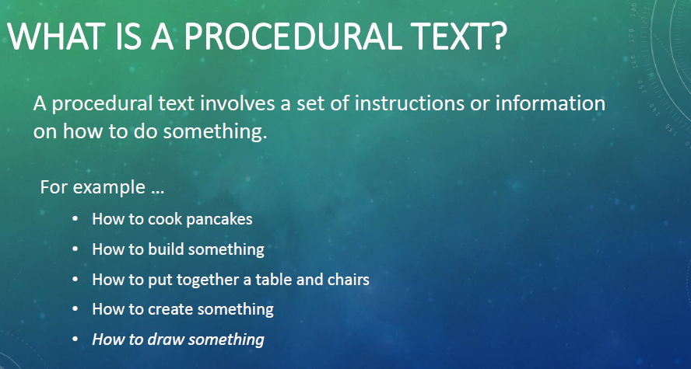  - Whole class viewing of video tutorial on how to make a paper plane  Students view and follow a video tutorial for making a paper airplane  (https://www.youtube.com/watch?v=i8qxExknDSw)  - Whole class reflection and discussion  Teacher discusses with students:  -What made the instructions easy to follow and why (e.g. great to watch the plane being made)  -What made the instructions difficult to follow and why (e.g. no written instructions, only the voice and the pictures of the hands)  -Do you think you would remember the steps to follow, or would you have to watch the video again?  -How important is it to follow the steps in the correct order? What might happen if you don’t?  - Listening to and following verbal instructions.  Teacher reads the instructions for ‘how to draw a cat’ from the PowerPoint slide, allowing students time to follow each individual instruction.  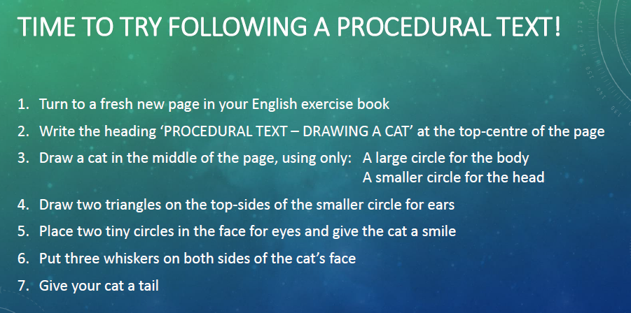  - Reflecting on what they found easy/difficult  Teacher discusses with students:  -How is this different from the video on how to make a paper plane?  -What made it easy and why? (e.g. having the instructions displayed on the slide, the teacher reading the instructions aloud, the steps being numbered)  -What made it difficult and why? (e.g. having to concentrate of listening, working individually without being able to compare their own drawings with others)  -What would have helped and why? (e.g. pictures, diagrams, teacher repeating the questions, reading more slowly, ability for students to ask questions or check progress part-way through the task)  -How important is it to follow the steps in the correct order? What might happen if you don’t?  - Introducing the structure of a procedural text  Teacher introduces the structure of a procedure text using How to draw a cat. Teacher asks:  -What were we trying to do? What was the purpose? (To draw a cat)  -What did we need in order to do it? (instructions, pen or pencil, paper)  -What did we have to follow to do it? (instructions written as numbered steps)  -How did we check at the end that we had drawn the cat correctly? (each held up our pictures)  As students answer each question, the teacher shows an animated slide with the technical terms for each stage in the procedure genre e.g.  - to draw a cat = purpose/goal  - instructions, pen or pencil, paper = materials  - steps to follow = method  - checking the result is correct = evaluation (optional)  The teacher emphasises that we can call these different parts of the structure ‘stages’. To reiterate what each stage of a procedure text does, the teacher gives students the above structure on cut up, jumbled cards. Students work in pairs to match the stage of the genre with what the stage does. | Introductory Activity & Orientation to the Topic  This activity encourages students to identify what makes a procedural text effective and introduces some of the terms students will use to discuss the structure and language of procedure texts.  - Activating prior knowledge and connecting with students’ experience  - Modelled reading focus on vocal skills, listening and hands-on tasks  - Modelling vocal qualities – stress, intonation, pauses etc. – enables students to make meaning of the text and provides a concrete experience of listening to and following a set of instructions. In this case, the challenge is increased by not having visual images to support listening.  - Encouraging students to reflect on what features help/hinder the reader when following instructions  - Introducing the technical terms for naming parts of the text structure.  - Building familiarity with the metalanguage e.g. stages, goal, materials etc. | - Teacher observes/notes students’ capacity to listen to and follow the instructions to draw a cat.
Stage 1 of the Genre Teaching/Learning Cycle: Building the Field (topic or content knowledge)  Teacher explains that a recipe is one kind of procedural text that is used to tell people how to cook or prepare food. The stages in a recipe might be different from other kinds of texts that give instructions. For example, a recipe will have ‘Ingredients’ as a stage. ‘Ingredients’ will tell you what things you need to have to make the food correctly.  Activity 1: Sharing favourite recipes in groups  - Students use think, pair, share to describe their favourite food and/or recipe as a way of connecting with their life and culture and to help build shared cultural understanding and knowledge in the classroom.  - Students are asked to explain and give reasons for their choices.  - Discuss as a group different kinds of ingredients, cooking methods of the different foods/recipes. | Activity 1  - Activating prior knowledge and providing an orientation to the topic.  - Making connections with cultural knowledge and experience  - Describing, explaining and giving reasons
Activity 2: Brainstorming & creating semantic webs in groups  - Display PowerPoint Slide with picture of hamburger and title How to make a basic hamburger as a stimulus for discussion.  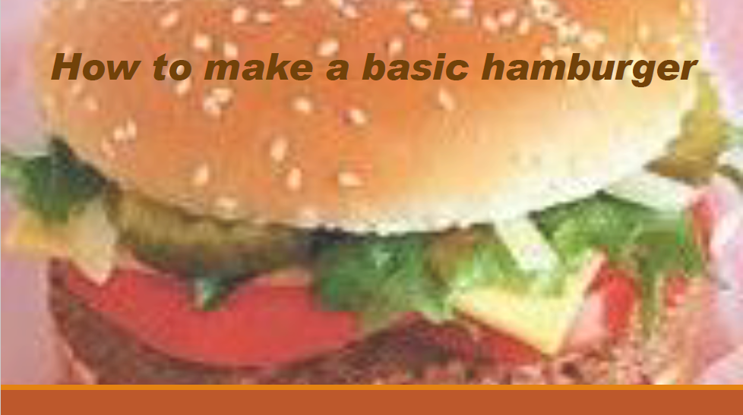  - Brainstorm in small groups  Brainstorm in small groups what they already know about the topic. Have they eaten one? Have they made one or seen it being made? As a whole group record students’ suggestions.  - Whole class discussion to expand the brainstorm  Ask students if they have ever had a burger and ask them to describe it. Elicit language from students through questioning e.g. What kind of burger? Where did you get it from? When? Why is it delicious? Add additional words/ /phrases to the brainstorm, e.g. Add words to the brainstormed vocabulary they have already listed, e.g. meat burger, gourmet burger, McDonald’s double cheese and pickles burger…  (Write them up on the board for students to copy, modelling ‘chunking’ the words to aid with spelling.)  - Whole class creates a semantic web  Using the words and phrased from the brainstorm, the class creates a semantic web. For example, the teacher asks students to locate all the words related to the ingredients and adds the appropriate heading, then they locate all the words related to taste and adds the appropriate heading.  The ideas and words generated from the group are categorised under subheadings, with each group contributing their ideas. (Teacher reminds students that in recipes we use the term ‘ingredients’ for all the things that go into making the recipe.) | Activity 2  - These activities help students to engage students with the topic and also prepare learners for potential linguistic, cultural or conceptual difficulties.  - Using adjectives and descriptive language  - Examples – juicy, meat, can be Halal, Kosher, large, McDonalds, good to eat, tasty, vegetables, cheese, tomato sauce... | - Teacher observes/notes students’ brainstorming and semantic webs to ascertain students’ topic knowledge.
Activity 3: Categorising and sequencing the mentor text  - Provide a set of cards showing ‘How to make a basic hamburger’ and ask students to work in small groups to sequence them in order. (NB These cards contain exactly the same wording as the mentor text but have pictures; source: Hertzberg, p. 119)  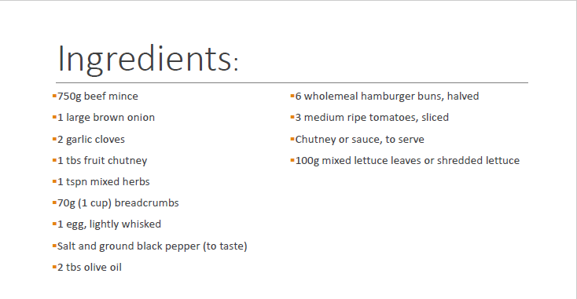  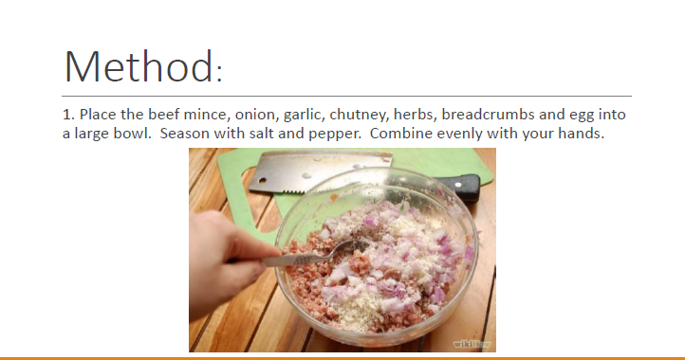  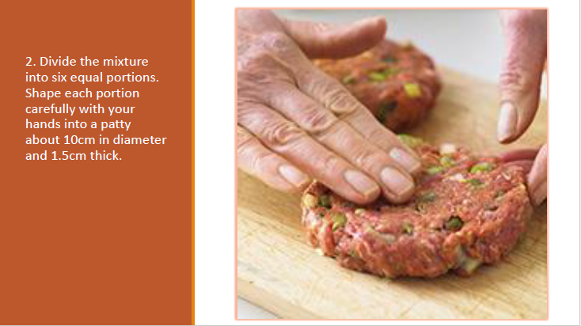  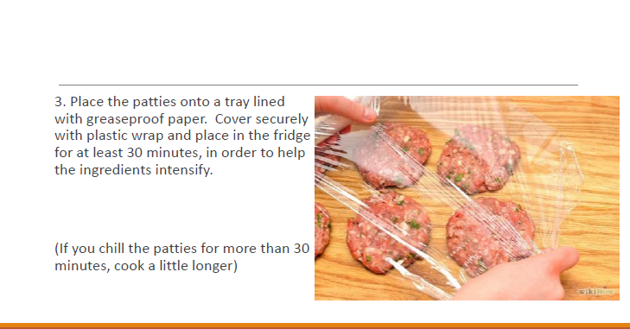  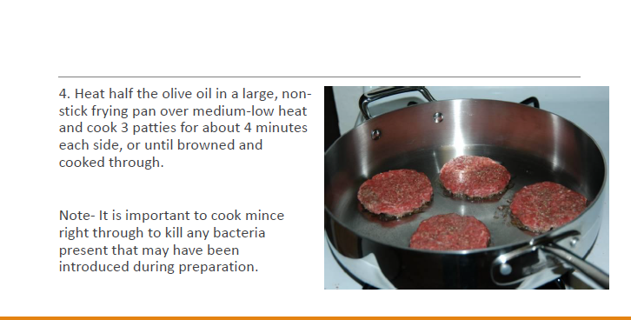  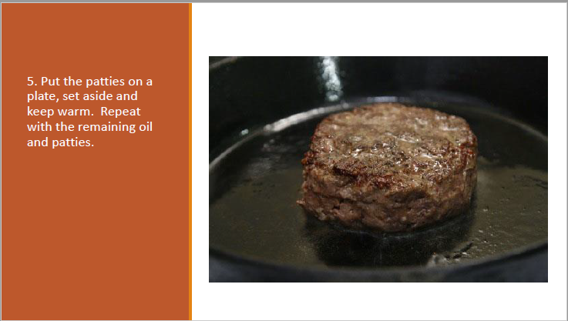  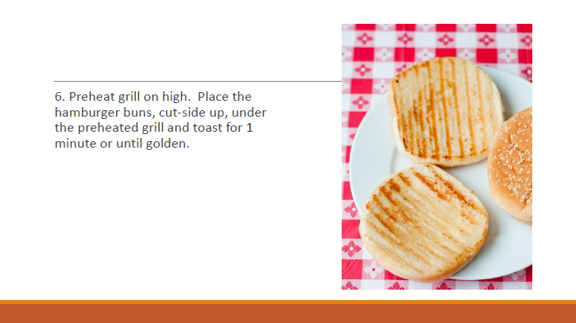  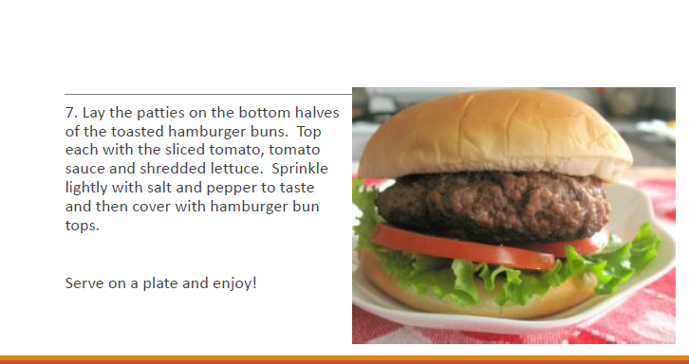  - Ask groups to come up with appropriate sub-headings for each of the sections (remove headings from slides). Ask each group to explain how they decided on their sub-headings and how they decided where the information belonged. | Activity 3  - This activity introduces key terms related to the text structure e.g. Goal (aim or purpose of the recipe), Materials (things you use to prepare the recipe e.g. tray), Ingredients (food items you will use in the recipe) Method (the steps involved in making the recipe), Evaluation (what the result will be like)  - Discussing the structural features of the procedural text and the way students have sequenced it presents new vocabulary in the context of discussion around the text making it more meaningful.  - Key terms related to linguistic structures and features are shown in context.
Activity 4: ‘Hands-on’ experiential learning  - Modelling and demonstration to the whole class  First, ask the groups to jumble up the cards under the heading ‘Method’ and turn them upside down. The Food Technology teacher (or other teacher) performs modelled reading of the recipe while demonstrating it. As the demonstrating teacher follows the Method, he/she pauses for students to locate the correct card and place it in the correct sequence.  - (Optional) Students can then work in small groups to continue to cook more burgers in order to engage in the context.  - Whole class reflection and discussion  Students discuss what made the instructions easy/difficult to follow (e.g. pictures, observing some-one following the steps). Students recycle the vocabulary for naming the parts of the structure of a procedure text that they have already learned.  Students also describe the language features using their existing understandings, with the teacher reformulating the language into the correct terminology (e.g. action verbs, adverbials) as a means of scaffolding in preparation for the grammar focus in the next Activity. For example, the teacher can draw attention to the action verbs (imperatives) at the start of each of the steps e.g. place, divide, heat, and the words that tell us how or where e.g. into a large bowl, onto a tray. | Activity 4  - Modelling vocal qualities – stress, intonation, pauses etc.  - Language used in context
STAGE 2 OF THE GENRE TEACHING/LEARNING CYCLE:  Modelling and Deconstruction (mentor text)  Activity 5: Focusing on reading, grammar and language  - Reading and deconstruction of the text  After the teacher reads aloud the annotated mentor text, ‘How to make a basic hamburger’ outlining the language features, teacher and students deconstruct the mentor text. Students label their own copy of the mentor text to identify all the structures and language features of the text, as the teacher works through modelling the text.  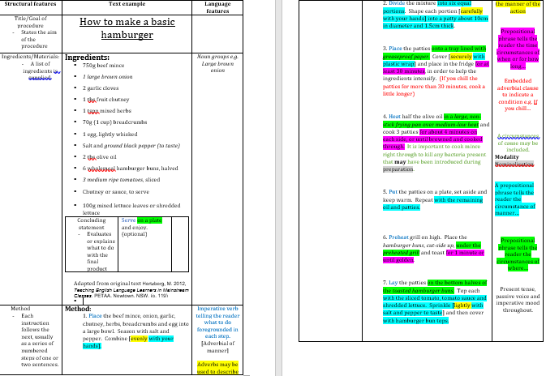  - Modelled reading of the mentor text, focusing on reading strategies  Teacher reads and uses ‘think aloud’ to verbalise the techniques that skilled readers use. Teacher models ‘pause and predict’, stopping at key points to ask students ‘What do you think the next step might be?’ and modelling strategies for decoding unfamiliar words, such as using the context to determine unfamiliar words, phonetically sounding out difficult words, intonation and pausing for punctuation.  - Close reading (if required)  To scaffolding joint reading, margin questions help support the sort of close reading needed for a complex text. These might include summarising the meaning of a sentence (this next sentence tells us about), paraphrasing meanings, discussing significant words or phrases and visualising what it would look like.  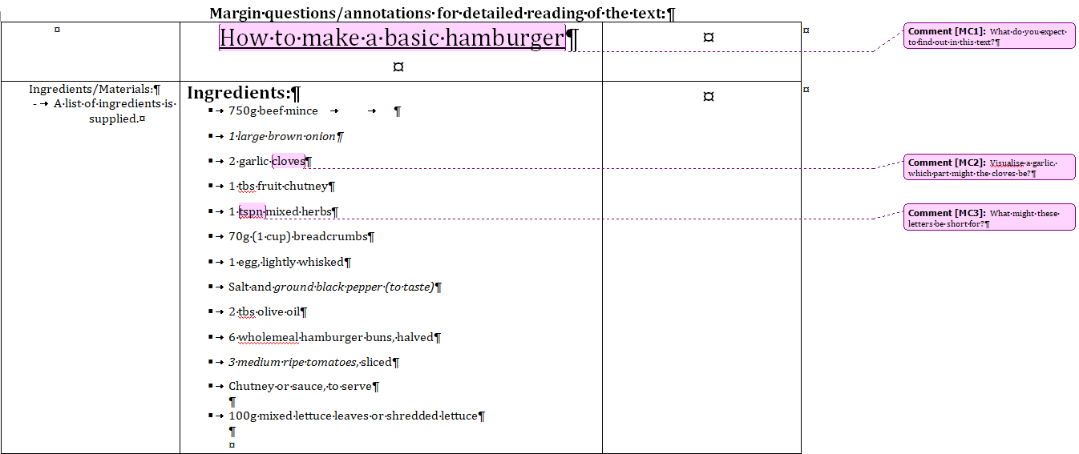  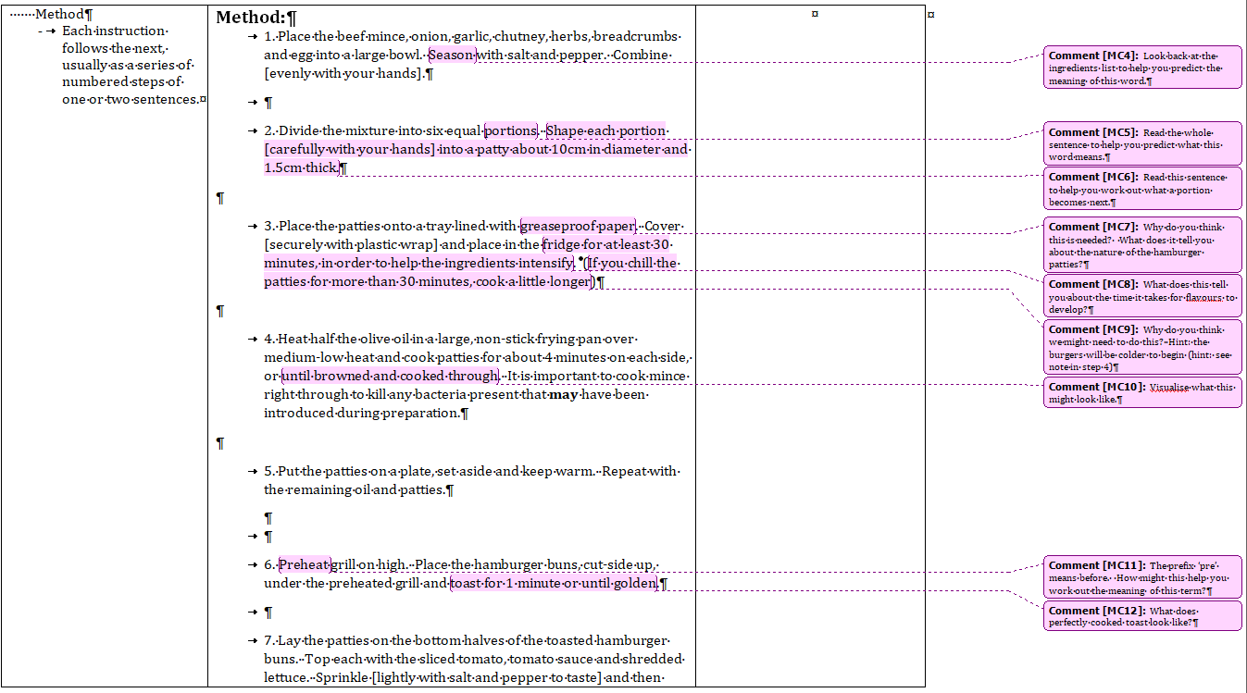  - Whole class discussion focusing on the context for the text  Discuss with students asking questions such as:  -Why has this text been written?  -Who do you think wrote this text?  -Who is the reader/s this text has been written for?  -When might some-one use a text like this?  -Whose perspective is represented in this text?  -What is not talked about in this text?  -What other ways are there to write about this topic? (DEECD, 2008).  -Is there any culture where this text would not be used?  - Creating a flow chart in small groups  Students create a flow chart identifying main ideas, steps and stages using pictures, words and arrows to show the progression of steps in the text. | Activity 5  - Having now experienced the procedure for making a hamburger in action, students analyse the text in greater detail, with further recycling of the technical terms for the structural and linguistic features of procedural texts (e.g. action/imperative verbs, adjectives, adverbials etc.  - Explicit modelling of reading and meaning-making strategies to support students in understanding and engaging with the text e.g. predicting, using context clues, chunking words, phonetically sounding out, intonation and observing punctuation. Does this belong here, with the above?  - Sequencing the text can be described as ‘message abundancy’( Gibbons, 2009, p.156) in that it provides EAL students with the opportunities to ‘hear, see, say and read’ the target language repeatedly, while also highlighting how the visual elements (multimodality) add meaning to the text.  - Providing scaffolding prompts to help learners identify different elements in the text supports the reader in learning to predict meanings from context, encourages reading ahead or several sentences ahead or reading several sentences at a time to gain meaning and helps readers make inferences. Visualizing may help them put themselves in the situation and also shows readers how to take on code-breaking of longer words. (Gibbons, 2009).  - Engaging in critical questioning about the text encourages students to consider the text in a wider social and cultural context. While the subject matter of the mentor text in this case is fairly straightforward, encouraging students to ask questions about authorship, purpose, audience and cultural aspects of the text etc. supports the development of critical reading skills, often required in curriculum learning areas (Gibbons, 2009). Such questions may also generate questions about the way hamburger is often used as a generic term (a generalised participant), even though ham is not an ingredient acceptable in all cultures, or why people might prefer to say burger rather than hamburger for either cultural or dietary reasons (e.g. vegetarians or vegans).  - Creating a flow chart encourages students to focus on the visual features of procedures and how they can assist comprehension. | - Teacher observes students labelling the structure and language of the text and checks accuracy and understanding.  - Teacher collects and analyses flow charts
Activity 6: Listening skills and grammar focus on prepositions, verbs and adverbs  - Modelling reading with a focus on preposition phrases  Read the text Bears in the Night by Stan and Jan Berenstain for simple examples of preposition phrases accompanied by pictures to support meaning. Vocal qualities of stress, intonation and pauses should be modelled by the teacher during the reading of the text.  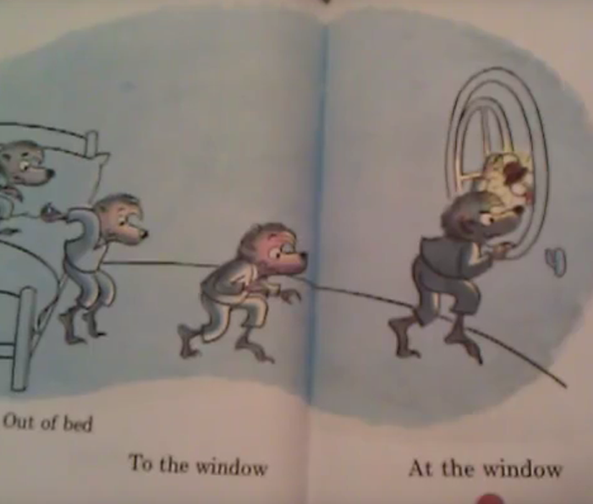  - Reconstructing a procedure text using Dictogloss (see link on last page of unit)  Teacher reads the text Directions to Fairy Park once while students listen. Teacher reads the text a second time and students make notes. Students then work in pairs or small groups, sharing their notes in order to reconstruct the text, focusing on meaning as much as on accuracy. The teacher asks some pairs/groups to read their versions aloud and the whole class discusses similarities and differences.  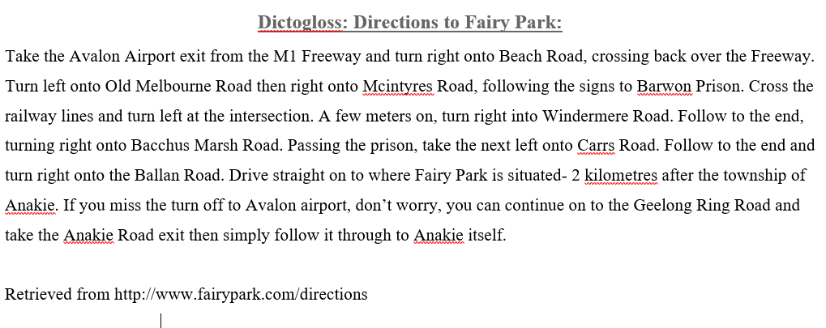  - Whole class discussion identifying text features from Dictogloss activity  -What actions were used? (e.g. take, turn, cross)  -What information was given to add detail to the action? (e.g. passing the prison, if you miss the turn)  -How important were the preposition phrases?  Students describe the language using their existing understanding with reformulating of the language by the teacher.  - Creation of a word/phrase bank for language features  A word/phrase bank (e.g. preposition phrases, imperative verbs) can be built cumulatively by teacher and students as new language features are discovered/generated.  - Write a set of directions for another student to follow  Each student writes directions to a location in the school grounds using suggested words and phrases from word bank. Students apply the vocabulary and grammar previously learned to produce the instructions, and students work in pairs to follow each other’s directions.  - Reflection and discussion  Students reflect on how difficult/easy the instructions were to follow and visuals that could be added to enhance meaning. Pairs give feedback to one another on the language items and visuals that would have helped them find the correct location. | Activity 6  - Modelling reading with stress, intonation and pauses. Focus on preposition phrases such as ‘to’ and ‘at’.  - Exposure to another relatable real-world procedure text builds the genre field knowledge. For ‘message abundance’, students are comparing and sequencing the language, reiterating and recycling the structural and linguistic concepts of procedure texts.  - This text and the following activities highlight the importance of particular language features to the overall purpose and goal of the text. Categories could cove include imperative verbs, preposition phrases, adjectives and adverbs.  - A shared word/phrase bank becomes a resource for the class and reiterates the different ways we can use particular language features (Kettle-Muspratt, 2015). | Teacher observes/notes students’ peer and self-reflection and feedback.
Activity 7: Grammar focus on circumstances  - Sequencing a text and cloze activity  Students work in pairs to sequence strips of text, then complete a cloze passage in pairs with a focus on circumstances.  - Writing in colours  Using a worksheet, students work first as a whole class to colour-code parts of speech in simple sentences, then work in pairs to complete the remaining sentences on the worksheet. This can be done using different coloured pens, or on computers.  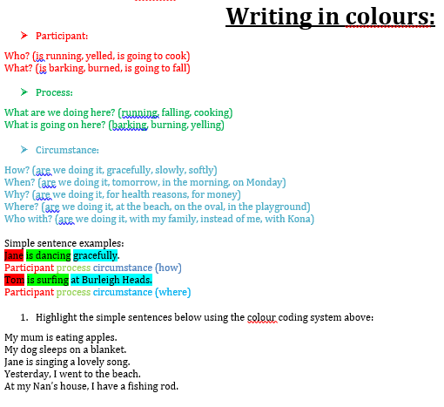  - Expanding sentences  Using a worksheet, students are given simple sentences to expand by adding describers, qualifiers and a circumstance.  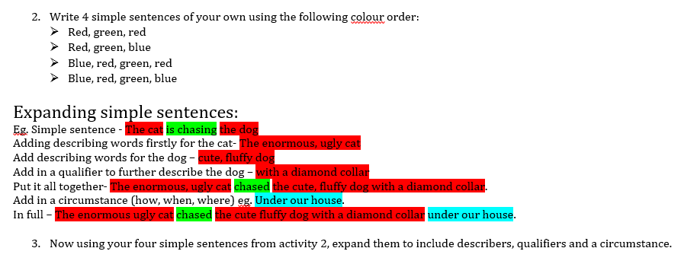 | Activity 7  - Discussion is needed between students, both to reconstruct the text and to complete the cloze. This strengthens knowledge of text structure and language features in procedure texts, particularly circumstances of manner, time and place. (Hertzberg, 2012, pp 122-3). It also engages students in oral language, and a language for talking about language (metalanguage), as they share ideas and responses in completing the task.  - Students identify participants, processes and, circumstances, punctuation etc. at the sentence level.  - Students expand sentences using describers, qualifiers and a circumstance. Practising expanding sentences supports students in adding depth and detail to their writing, and in varying syntax or the ordering of their sentence structure (Kettle-Muspratt, 2015). | Teacher checks coloured worksheets to monitor student understanding and accuracy.
STAGE 3 OF THE GENRE TEACHING/LEARNING CYCLE:  Joint Construction (new text)  Activity 8: Joint construction focusing on written sentences and punctuation  - Games for punctuation and sentence construction  Select appropriate games and activities to reinforce student learning (see link on last page of unit)  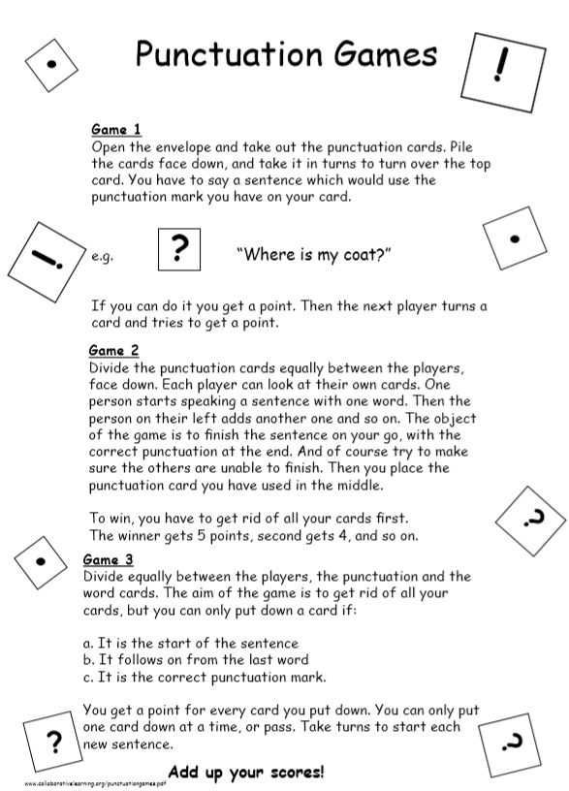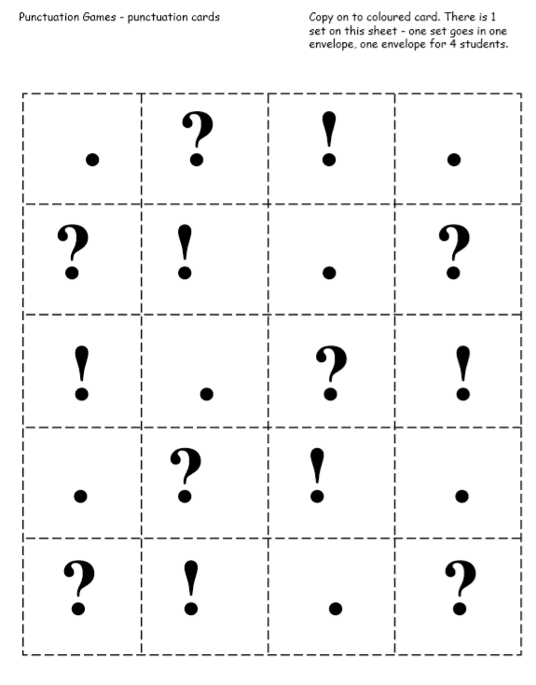  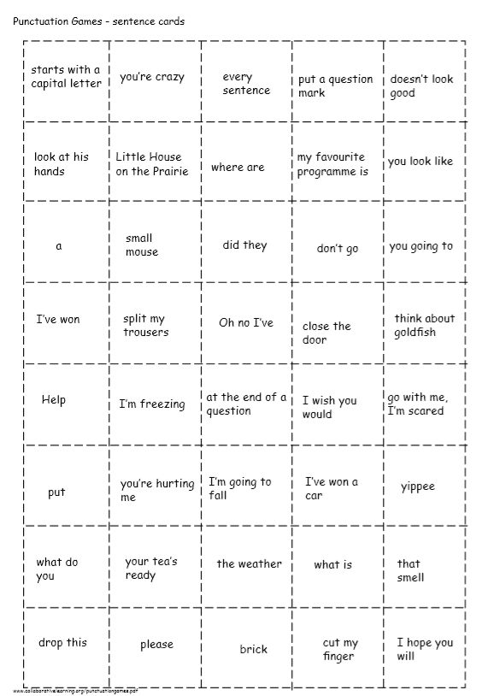 | Activity 8  - Engaging students in games encourages oral language, active learning and peer-to-peer learning in a supportive and interactive environment.  - Opportunities for discussion in students’ own words or first language (L1) helps them contextualise and make sense of the language (Dwyer & Robinson, 2012).  - The progressive scaffolding activity of expanding noun groups gives students practice using language to create more detailed sentences.  - Writing instructions for a game involves using language to identify, describe, explain, instruct, negotiate, justify, thereby working at multiple levels of meaning-making simultaneously. Students practise action and imperative verbs, adverbials, modals, circumstances and conditionals in the context of an authentic communicative task. This ‘shows students the decisions made in constructing a successful text’ (DECS, 2006) and emphasises the importance of precise language choices.
- Expanding noun groups
Students build noun groups, starting with a simple sentence, then adding adverbials using correct punctuation.

- Writing instructions for a game
Students play a game (Bingo, Tic Tac Toe, Connect 4 or UNO) in small groups, with each group beginning with a different game. One person instructs their group as to how to play the game. The group plays the game following these instructions. They then jointly construct written instructions for the game.

The groups then rotate, with each group using the instructions written previously, to play the next game. They edit/add information to the instructions, such as adding further detail to the noun group, adverbials, modals, circumstances or conditionals.

The groups then work as a whole class to edit one set of instructions, with the teacher modelling the writing process. This enables students to use spoken language to talk about the language of instructions and work with both peer and teacher support to construct a successful text.
Activity 9: Matching sentences from the mentor text to practise joint construction  - Matching up sentences  Using a worksheet, students match beginnings and endings of sentences in practising joint construction of the procedure ‘how to make a basic hamburger’, with the teacher using a Procedure template (Blake Education, 2006). Students work in pairs, using the pictures from the Barrier game to help them write sentences (Hertzberg, p.120)  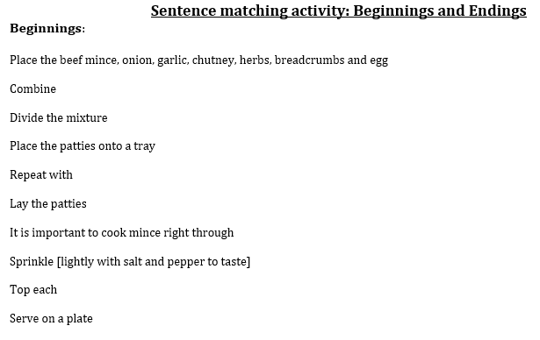  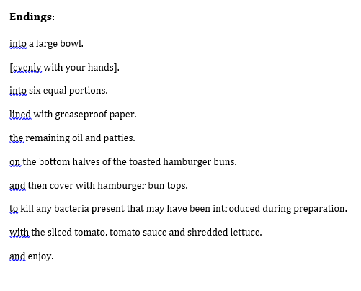 | Activity 9  - Providing beginnings and endings provides a scaffold that supports students in applying their new understandings of the language of the text, while the Procedure template supports them in identifying in which stage of the text the language belongs.
Stage 4 of the Genre Teaching/Learning Cycle:  Independent Construction  Activity 10: Students write their own procedure and create a PowerPoint presentation to share their procedure with the class.  - Selecting a topic  Students choose a topic of their own choice e.g. how to make a sock puppet, how to make pancakes etc. Teachers can guide students requiring higher levels of support towards simpler topics, and provide the necessary scaffolding to ensure a successful outcome.  - Writing a procedure text  Students write a procedure for their own topic using the stages (sub-headings) of the genre.  NB Students requiring a higher level of support can be given a blank template with prompts to scaffold them in completing the task.  Procedure Template  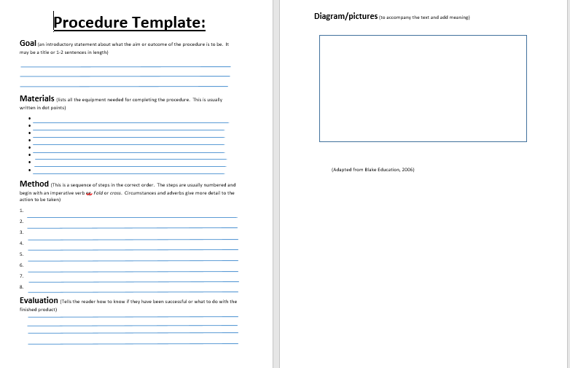  - Independent writing using an assessment rubric  The teacher introduces and talks through an assessment rubric as a guide as to what is expected. Students write their own texts using the explicit rubric.  Assessment Rubric  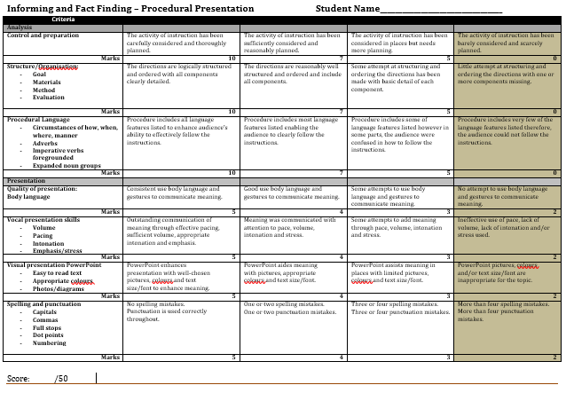  - Editing and proofreading  Students engage in peer and self-assessment using the rubric and checklist to improve the overall quality and standard of their work  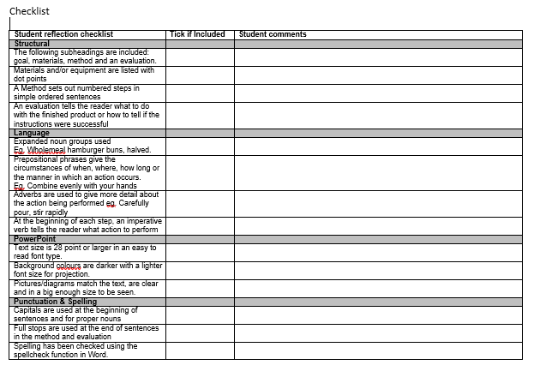  - Redrafting and publishing  Using the rubric, students redraft and publish their presentations for rehearsal. | Activity 10  - Providing scaffolds enables the teacher to differentiate the learning for students requiring higher levels of support in completing the task.  - Editing, proofreading and redrafting their presentations provides students with ‘message abundance’ to reinforce key vocabulary and language patterns and structures. Recycling the language builds student confidence and self-esteem.  - Providing an explicit assessment rubric enables targeted and meaningful feedback and micro-scaffolding where needed from the teacher to help improve the text. | - Assessment of final text and power point slides. See link to the TEAL Writing Assessment Task 13, Making a pizza: Text reconstruction, to view a number of samples of the procedure genre.  - Teacher observes students during peer feedback discussions.  - Teacher collects and comments on student peer and self-assessment rubric and checklist notes.
Activity 11: Students rehearse their presentations in small groups  - Students rehearse the presentation of their procedure texts in small groups, giving each other feedback with the aid of a checklist on oral presentations |  | - See the TEAL topics Involving Learners Actively in Assessment and Enhancing Teacher Feedback in the Professional Learning section for more ideas about engaging students in self and peer assessment in Activity 11 and Activity 12.
Activity 12: Student presentations and reflection  - Students present their procedures to the class, over two lessons if necessary. As part of peer assessment, the class (audience) can be asked to individually evaluate presentations by making written notes on each one, using a few questions, such as:  -Were the instructions in the procedure clear and easy to follow?  -Do you think you would be able to follow the instructions?  -Were pictures or diagrams used to support the written text?  -Did the speaker try to engage the audience?  -What did the speaker do well?  -How could it be improved?  - Students write a reflection on how the presentation of their procedure went, using prompt questions:  -What do you think went well with the presentation and the procedure?  -What did not go well?  -How could the instructions and presentation be improved next time? | Activity 12  - Engaging the class as active listeners and viewers of the presentations encourages participation and enhances the collective learning from the unit. (NB Students still developing proficiency in English may find it confronting to be evaluated by their peers. Teachers should use their judgment, and their knowledge of the students, when considering to include the peer assessment of presentations, and may choose instead to simply ask What did the speaker do well?) | - Assessment of oral presentations by teacher and class mates.  - See the TEAL topic Improving the Trustworthiness of Assessment, in the Professional Learning section, for analysed samples of Writing Assessment Task 13 – Making a pizza: Text reconstruction. This is accompanied by a suggested professional learning process.

Unit evaluation
General evaluation  Were the students interested in the topic?  Did planned activities need to be modified? Why?  Which teaching activities were particularly successful? |  | - This procedural text unit was significantly modified from a mainstream classroom unit in order to focus on explicit language teaching using the teaching and learning cycle. The previous (unmodified) unit focused on exposure to many different procedural text types, which is engaging for mainstream students but lacked focus on teaching the structural and language features needed for EAL students.  - Utilising texts from real world contexts was another modification to the original unit. This was successful in that it created a rich environment for learning and encouraged the use of ‘authentic’ rather than simplified or fictional language, thus improving EAL students’ progress in learning academic language.
Content learning goals  Were the topic/content objectives achieved?  Did the topic lead to new learning? |  | - The parts of the unit taught involved the use of a ‘mentor text’ and message abundancy with the structural features of the genre. Limited language features, namely prepositions, were taught as per the previous (unmodified) unit, where the lack of time for explicit teaching resulted in most students communicating basic instructions but lacking detail through the use of adverbials, circumstances and expanded noun groups. Thus, the activities included in this unit promote message abundancy and allow students to practise the skills in using these parts of grammar before independently creating their own instructions.  - As students varied in their understanding of how to set out instructions on PowerPoint, a mentor text used in combination with an example modelled on PowerPoint gave them a sense of what was expected in the finished product.  - This unit includes activities which focus on integrating visuals for making meaning in procedures. As students’ visuals do not always match or add meaning to the text, explicit criteria for the visual presentation has been added to the assessment rubric.
English language learning goals  Were general English language learning needs highlighted by the unit?  What particular literacy needs were highlighted by the topic?  Was there a balance between written and spoken texts? |  | - Reading skills were focused on in this unit to enable students to develop skills of effective readers. Repeated use of the mentor text in many different activities enabled students to understand meaning.  - Modelled reading, with the use of intonation and pausing, was used to build vocal confidence for student presentations.  - The focus on speaking and reading activities addresses one of the challenges identified with previous assessment tasks, where students need to read and convey meaning to the audience whilst demonstrating the procedure or be the volunteer who listens and reads while carrying out the procedure, both of which require a high level of comprehension. The assessment has since been modified to make these vocal qualities explicit.
EAL considerations  How successfully did the unit involve the EAL students?  Which activities worked for them, which did not?  Which English language needs were identified as a priority for future units? |  | - Collaborative group work is a major feature of the lessons throughout the unit to enable peer support, talking and learning in a setting where the students can feel confident to practise the language and ‘take risks’ in small groups rather than in front of the whole class. This enables students to say, hear and write the language using their own words or language before the teacher reformulates the language into the correct terminology. It also provides practice of spoken language skills needed for the presentation of the instructions to the class at the end of the unit.  - Group work also promotes cultural acceptance via collaboration with different classmates through varied group arrangements. Cultural inclusiveness is factored into the unit with the sharing of favourite recipes. Not only does this acknowledge what ‘cultural and linguistic resources’ students bring to the classroom but helps students connect the study to their home life and culture.
Ideas for future units/activities  What language focuses need to be targeted again in future units?  Which future topics would complement this unit? |  | - An area to be strengthened in future is Joint construction. This took place mainly between peers in groups, with varying results. Some students would also have benefited from having a template to work from at the independent construction stage to ensure they created texts in the correct order, which is why a procedure template has been added to the modified unit.  - Students’ delivery of their presentations was another area for improvement. Vocal qualities were not utilised to create meaning in their instructions. This was also the aspect students reflected about the most following their presentations. Criteria for the delivery of the presentation has since been added into the assessment rubric so that this area is allocated greater emphasis. Modelled reading activities focus on vocal qualities to encourage students to incorporate meaning to their instructions through the use of stress, intonation and emphasis.  - Future topics could focus on building students’ knowledge of the structure and language of different kinds of texts across curriculum learning areas, using similar scaffolding processes and activities.
 | Assessment for learning strategies  Did the chosen assessment strategies ensure students achieved the unit learning goals?  Did the assessment feed into planning and teaching?  Were students involved in the assessment process?  Were the success criteria for the focused analysis assessment tasks clear and student friendly?  Were students able to use criteria to provide feedback to their peers?  Were students able to use feedback from assessment to improve their learning? | - To assist with students’ reflective practice, a self-assessment checklist has been added to the unit to assist them in evaluating their own learning.  - More time could be spent on the scaffolding the processes of reflecting on learning and self and peer assessment, as this is an area many students, not only EAL students, find difficult and challenging. For example, explicit teaching could focus on modality and other language resources used to make feedback constructive.

Links
Dictogloss (Activity 6)
https://www.education.vic.gov.au/school/teachers/teachingresources/discipline/english/literacy/speakinglistening/Pages/exampledictogloss.aspx
Punctuation Games (Activity 8)
http://www.collaborativelearning.org/punctuationgames.pdf
TEAL
- The TEAL Writing Assessment Task 13, Making a pizza: Text reconstruction, provides a number of samples of the procedure genre.
http://teal.global2.vic.edu.au/assessment-tools/common-writing-assessment-tasks/choosing-an-assessment-task-2/13-making-a-pizza-text-reconstruction/
- The TEAL Professional Learning topic, Improving the Trustworthiness of Assessment, has a number of analysed samples of Writing Assessment Task 13 – Making a pizza: Text reconstruction. This is accompanied by a professional learning (moderation) process that teachers can engage in individually or with colleagues to assess students’ English language proficiency, particularly at the level of linguistic structures and features.
- The TEAL Professional Learning topics, Involving Learners Actively in Assessment and Enhancing Teacher Feedback provide further ideas and resources for Activity 11 and Activity 12.

References
Berenstain, S & J. (1982) Bears in the Night, Great Britain: Harper Collins.
Blake Education. (2006) Targeting Text- Book 2- Recount, Procedure, Exposition, Upper Primary, New South Wales: Author.
Dang, T. (2013). Let's make a Paper Plane that flies Over 100 Feet | Three D, Retrieved from https://www.youtube.com/watch?v=i8qxExknDSw.
Department for Education and Children’s Services. DECS. (2006). Teaching ESL Students in Mainstream Classrooms Teacher Development Course. South Australia: Author.
Department of Education and Early Childhood Development. DEECD. (2008). Teaching Strategy- Before Reading: Factual texts, retrieved from http://www.education.vic.gov.au/Documents/school/teachers/teachingresources/diversity/eal/continuum/beforereadact.pdf
Dwyer, R., & Robinson, W. (2012). Punctuation Games, retrieved from http://www.collaborativelearning.org/punctuationgames.pdf
Fairy Park (accessed 21/10/15). Retrieved from http://www.fairypark.com/directions.
Gibbons, P. (2009). English Learners Academic Literacy and Thinking, Portsmouth, USA: Heinemann.
Hertzberg, M. (2012). Teaching English Language Learners in Mainstream Classrooms, Sydney, NSW: PETAA.
Kettle-Muspratt, F. (2015) Step by step with Functional Grammar, Lexis Education, retrieved from http://www.lexised.com/resources/.
Rose, D. (2017) Reading to Learn: Accelerating learning and closing the gap, Reading to Learn.

APPENDICES

ACTIVITY 1 – What is a procedural text – How to draw a cat.

ACTIVITY 2- How to make a basic hamburger

ACTIVITY 3(a) Mentor text – with linguistic features highlighted
Structural features | Text example | Language features
Title/Goal of procedure  - States the aim of the procedure | How to make a basic hamburger
Ingredients/Materials:  - A list of ingredients is supplied. | Ingredients:  - 750g beef mince  - 1 large brown onion  - 2 garlic cloves  - 1 tbs fruit chutney  - 1 tspn mixed herbs  - 70g (1 cup) breadcrumbs  - 1 egg, lightly whisked  - Salt and ground black pepper (to taste)  - 2 tbs olive oil  - 6 wholemeal hamburger buns, halved  - 3 medium ripe tomatoes, sliced  - Chutney or sauce, to serve  - 100g mixed lettuce leaves or shredded lettuce | Noun groups e.g. Large brown onion
Method  - Each instruction follows the next, usually as a series of numbered steps of one or two sentences. | Method:  - 1. Place the beef mince, onion, garlic, chutney, herbs, breadcrumbs and egg into a large bowl. Season with salt and pepper. Combine [evenly with your hands].  - 2. Divide the mixture into six equal portions. Shape each portion [carefully with your hands] into a patty about 10cm in diameter and 1.5cm thick.  - 3. Place the patties onto a tray lined with greaseproof paper. Cover [securely with plastic wrap] and place in the fridge for at least 30 minutes, in order to help the ingredients intensify. (If you chill the patties for more than 30 minutes, cook a little longer)  - 4. Heat half the olive oil in a large, non-stick frying pan over medium-low heat and cook 3 patties for about 4 minutes on each side, or until browned and cooked through. It is important to cook mince right through to kill any bacteria present that may have been introduced during preparation.  - 5. Put the patties on a plate, set aside and keep warm. Repeat with the remaining oil and patties.  - 6. Preheat grill on high. Place the hamburger buns, cut-side up, under the preheated grill and toast for 1 minute or until golden.  - 7. Lay the patties on the bottom halves of the toasted hamburger buns. Top each with the sliced tomato, tomato sauce and shredded lettuce. Sprinkle [lightly with salt and pepper to taste] and then cover with hamburger bun tops. | Imperative verb telling the reader what to do foregrounded in each step.  [Adverbial of manner]  Adverbs may be used to describe the manner of the action  Prepositional phrase tells the reader the time circumstances of when or for how long…  Embedded adverbial clause to indicate a condition e.g. If you chill…  A circumstances of cause may be included.  Modality  Nominalisation  A prepositional phrase tells the reader the circumstance of manner…  Prepositional phrase tells the reader the circumstances of where…  Present tense, passive voice and imperative mood throughout.
Concluding statement  - Evaluates or explains what to do with the final product | Serve on a plate and enjoy. (optional)

Adapted from original text Hertzberg, M. 2012, Teaching English Language Learners in Mainstream Classes, PETAA, Newtown, NSW. (p. 119)
ACTIVITY 3(b) Mentor text – with margin questions
Margin questions/annotations for detailed reading of the text
Title/Goal of procedure  - States the aim of the procedure | How to make a basic hamburger | What do you expect to find out in this text?
Ingredients/Materials:  - A list of ingredients is supplied. | Ingredients:  - 750g beef mince  - 1 large brown onion  - 2 garlic cloves  - 1 tbs fruit chutney  - 1 tspn mixed herbs  - 70g (1 cup) breadcrumbs  - 1 egg, lightly whisked  - Salt and ground black pepper (to taste)  - 2 tbs olive oil  - 6 wholemeal hamburger buns, halved  - 3 medium ripe tomatoes, sliced  - Chutney or sauce, to serve  - 100g mixed lettuce leaves or shredded lettuce | Visualise garlic which part might the cloves be?  What might these letters be short for?
Method  - Each instruction follows the next, usually as a series of numbered steps of one or two sentences. | Method:  - 1. Place the beef mince, onion, garlic, chutney, herbs, breadcrumbs and egg into a large bowl. Season with salt and pepper. Combine [evenly with your hands].  - 2. Divide the mixture into six equal portions. Shape each portion [carefully with your hands] into a patty about 10cm in diameter and 1.5cm thick.  - 3. Place the patties onto a tray lined with greaseproof paper. Cover [securely with plastic wrap] and place in the fridge for at least 30 minutes, in order to help the ingredients intensify. (If you chill the patties for more than 30 minutes, cook a little longer)  - 4. Heat half the olive oil in a large, non-stick frying pan over medium-low heat and cook patties for about 4 minutes on each side, or until browned and cooked through. It is important to cook mince right through to kill any bacteria present that may have been introduced during preparation.  - 5. Put the patties on a plate, set aside and keep warm. Repeat with the remaining oil and patties.  - 6. Preheat grill on high. Place the hamburger buns, cut-side up, under the preheated grill and toast for 1 minute or until golden.  - 7. Lay the patties on the bottom halves of the toasted hamburger buns. Top each with the sliced tomato, tomato sauce and shredded lettuce. Sprinkle [lightly with salt and pepper to taste] and then cover with hamburger bun tops. | Look back at the ingredients list to help you predict the meaning of this word.  Read the whole sentence to help you predict what this word means  Read this sentence to help you work out what a portion becomes next  Why do you think this is needed? What does it tell you about the nature of the hamburger patties?  What does this tell you about the time it takes for flavours to develop?  Why do you think we might need to do this? Hint: the burgers will be colder to begin (hint: see note in step 4)  Visualise what this might look like.  The prefix ‘pre’ means before. How might this help you work out the meaning of this term?  What does perfectly cooked toast look like?
Concluding statement  - Evaluates or explains what to do with the final product | Serve on a plate and enjoy. (optional)

ACTIVITY 6 Dictogloss
Dictogloss: Directions to Fairy Park:

Take the Avalon Airport exit from the M1 Freeway and turn right onto Beach Road, crossing back over the Freeway. Turn left onto Old Melbourne Road then right onto Mcintyres Road, following the signs to Barwon Prison. Cross the railway lines and turn left at the intersection. A few meters on, turn right into Windermere Road. Follow to the end, turning right onto Bacchus Marsh Road. Passing the prison, take the next left onto Carrs Road. Follow to the end and turn right onto the Ballan Road. Drive straight on to where Fairy Park is situated- 2 kilometres after the township of Anakie. If you miss the turn off to Avalon airport, don’t worry, you can continue on to the Geelong Ring Road and take the Anakie Road exit then simply follow it through to Anakie itself.
Retrieved from http://www.fairypark.com/directions

ACTIVITY 7 Writing in colours:
- Participant:
Who? (is running, yelled, is going to cook)
What? (is barking, burned, is going to fall)

- Process:
What are we doing here? (running, falling, cooking)
What is going on here? (barking, burning, yelling)

- Circumstance:
How? (are we doing it, gracefully, slowly, softly)
When? (are we doing it, tomorrow, in the morning, on Monday)
Why? (are we doing it, for health reasons, for money)
Where? (are we doing it, at the beach, on the oval, in the playground)
Who with? (are we doing it, with my family, instead of me, with Kona)

Simple sentence examples:
Jane is dancing gracefully.
Participant process circumstance (how)
Tom is surfing at Burleigh Heads.
Participant process circumstance (where)

- Highlight the simple sentences below using the colour coding system above:
My mum is eating apples.
My dog sleeps on a blanket.
Jane is singing a lovely song.
Yesterday, I went to the beach.
At my Nan’s house, I have a fishing rod.

- Write 4 simple sentences of your own using the following colour order:

- Red, green, red
- Red, green, blue
- Blue, red, green, red
- Blue, red, green, blue

ACTIVITY 9 Sentence matching activity: Beginnings and Endings Beginnings:
SENTENCE BEGININGS
- Place the beef mince, onion, garlic, chutney, herbs, breadcrumbs and egg
- Combine
- Divide the mixture
- Place the patties onto a tray
- Repeat with
- Lay the patties
- It is important to cook mince right through
- Sprinkle [lightly with salt and pepper to taste]
- Top each
- Serve on a plate

SENTENCE ENDINGS
- into a large bowl.
- [evenly with your hands].
- into six equal portions.
- lined with greaseproof paper.
- the remaining oil and patties.
- on the bottom halves of the toasted hamburger buns.
- and then cover with hamburger bun tops.
- to kill any bacteria present that may have been introduced during preparation.
- with the sliced tomato, tomato sauce and shredded lettuce.
- and enjoy.

ACTIVITY 10(a) Procedure Template

ACTIVITY 10(b) ASSESSMENT RUBRIC Procedural Presentation

Student Name
Criteria
Analysis
Control and preparation | The activity of instruction has been carefully considered and thoroughly planned. | The activity of instruction has been sufficiently considered and reasonably planned. | The activity of instruction has been considered in places but needs more planning. | The activity of instruction has been barely considered and scarcely planned.
Marks | 10 | 7 | 5 | 0
Structure/Organisation:  - Goal  - Materials  - Method  - Evaluation | The directions are logically structured and ordered with all components clearly detailed. | The directions are reasonably well structured and ordered and include all components. | Some attempt at structuring and ordering the directions has been made with basic detail of each component. | Little attempt at structuring and ordering the directions with one or more components missing.
Marks | 10 | 7 | 5 | 0
Procedural Language  - Circumstances of how, when, where, manner  - Adverbs  - Imperative verbs foregrounded  - Expanded noun groups | Procedure includes all language features listed to enhance audience’s ability to effectively follow the instructions. | Procedure includes most language features listed enabling the audience to clearly follow the instructions. | Procedure includes some of language features listed however in some parts, the audience were confused in how to follow the instructions. | Procedure includes very few of the language features listed therefore, the audience could not follow the instructions.
Marks | 10 | 7 | 5 | 0
Presentation
Quality of presentation:  Body language | Consistent use body language and gestures to communicate meaning. | Good use body language and gestures to communicate meaning. | Some attempts to use body language and gestures to communicate meaning. | No attempt to use body language and gestures to communicate meaning.
Marks | 5 | 4 | 3 | 2
Vocal presentation skills  - Volume  - Pacing  - Intonation  - Emphasis/stress | Outstanding communication of meaning through effective pacing, sufficient volume, appropriate intonation and emphasis. | Meaning was communicated with attention to pace, volume, intonation and stress. | Some attempts to add meaning through pace, volume, intonation and stress. | Ineffective use of pace, lack of volume, lack of intonation and/or stress used.
Marks | 5 | 4 | 3 | 2
Visual presentation PowerPoint  - Easy to read text  - Appropriate colours  - Photos/diagrams | PowerPoint enhances presentation with well-chosen pictures, colours and text size/font to enhance meaning. | PowerPoint aides meaning with pictures, appropriate colours and text size/font. | PowerPoint assists meaning in places with limited pictures, colours and text size/font. | PowerPoint pictures, colours and/or text size/font are inappropriate for the topic.
Marks | 5 | 4 | 3 | 2
Spelling and punctuation  - Capitals  - Commas  - Full stops  - Dot points  - Numbering | No spelling mistakes.  Punctuation is used correctly throughout. | One or two spelling mistakes.  One or two punctuation mistakes. | Three or four spelling mistakes.  Three or four punctuation mistakes. | More than four spelling mistakes.  More than four punctuation mistakes.
Marks | 5 | 4 | 3 | 2
Score: /50

Checklist
Student reflection checklist | Tick if Included | Student comments
Structural
The following subheadings are included: goal, materials, method and an evaluation.
Materials and/or equipment are listed with dot points
A Method sets out numbered steps in simple ordered sentences
An evaluation tells the reader what to do with the finished product or how to tell if the instructions were successful
Language
Expanded noun groups used
Eg. Wholemeal hamburger buns, halved.
Prepositional phrases give the circumstances of when, where, how long or the manner in which an action occurs.
Eg. Combine evenly with your hands
Adverbs are used to give more detail about the action being performed e.g. Carefully pour, stir rapidly
At the beginning of each step, an imperative verb tells the reader what action to perform
PowerPoint
Text size is 28 point or larger in an easy to read font type.
Background colours are darker with a lighter font size for projection.
Pictures/diagrams match the text, are clear and in a big enough size to be seen.
Punctuation & Spelling
Capitals are used at the beginning of sentences and for proper nouns
Full stops are used at the end of sentences in the method and evaluation
Spelling has been checked using the spellcheck function in Word.

