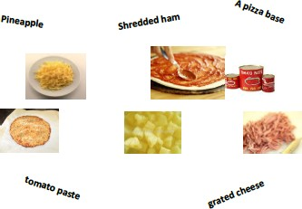Making a pizza

Ingredients: Draw a line from the ingredients to the pictures

Steps
Cut into slices and serve with salad
Spread the tomato paste on the pizza base
Place in the oven and cook for twenty minutes
Cover with all the ingredients with the grated cheese
Add pineapple pieces
Sprinkle the shredded ham over the pizza base
Turn on the oven to 180C

