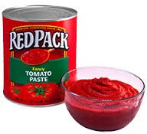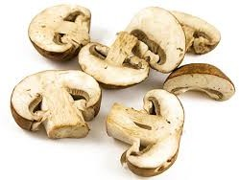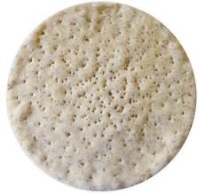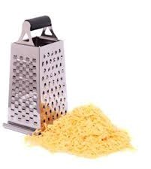

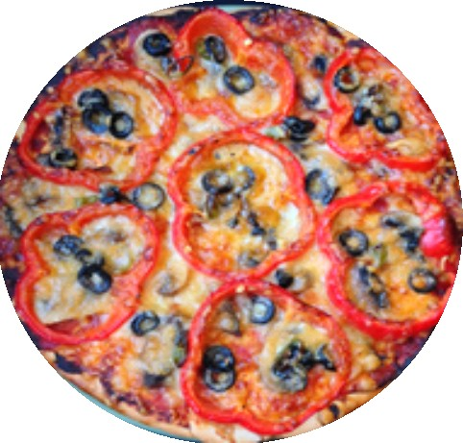
Making a pizza

Ingredients
- A pizza base
- Tomato paste
- Sliced mushrooms
- Sliced capsicum
- Olives
- Grated cheese

Steps
- Turn on the oven to 180C.
- Spread the tomato paste on the pizza base.
- Put the sliced mushrooms on the pizza base.
- Place the capsicum slices over the mushrooms.
- Add some olives.
- Cover all the ingredients with the grated cheese.
- Place the pizza in the oven and cook for twenty minutes.
- Cut the pizza into slices and serve it with salad.

