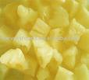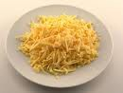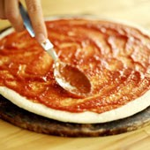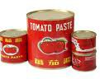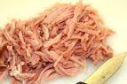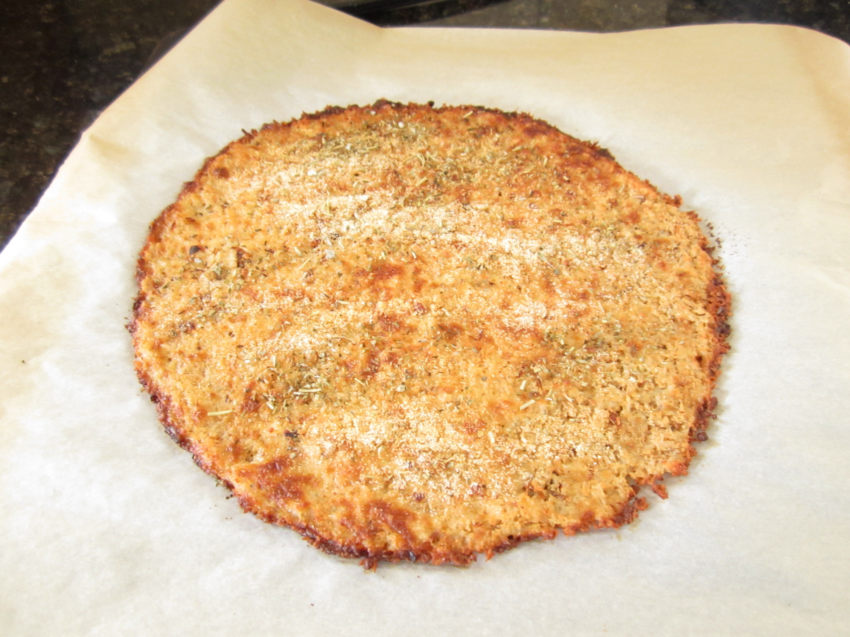Making a pizza

Ingredients
- A pizza base
- Shredded ham
- Pineapple pieces
- Tomato paste
- Grated cheese

Steps
- Turn on the oven to 180C
- Spread the tomato paste on the pizza base
- Sprinkle the shredded ham over the pizza base
- Add pineapple pieces
- Cover with all the ingredients with the grated cheese
- Place in the oven and cook for twenty minutes
- Cut into slices and serve with salad

