My Diary

Friday 25 July

After school I played football.

In the evening my whole family went out to a restaurant. We had an Indian meal. It was really yummy!

Saturday 26 July

In the morning we went for a walk. We walked from Coogee to Bondi. It was fantastic! I was really tired.

In the afternoon we had lunch in a café at Bondi Beach. I had fish and chips. YUM!

In the evening we went to the cinema and watched Maleficient. It was scary but I really enjoyed it!
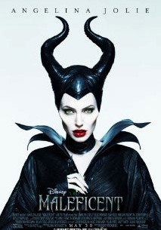
Sunday 27 July

In the morning I tidied my bedroom. Mum and I made a chocolate cake.

In the afternoon some friends came for a BBQ. My dad cooked sausages and chicken on the barbecue. We had roast potatoes and salad. Then we ate my cake. It was delicious.

In the evening I did some homework and then we watched a film on TV.

My weekend was FUN FUN FUN!!

