How to use the TEAL forums.

- Log in to the TEAL site. You’ll find the “Log in Section” in the top left-hand corner of any page of the site.

- Enter your email address (or user name) and password.
If you’ve forgotten your password, click on ‘Lost your password’ and follow instructions.
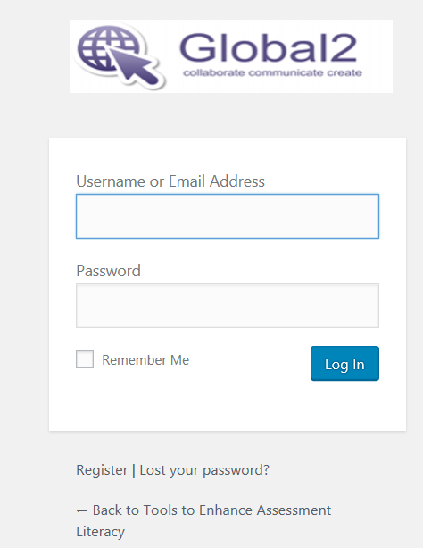

- Take yourself to the forums using the black menu across the top of your screen.
For those of you at a workshop, the link to the Professional Learning forum is here:
http://teal.global2.vic.edu.au/forums/forum/professional-learning/
- Check that you’re logged in.
Tip: You’ll know you’re logged in if you can see the word ‘Howdy’ in the top right-hand corner of your page.

- If you wish to post something new, you need to scroll down to the bottom of the page of topics.

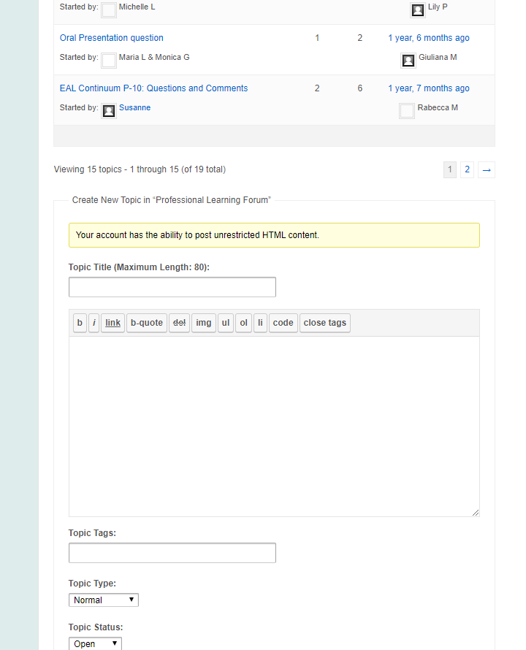

- Then Give your discussion topic a title.
Write your thoughts in the box underneath that.

Ready to post? Click submit.
(NB For teachers who’d like a few more bells and whistles in the way of fonts and privacy options, you can also post via your dashboard.)

- If you wish to comment on something someone else has written, click to open the topic.

For example. Click on “Oral Language….” to open that discussion.
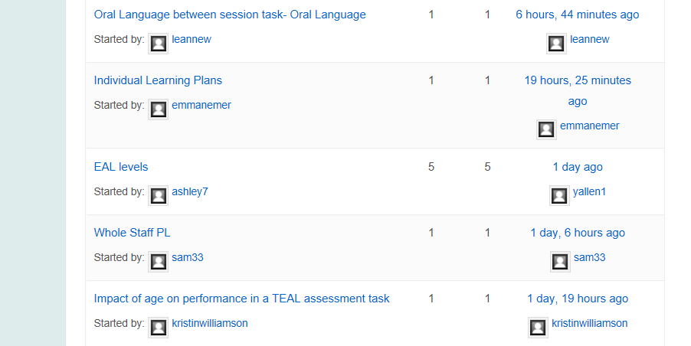

To comment, first scroll to the bottom of the page, which looks like this:
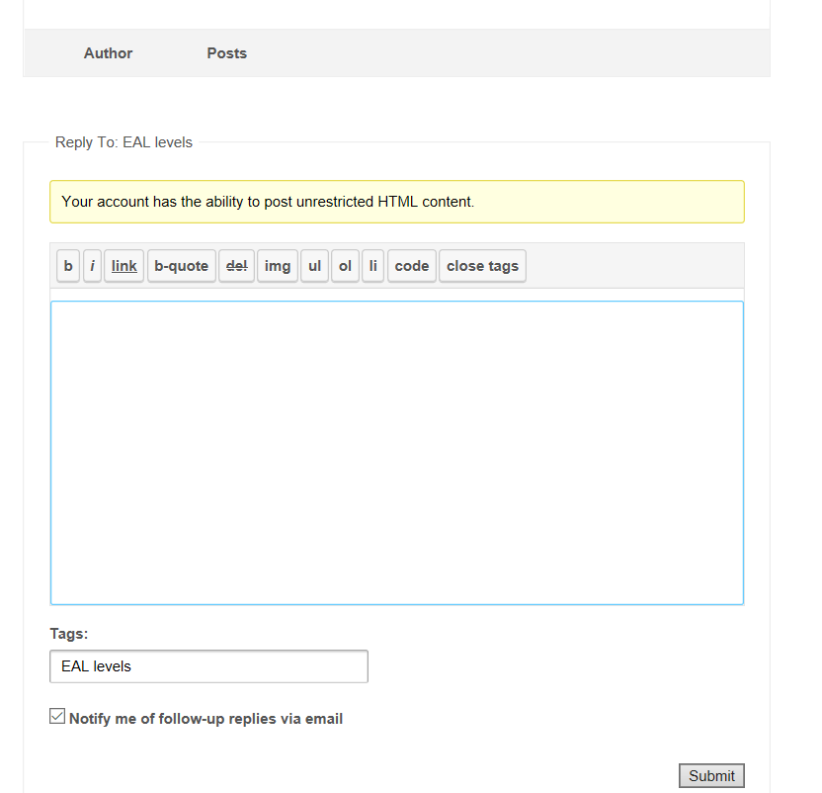
Type your thoughts in the blue box. Then click ‘submit’ when you’d like to see them online.

Thanks for contributing to our TEAL community.

