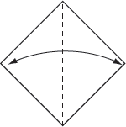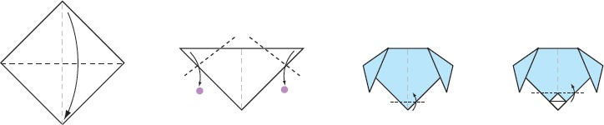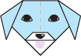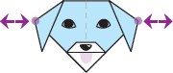WRITING ASSESSMENT TASK:

Task procedure: (instructions for students) and stimulus/prompt: (rubric, visuals )

1
2

3
4

fold nose dog
paper

- Get a piece of square

- the paper.

- Draw the eyes, ears, whiskers, tongue and on
your dog.

- Make your bark.

