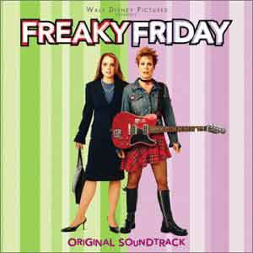A Film Review

Freaky Friday is a must-see, feel good role-reversal family comedy starring Jamie Lee Curtis as the up-tight Mum and Lindsey Lohan as the rock-chick daughter.
Dr. Tess Coleman and her fifteen-year-old daughter are not getting along. They don’t see eye-to-eye on clothes, hair, music or men. One Thursday evening things get really bad. Anna is furious that her mother doesn’t support her musical ambitions and Tess, who is a widow, and just about to get married again can’t understand why Anna won’t give her fiancé a break. They go out for a Chinese meal and eat two magical fortune cookies. Friday becomes really freaky when they wake up and find they have switched bodies! As they live each other’s lives they begin to understand each other much better. But, Tess is due to get married so the two have to find a way to switch back – and fast!
A fresh, delightful, well crafted film – It’s a bit cheesy in parts, but there’s a good plot. Curtis and Lohan play their parts well and don’t go overboard – so they keep us believing. Great dialogue, hilarious moments which will you splitting your sides! The film deals with a universal theme that many teenagers and their parents will identify with. Highly recommended.
Star Rating: ****

