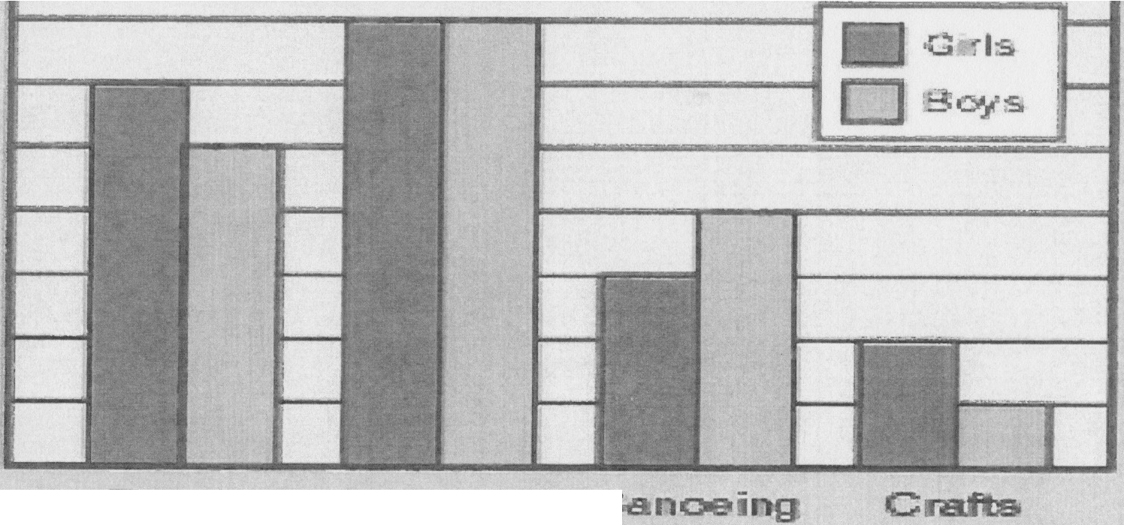

**t-vitiee**

E

30'JS.

30

25

.20

'15

"10

5

0

E

**:**:**z**::f

..**:I**s**,.,**

0

&

**C**

(.)

35

e

**Participa on in Can,p Activities**