**ORAL LANGUAGE ASSESSMENT TASK:**

**Task procedure:** *(Instructions for students)* **and stimulus/prompt:** *(rubric, visuals )*

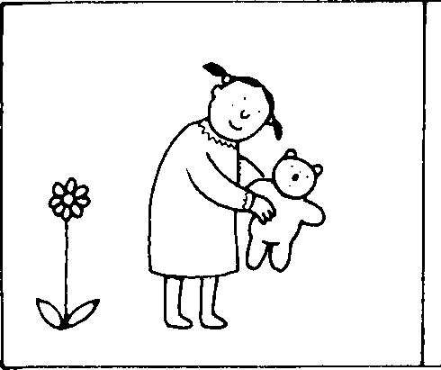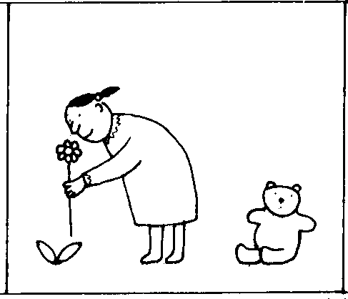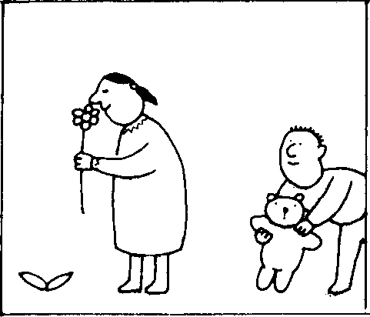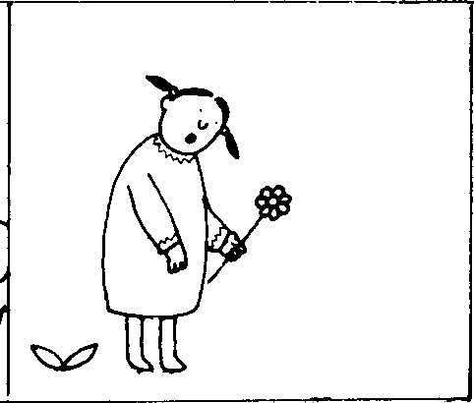

Tell the story using the cards your teacher gave you