Pedestal Fan Product Information

Feature | Dyson AM03 Pedestal fan | Omega Altise Tower Fan | Pedestal fan GVO40PF
Appearance | 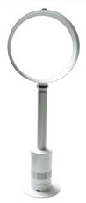  Sleek and stylish | 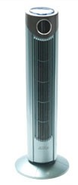  Simple and elegant | 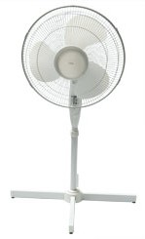  Traditional appearance
Airflow (in room at 28 degrees,  person sitting 3 metres away) | Adequate, but uneven, didn’t feel powerful. | Good | Good
Noise in Decibels (Db)  Higher = more noise | 54Db | 44Db | 42Db
Power consumption at high speed, in watts (w)  Lower = less power used | 61 w | 43w | 33w
Cleaning | Easy to clean, no moving parts | Easy to clean, wipe outside of tower | Need to remove cage to clean blades
Safety | No moving parts | Blades fully enclosed in tower | Blades in removable cage
Price | $599 | $76 | $19

Source: Choice magazine 2012 see http://www.choice.com.au/reviews-and-tests/household/heating-and- cooling/home-cooling/first-look-dyson-pedestal-fan.aspx

