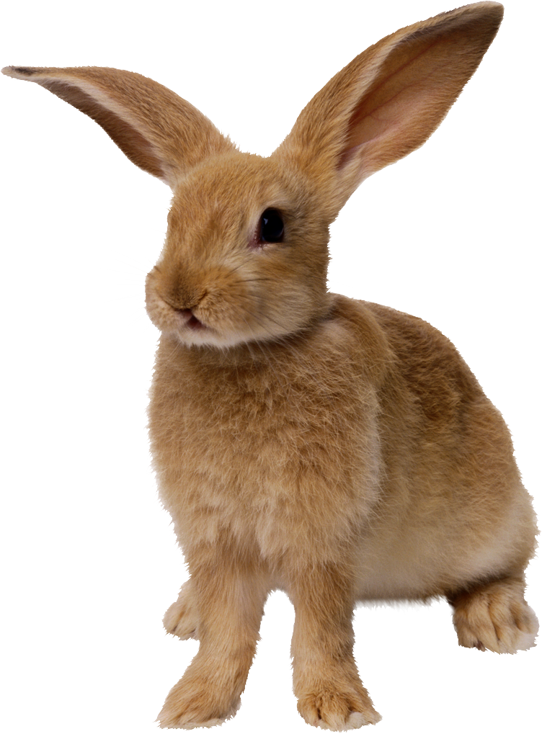
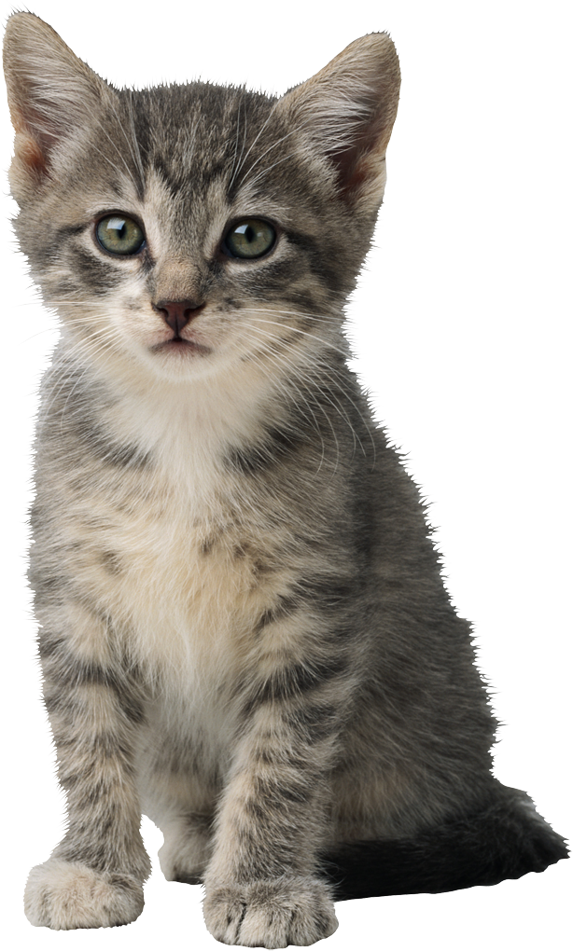
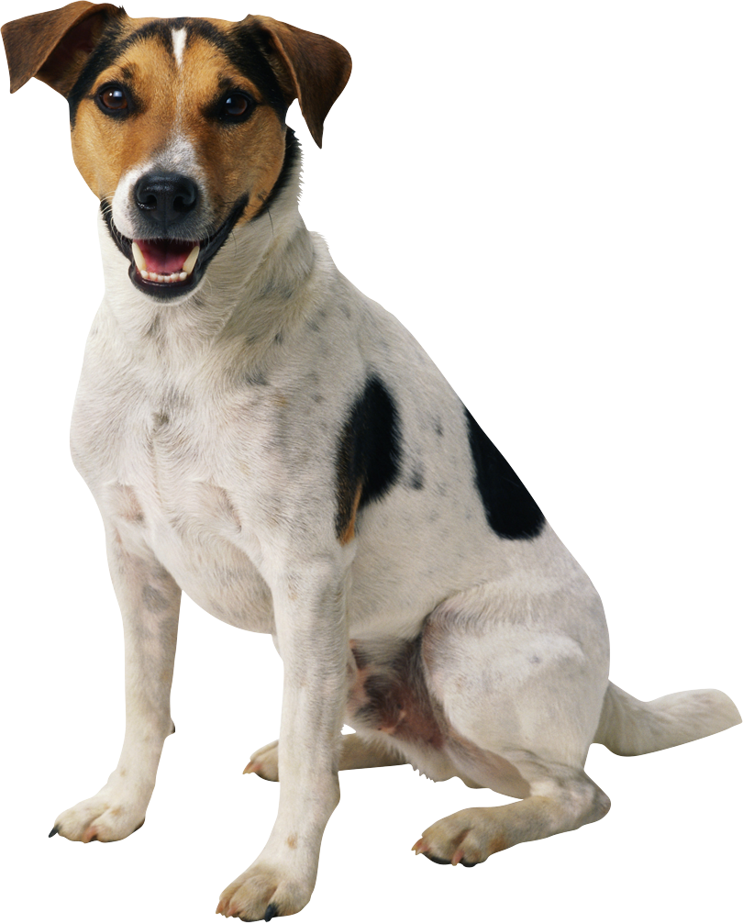
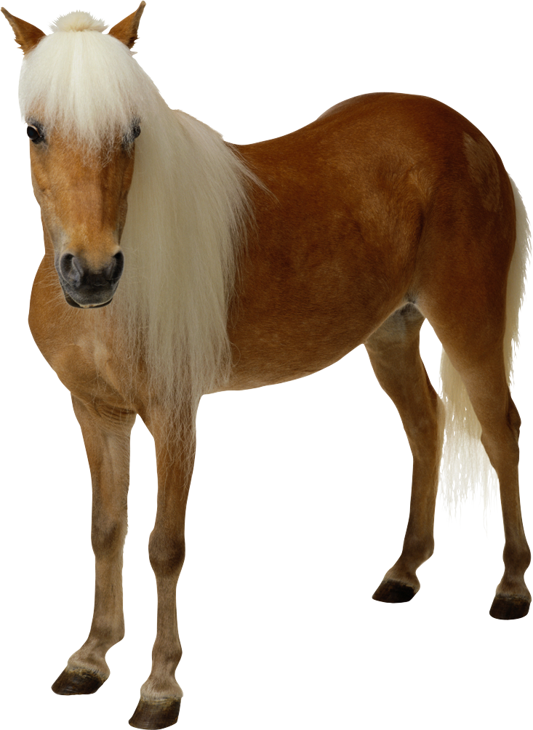
My Favourite Animal

Animal | Country | Appearance | Food and drink | Behaviour | Reason
- cat | - all over the world | - small  - soft fur  - many different colours | - meat  - fish  - milk | - sleep a lot  - like to be warm  - like living with people | - friendly  - purr  - play

