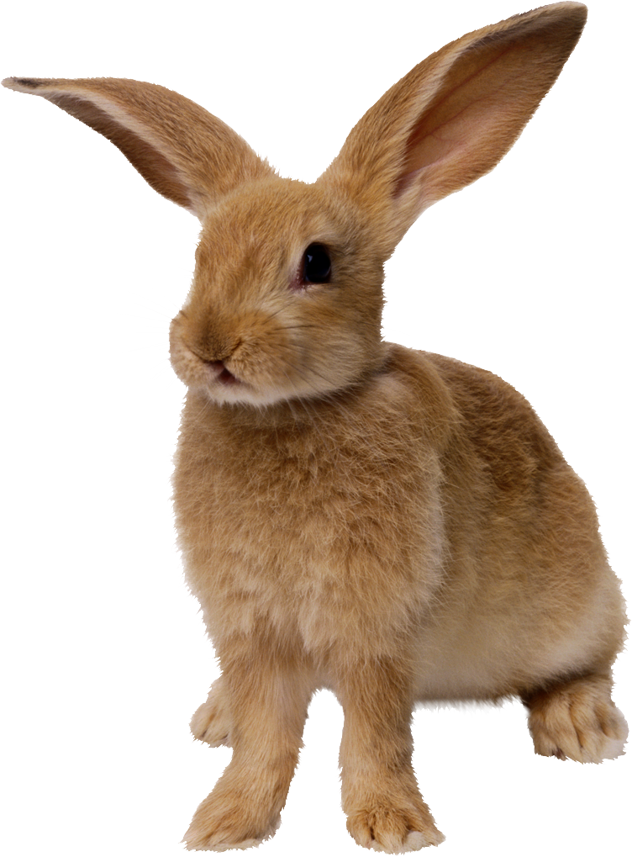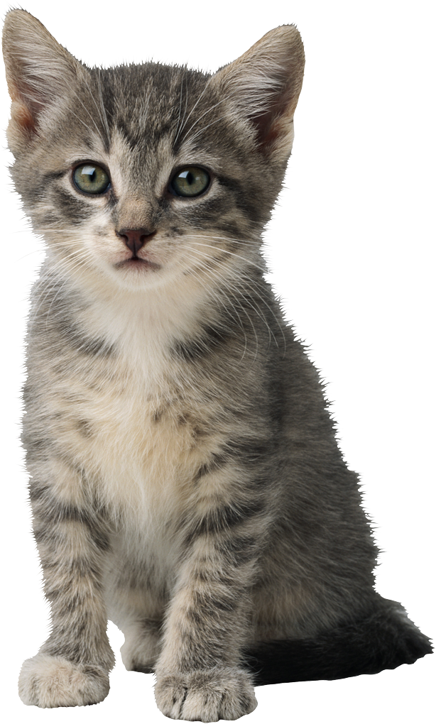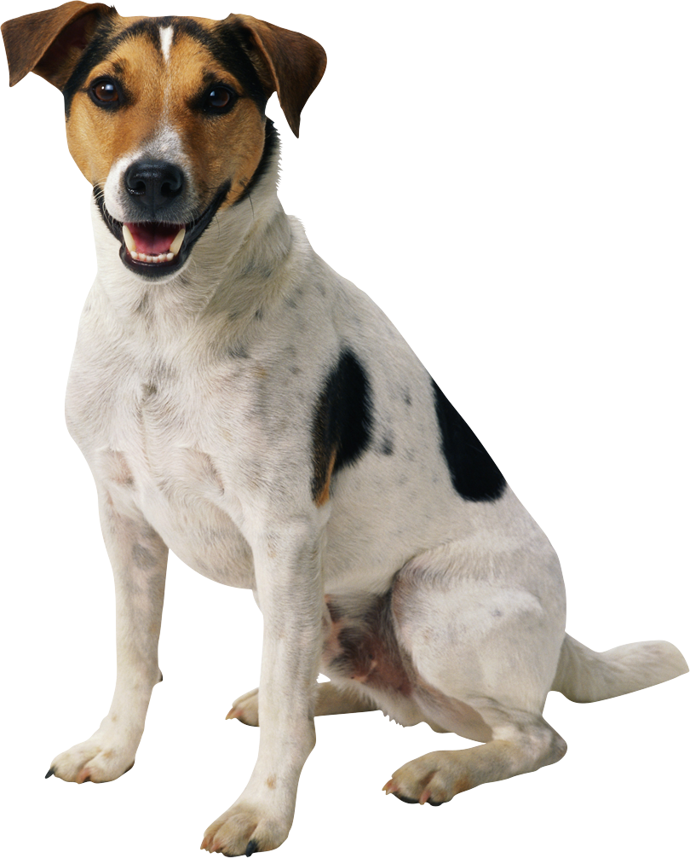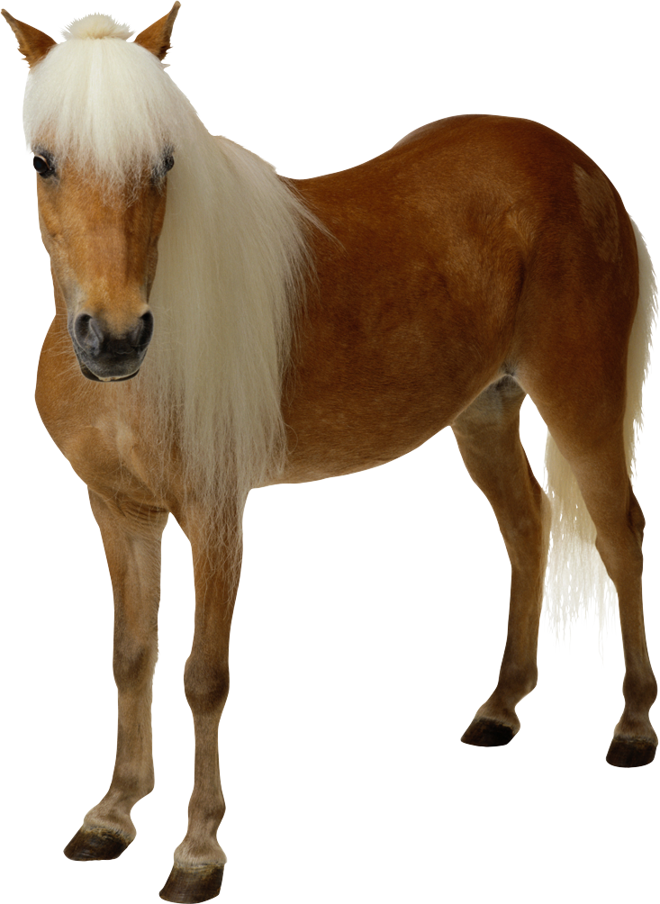My Favourite Animal

|  |  |  |  |  |  |
| --- | --- | --- | --- | --- | --- |
| **Animal** | **Country** | **Appearance** | **Food and drink** | **Behaviour** | **Reason** |
|  |  |  |  |  |  |