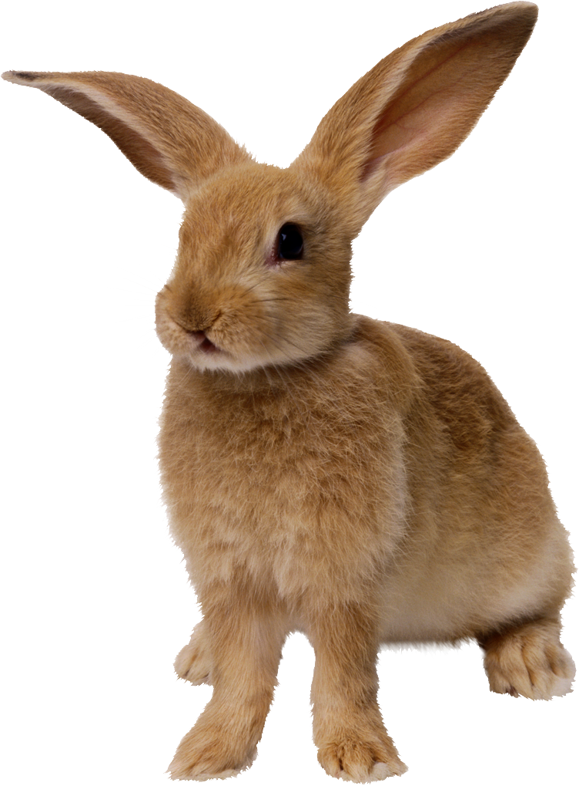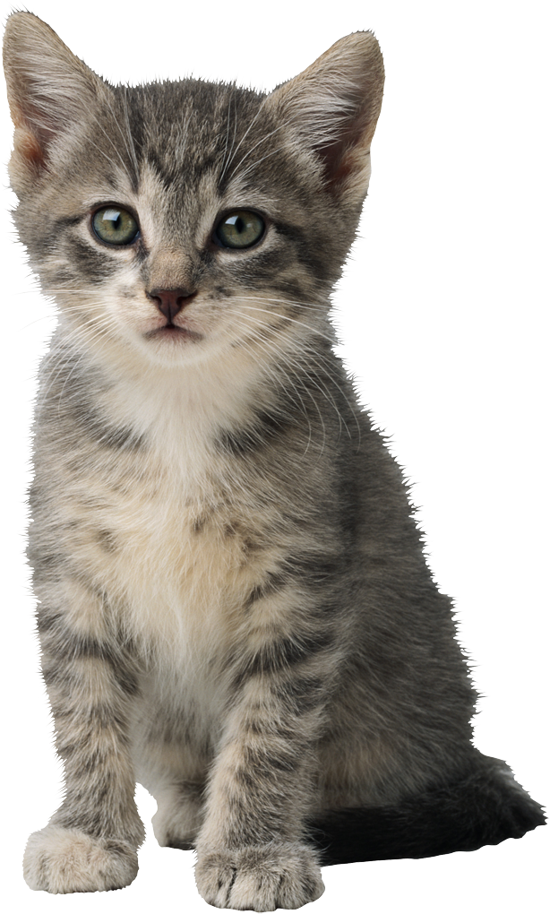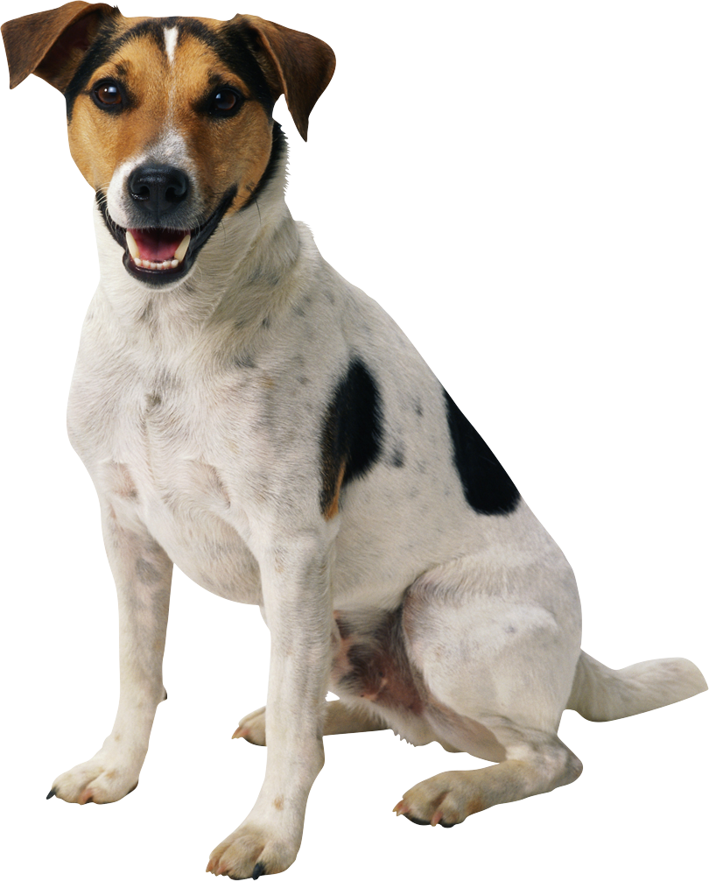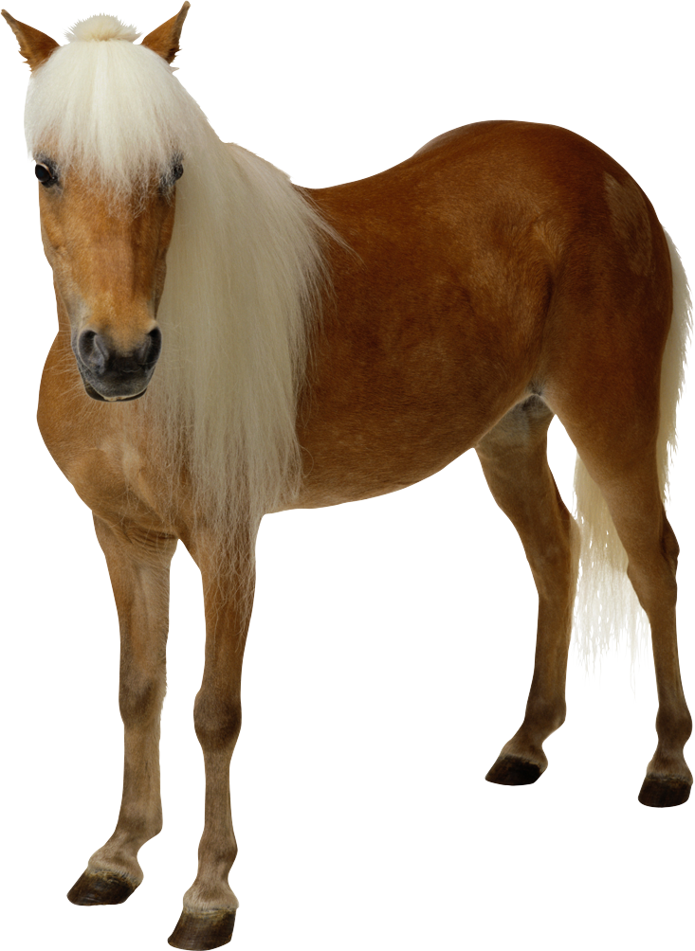WRITING ASSESSMENT TASK:
Task procedure: (instructions for students) and stimulus/prompt: (rubric, visuals )

Use your notes to write about your favourite animal

My Favourite Animal

