WRITING ASSESSMENT TASK:

Task procedure: (instructions for students) and stimulus/prompt: (rubric, visuals )

Choose a new product from the pictures below and write an advertisement for it Remember to:
- think of a name for your product
- write a caption
- describe the product and how it works
- say what makes it special
- make people want to buy it!

Possible products to write texts for:
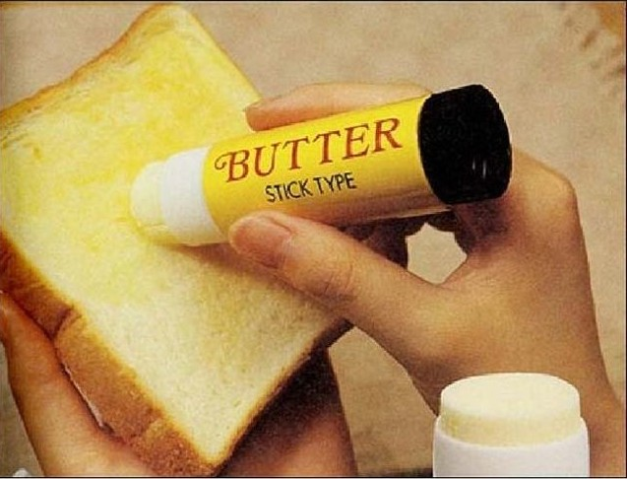 | (NOTE: there is a small dish that goes round and round inside the plastic cone)  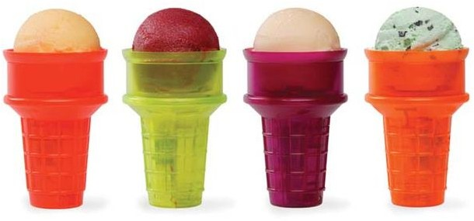
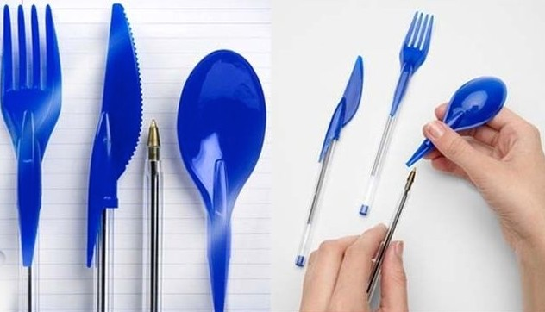 | 