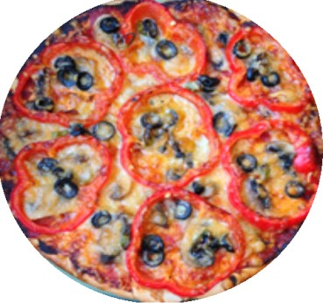**Making a pizza**

# Ingredients: Draw a line from the ingredients to the pictures.

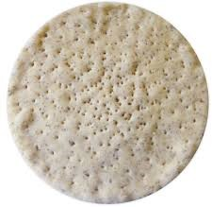

tomato paste

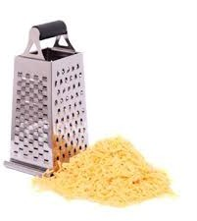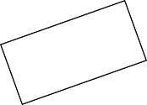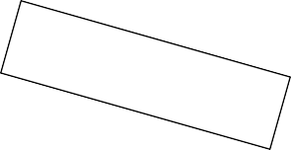

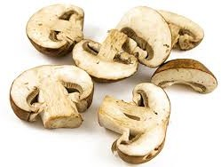

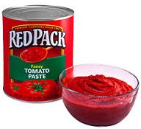**Steps: Put the steps in the correct order 1 - 8**



grated cheese

* Spread the tomato paste on the pizza base.
* Place the pizza in the oven and cook for twenty minutes.
* Add some olives.
* Put the sliced mushrooms on the pizza base.
* Place the capsicum slices over the mushrooms.
* Cut the pizza into slices and serve it with salad.
* Turn on the oven to 180C.
* 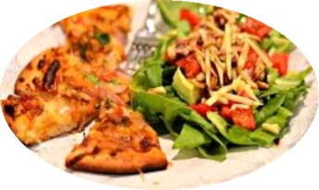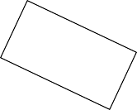Cover all the ingredients with the grated cheese.