Unit name: What’s the matter?
Student Year level/EAL Stage/s: Level 3/4, Stage B3

Learning area/s: English, Science

Victorian curriculum/content links:

Students explore key concepts about matter and changes that occur through conducting science experiments.
SCIENCE – AusVELS Achievement Standard – Level 3.
- A change of state between solid and liquid can be caused by adding or removing heat
- Heat can be produced in many ways and can move from one object to another; a change in the temperature of an object is related to the gain or loss of heat by the object
- Science involves making predictions and describing patterns and relationships
- Compare results with predictions, suggesting possible reasons for findings
English – AusVELS Achievement Standard – Level 3
Speaking and Listening
- Learn extended and technical vocabulary and ways of expressing opinion including modal verbs and adverbs
- Listen to and contribute to conversations and discussions to share information and ideas and negotiate in collaborative situations and use interaction skills, including active listening and clear, coherent communications
- Plan and deliver short presentations, providing some key details in logical sequence, using appropriate tone, pace, pitch and volume
Reading and viewing
- Understand how different types of texts vary in use of language choices, depending on their purpose, audience and context, including tense and types of sentences
- Analyse how different texts use verb groups to represent different processes (action, thinking, feeling, saying, relating)
Writing
- Understand that verbs represent different processes (doing, thinking, saying, and relating) and that these processes are anchored in time through tense
- Plan, draft and publish imaginative, informative and persuasive texts demonstrating increasing control over text structures, language features, print selection and multimodal elements appropriate to the audience and purpose
Class description: The class consisted of 27 Year 3/4 students, with 50% of students coming from a non-English speaking background. Eight of these students came from South Sudan and spoke Dinka and Arabic at home. They had all experienced trauma in Kenyan refugee camps, and had been separated from family members. These students had been placed on the Victorian ‘EAL Developmental Continuum P–10’ at stage B3
Main genre focus: Hybrid text- Science experiment report. The students were required to prepare and present an oral science experiment report, explaining a scientific phenomenon, to peers, at a school science expo, after independently writing a science experiment report.

Specific EAL learning needs to be covered in this unit:
The Targeted EAL Focus Group students needed assistance with:
- Writing in the range of text types required for a science experiment text, e.g. procedural, descriptions
- Using correct tenses
- Including a range of descriptive and more technical vocabulary
- Including paragraphs
- Punctuation, e.g. capital letters, full stops
Students were expected to prepare and present an oral science experiment report, explaining a scientific phenomenon at a school science expo after independently writing a science experiment report. To achieve this the EAL focus group participated in additional science experiments, using visual and audio-visual materials to build understanding of content and subject terminology. This also reinforced the correct structure and grammatical features of a science experiment report.
Collaboration with other teachers: At this school, the classroom teachers support the EAL students in the mainstream, as there is minimal additional support for EAL students. A Backward Mapping example text was created by the team of Year 3/4 teachers, which specifically identified the linguistic features and structures of a scientific experiment report. The teachers could not source appropriate model texts, which both matched the structure of the hybrid text, and the age and stage of the students. As a result, they developed a series of DVDs, showing scientific experiments and modelling the hybrid text required for a scientific experiment report.

Years: 3 & 4  Level 3 EAL Stage B3 |  | Unit name: What’s the matter? |  |  |  |  |  | Time allocation:  1 Term
Topic focus | Victorian curriculum/content objectives  Science  - There is a difference between solids, liquids and gasses  - There are three main states of matter  - Changes in matter can occur as a result of applying heat, cooling and chemicals  - Change can be either reversible or non-reversible  - Each state of matter has particular properties that assist with classification  English  - Prepare and present an oral science experiment report, explaining a scientific phenomenon, to peers at a science expo.  - Independently write a science experiment report. |  |  | Main text focus
 |  |  |  | Text-type and mode | Listened to |  | Spoken |  | Read | Written |  | Viewed | Produced
 |  |  |  | Narrative
 |  |  |  | Recount
 |  |  |  | Procedure
Topic specific vocabulary  experiment, aim, hypothesis, predictions, procedure, results, observations, description, conclusion, solids, liquids, gasses, molecules, density, expand, liquefy |  |  | Linguistic structure focus  Text type: Science experiment report  Social purpose/genre: To inform the audience of a scientific phenomenon through recounting the process of scientific investigation.  Structure:  Title (Name of investigation/experiment)  Aim (investigative question)  Hypothesis (prediction)  Procedure (equipment/ materials/steps)  Results (observations/description of change)  Conclusion (generalisations) | Report
 |  |  |  | Explanation
 |  |  |  | Discussion
 |  |  |  | Argument/ exposition
Assessment types used  Teacher led - Informal observation - Planned observation - Questioning/discussion - Focused analysis of student work Self and peer - Self-reflection - Peer discussion - Peer observation |  |  |  | Other: Hybrid Text: Science experiment report featuring: Procedure, Description, Scientific Conclusion
 |  |  | Grammatical features focus  - Verb/Process – Action verbs, sensing/perceiving verbs, relating verbs  - Present tense/Imperatives (Procedure)  - Future tense (Prediction and developing a hypothesis)  - Past tense using some passive voice (Description and Conclusion)  - Noun/Participant – Specific/General (Specific content vocabulary, describing subject and process)  - Adverbial circumstances – time/place/manner (Detailed information on how, where, when to complete action) | Functions
 |  |  |  | Classroom learning  - arguing  - classifying  - establishing limits  - evaluating  - hypothesising  - identifying  - judging  - offering  - persuading  - planning  - predicting  - requesting  - sequencing  - warning |  | Getting things done  - comparing  - clarifying  - describing processes and change  - explaining cause and effect  - instructing  - inquiring  - justifying  - questioning  - reporting  - suggesting |  |  |  |  | Maintaining communication  Expressing:  - apology  - appreciation  - approval  - certainty  - concern  - frustration  - indifference  - intention  - needs/wants  - preferences  - probability  - regret
EAL focus-Learning intentions
- Additional science experiments, using hands on equipment, materials, and visual and audio-visual scaffolds to build EAL students understanding of:
  - content and subject terminology
  - correct structure and grammatical features of a science experiment report.
Resources
Dahl, R. 1982. George’s Marvellous Medicine. Victoria, Australia: Penguin.
Georges Marvellous Medicine video (1:00:30) https://www.youtube.com/watch?v=wclY8F-UoTE
http://www.abpischools.org.uk/topic/solids-liquids-gases/2/1 (Click on buttons 2, 3 and 6 for individual explanations).
Scholastic, 1991. Matter. Australia: Scholastic.
Rossbridge, J. 2015. Putting it in writing. Newtown, NSW, Australia: PETAA.
Curmi, V. & Hein, J. 2012. Mr Hein and Mrs Curmi’s Sizzling Science Experiments – Melting Chocolate’ (09.56)
http://fuse.education.vic.gov.au/?5B8CHR

Level 3/4/Stages B2/B3: Ideas for activities

These activity suggestions are linked to the aspects of language in the EAL Developmental Continuum at Stages B2 and B3. The shaded activities types are included in this unit.

Listening and speaking | Reading | Writing
Text/Communication  To participate in different learning contexts and explore a range of oral text-types:  - take part in conversations and discussions about personal experiences and interests  - discuss topics related to the KLAs  - take part in listening to, preparing and delivering a formal talk to others, e.g. debates, explanations  - take part in listening to, preparing and presenting performances, e.g. stories, plays, poems, wordplay. | Text/Communication  To read and view a wide range of texts for a range of purposes:  - read and research texts for information  - read and reflect on novels, poems, short stories, viewed texts  - follow written instructions and directions  - obtain information from advertisements, posters, signs, captions, etc.  - obtain information from diagrams, tables, maps, plans, graphs, etc. | Text/Communication  To introduce students to writing various texts for a range of purposes:  - write a range of factual texts to fulfil particular purposes  - write a range of fictional texts to fulfil particular purposes  - give information in graphic form, e.g. maps, diagrams, graphs  - give information through signs, captions, tables, etc.  - share and talk about their own writing.
Contextual understanding  To develop awareness and skills in using the oral text-types appropriate to particular purposes and audiences:  - compare the effectiveness of spoken texts in serving particular purposes, e.g. reports, explanations  - identify the characteristics of a variety of text-types  - use non-verbal language in drama and role-play  - compare how spoken texts change, depending on the formality of the situation. | Contextual understanding  To interpret the information in factual and fictional texts according to purpose and context:  - discuss how texts change according to purpose and audience  - talk about the best way to present information and why formats vary, e.g. table, graph, written text  - talk about the reasons for different opinions about the meaning of a text. | Contextual understanding  To recognise that particular text-types have particular features that will be affected by the writer’s purpose and audience:  - talk about the purposes and audiences they are writing for  - discuss the importance of vocabulary choice and writing style when writing for different audiences  - talk about the most purposeful and useful ways of presenting information, e.g. a table, a graph, written text.
Linguistic structures and features  To use the structures and features of a variety of common spoken texts:  - discuss the impact of, and develop a vocabulary to discuss aspects of, spoken texts, e.g. pace, intonation  - talk about the cohesive devices used in spoken texts, e.g. sequencing, pronoun referencing, use of topic sentences  - learn the specialised language of particular topic areas. | Linguistic structures and features  To focus on text structures and features to assist in reading a wide range of texts:  - recognise the characteristic features of particular texts, e.g. choice of vocabulary, cohesion, topic sentences  - use book organisation features to access information, e.g. contents page, index, headings  - discuss how additional features of texts assist or affect interpretation, e.g. layout, illustrations, diagrams. | Linguistic structures and features  To use knowledge of the characteristic structures and features of common texts to write appropriately for a range of purposes:  - compare texts written for a range of purposes and identify patterns in texts  - identify the features that make one text more effective than another  - learn and use appropriate vocabulary  - talk about and use punctuation in their writing  - use layout to assist in the presentation of their writing.
Strategies  To reflect on and use effective oral communication strategies with teachers and other students:  - identify and practise effective small-group communicative strategies  - listen for information and respond appropriately  - plan for, rehearse and modify own spoken texts. | Strategies  To practise strategies that assist in reading for enjoyment, interpretation and information:  - talk about and use strategies for effective reading, e.g. skimming and scanning text  - select texts for own purposes  - read silently and aloud  - use a range of strategies when reading and finding out the meaning of new words  - research a topic and find appropriate information. | Strategies  To develop a range of strategies and resources for planning, reviewing and ensuring the appropriateness of their writing:  - observe and practise strategies for writing, e.g. planning, topic selection, gathering information, note taking  - use models to write texts for particular purposes  - review writing to identify aspects that may be improved, e.g. handwriting, presentation, spelling, sentence linking  - use different resources to check and confirm spelling.

Teaching and learning activities | Linguistic focus | Assessment for learning ideas
N.B. Only a selection of the many teaching and learning activities the students engaged in are included in this unit  Whole Class  Discuss the unit learning intentions.  The aim of this unit is to assist students to begin to understand:  - The difference between solids, liquids and gasses  - Changes in matter can occur as a result of applying heat, cooling and chemicals  - Scientific Inquiry through developing investigative questions, making predictions, planning and conducting investigations, comparing results with investigations and using tools and materials safely  - Scientific procedures and produce simple spoken and written science experiment reports to explain a scientific phenomenon. |  | Unit learning intentions  List and discuss the learning intentions of the unit with the students to ensure they know what they are aiming to achieve throughout the unit.  By the end of the unit they will be able to understand:  Science  - There are three main states of matter  - The difference between solids, liquids and gasses  - Changes in matter can occur as a result of applying heat, cooling and chemicals  - Change can be either reversible or non-reversible  - Each state of matter has particular properties that assist with classification  Science involves:  - making predictions  - planning and conducting investigations  - describing patterns and relationships  - comparing results with predictions  - suggesting possible reasons for findings  - using tools and materials safely  English  Students will:  - Prepare and present an oral science experiment report, explaining a scientific phenomenon, to peers at the school science expo.  - Independently write a science experiment report.
NOTE: Setting the context/Building the Field/Tuning in
In this stage the focus is placed on ‘developing scientific inquiry as students are being scientists through hands on activities and oral language development’. (Rossbridge, 2015. p.65)
The teacher:
- Establishes what shared or prior understandings students have of scientific knowledge and scientific methods and what needs to be explored
- Builds on the students’ knowledge of the three states of matter (solids, liquids & gases).
- Builds on the students’ knowledge of the language required to produce an oral and written scientific experiment report

Teaching and learning activities | Linguistic focus | Assessment for learning ideas
Building scientific content about changes  - Listening to, reading, and viewing a range of texts to tune students into a science topic, matter and experimentation e.g. Read Roald Dahl’s book, ‘George’s Marvellous Medicine’ as an ongoing serial reading task. Dahl, R. 1982. George’s Marvellous Medicine. Victoria, Australia: Penguin.  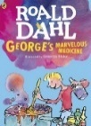  View YouTube video concurrently to ensure EAL students’ understandings  https://www.youtube.com/watch?v=dTx-mCriQOE  - Teacher guided questions asked at different stages in the text/pausing of video to orally introduce stages of a science experiment report.  - Class word wall/ glossary commenced and added to in an ongoing way throughout the unit e.g. aim, hypothesis, conclusion…with definitions provided by students  George was behaving like a scientist when he produced his marvellous plan.  - What was George’s marvellous plan to do/make? (Make a ‘Marvellous Medicine’ – Title)  - Why did George want to make this Marvellous Medicine? (To cure Grandma Kranky of her nastiness – Aim).  - What did George predict would happen? (The magic medicine would be so fierce and fantastic that it would frighten Grandma Kranky so much that it would completely cure her of her nastiness or ‘blow off the top of her head’ p. 14 – Hypothesis)  - What did George need and what did he do? (equipment, materials and steps – Procedure)  - What did George observe happened to Grandma Kranky after she took the magic medicine? (Description)  - Did the magic medicine frighten Grandma Kranky so much that it cured her of her nastiness or made her explode? (Conclusion) | Linguistic structure – Introduce orally the structure/stages of a science experiment report:  Title – Name of investigation/experiment  Aim – Investigative question.  What is being investigated?  Hypothesis – Prediction  What do we predict will happen?  Procedure – Steps  What do we need and what are the steps?  Description – Observation  What did we see happen?  Conclusion – Generalisation  What did we find out?  Linguistic features  Verb/process – Future tense – ‘I think George wanted to make the magic medicine to cure Grandma Kranky of her meanness’.  Past tense – ‘George observed that the magic medicine made steam come out of Grandma Kransky’s head and she grew taller’.  Noun/participant – Specific/General (technical) hypothesis, conclusion  ingredients added to George’s Marvellous Medicine e.g.Golden Gloss Hair Shampoo, Superfoam Shaving Soap…  Present tense/Imperatives/sequence markers, e.g. Number one. Pour in a bottle labelled Golden Gloss Hair Shampoo. | Observation  - Observe how students participate in the class discussions around the text.  - Note the understandings and interest students have in the text.  - Observe if students are able to respond to the questions that begin to orient them to the stages of a science experiment.  - Observe students use of future tense when they predict and past tense when they retell stages.  - Observe students understanding of technical vocabulary as they define new vocabulary in the word list/glossary
Whole Class  Building content about matter: solids, liquids and gases  - Teacher poses the following questions  - What is matter?  - What is a solid, liquid and gas?  - Can you name some examples of solids, liquids and gases?  - Students reflect on their own and then share/discuss their ideas with a partner.  - Students view two websites that explain simply the three states of matter. As they view they take notes and record their information on a data chart under the three headings, solids, liquids and gases.  https://www.youtube.com/watch?v=wclY8F-UoTE  http://www.abpischools.org.uk/topic/solids-liquids-gases/2/1  - Students share information and add new vocabulary with definitions to class word wall | Functions  - Listening for information about the 3 states of matter– solids, liquids, gases  - Recording information on a data chart under 3 subheadings – solids, liquids, gases  Linguistic features:  Noun/participant, – Specific e.g. Solids can be soft, bouncy or fluffy’.  Noun/participant, – General (technical), e.g. particles, shape, solid. liquid, gas, mass, atoms, water vapour…  Verb/process action – ‘Solids can change their shape if you squash them’.  Adverbial/circumstances, e.g. ‘In a solid the particles are packed tightly together and vibrate slowly’. | Observation, questioning and feedback  - Observe students as they share their ideas and complete the data chart to assess their understanding of the topic and their use of the technical vocabulary  - Teacher questions and provides immediate, on the spot, verbal feedback to the class and individuals  - Students add to their data charts in an ongoing way throughout the unit as they learn more about the three states of matter  - Students retain their data charts for future reference
EAL Focus Group  - Using the information from George’s Marvellous Medicine and the websites explaining the 3 states of matter, students brainstorm words or draw pictures that are related to solids, liquids and gases.  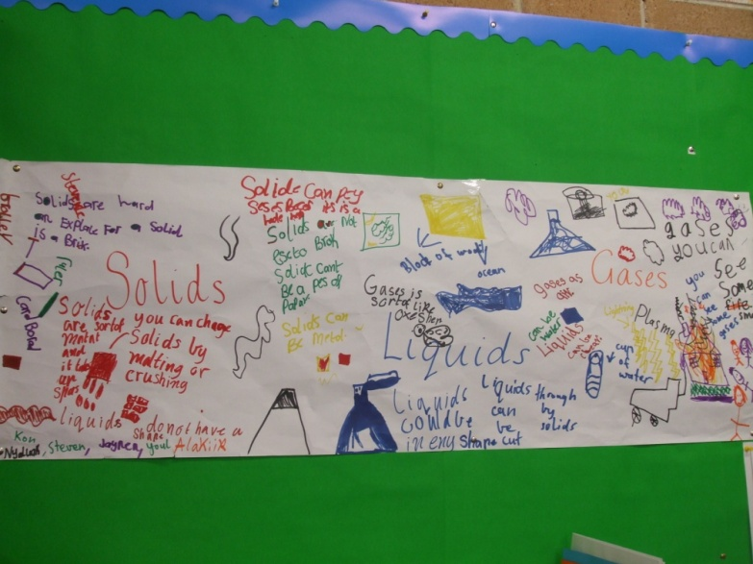 | Functions  - Describing  - Classifying  - Expressing modality  Linguistic structures and features:  Noun/participant, – Specific e.g. Solids can be soft, bouncy or fluffy’.  Noun/participant, – General (technical) e.g. particles, shape, solid. liquid, gas, mass, atoms, water vapour…  Linking bits of information, group + group, e.g. Liquids do not have a shape, Solids are hard  Classifying, Noun: Gases are sort of like oxygen  Low Modality: You can change solids by melting or crushing. | Observation of Brainstorming Task  - Observe development of student vocabulary and understandings from the book and websites as they record and/or illustrate them on large poster paper
Whole Class  Building content through hands on experiments to observe chemical changes  - Introduce the notion of experimentation in the classroom by videoing the teacher undertaking an experiment making 3 cups of tea with different water temperatures. Teacher orally introduces the stages of the science experiment report reinforced with sentence strips of the investigative questions and flash cards of the stages, e.g.  - What is the name of investigation/experiment? Title  - What is being investigated? Aim  - What do we predict will happen? Hypothesis  - What do we need and what are the steps? Procedure  - What did we see happen? Description  - What did we find out? Conclusion  - Students predict prior to experiment and observe, describe and discuss changes that occurred when different temperature liquids were added.  - Video is replayed and steps reinforced.  - Video muted and students retell steps. | Function  - Describing the purpose of different stages when conducting a science experiment  Linguistic structure  Structure/stages of a science experiment report.  Title – Name of investigation/experiment  Making a cup of tea using cold, warm and boiling water  Aim – Investigative question. What is being investigated?  To see how the colour of water changes when a teabag is added to cold warm and boiling water.  Hypothesis – (Prediction). What do we predict will happen?  Procedure – (Steps). What do we need and what are the steps?  Description – (Observation). What did we see happen?  Conclusion – (Generalisation). What did we find out?  Linguistic features:  Modality – I think that, could be, can, might, may...  Verb/process – Future tense – I think that there will be no change in the colour of the tea when different temperature water is added.  Past tense – We found out that the tea made with the hot water was the darkest colour. | Observation  - Observe if students are able to predict, observe, describe and explain the steps in the ‘Making a cup of tea’ experiment.  - Observe students use of future tense when they predict and past tense when they retell stages.  Analysis of student work  Planned Observation – Oral language analysis (pre-test).  - Listen to and film EAL students explaining how to make a cup of tea using water of different temperatures and the changes that they observed.  - Teacher analyses students’ transcripts to identify students’ strength and areas of need, e.g. grammar, appropriate vocabulary, pronunciation, fluency, intonation.
Whole Class  A science lab is set up in the classroom which includes simple, general science experiment cards and equipment.  - Students in pairs, take on the role of scientist by conducting their own science experiments guided by the investigative questions and flash cards of the stages  Sample tasks e.g.  - floating and sinking  - estimating the distance that small pieces of paper travel, when blown with a straw  - estimating the number of grains of rice being lifted from one container to another  - how many times a shoelace can be tied in one minute.  - Each group reports back to the class  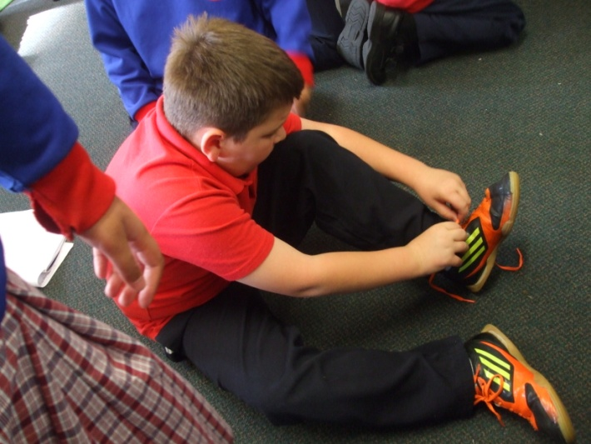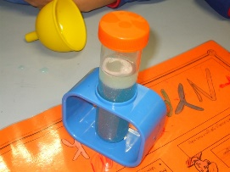 | Functions  - Stating a purpose for the science experiment  - Predicting /Hypothesising  - Expressing modality  - Giving instructions  - Observing, Analysing and interpreting  - Expressing cause and effect  - Checking against the hypothesis as the end of the experiment  Linguistic features  Future tense (to predict and unknown outcome) can + be  To see how many times a shoelace can be tied in one minute.  Modality – I think that a shoelace can/will/might be tied three times in one minute.  Past tense – We found out that the shoelace could be tied only two times in one minute.  Time connectives – to indicate sequence of the experiment and the procedure, e.g. first, next, then... | Observation, questioning and feedback  - Observe students as they undertake the experiments in the laboratory and report back to the class. Are they beginning to use the language of science experiments, e.g. aim, hypothesis, steps, observation…?  - Observe students use of the future tense to predict and the past tense when they retell what they did and their observations.  - Teacher guides students’ discussions and provides on the spot verbal feedback as students participate in the experiment and report back to the class. Teacher uses careful questioning and responses guiding students towards more scientific structures and vocabulary.
Whole Class  - Students divided into 4 groups and undertake a science experiment with teacher guided support  Science Experiments  - Popping Corn (To see what happens when popcorn kernels are added to heat)  - Melting Chocolate (To see what happens when a bowl of solid chocolate bits is placed over a bowl of boiling water) EAL focus group  - Dancing Raisins (To see what happens when raisins are added to a cup of lemonade)  - Colour Changing (To see what happens when two primary colours (Yellow & Blue) are mixed together)  - Teacher guides students’ discussions as they participate in the experiment reinforced by flashcards of stages and investigative questions  - Each group reports back to the class | Linguistic structure  Structure/stages of a science experiment report.  Title – Name of investigation/experiment  Aim – Investigative question.  What is being investigated?  Hypothesis – Prediction  What do we predict will happen?  Procedure – Steps  What do we need and what are the steps?  Description – Observation  What did we see happen?  Conclusion – Generalisation  What did we find out?  Linguistic features  Future tense (to predict and unknown outcome) – To see what happen when…  Modality – I think that … can/will/might …  Past tense – We found out that …  Time connectives – to indicate sequence of the experiment and the procedure e.g. first, next, then... | Observation, questioning and feedback  - Observe students participating in the group experiment and reporting back to the class. Are they beginning to use the language of science experiments, e.g. aim, hypothesis, steps, observation, conclusion, liquids, solids, gases …?  - Observe students use of the future tense to predict and the past tense to retell what they did and their observations.  - Teacher guides students’ discussions as they participate in the experiment and report back to the class. Teacher uses careful questioning and responses guiding students towards more scientific structures and vocabulary.  Analysis of student work  - Video the EAL students conducting the ‘Melting Chocolate’ experiment and reporting back to the class for future analysis by teacher.
NOTE: Deconstruction and Modelling
In the ‘Modelling/Deconstruction stage’ the teacher familiarises the students with the science experiment report genre so they are able to ‘read’ it and deconstruct it. It involves collaborative interaction with the teacher to:
  - Explore the social context of the text (purpose/audience)
  - Examine the structure of the text
  - Examine the language choices
  - Model text production
N.B. Because it is a hybrid text the teacher decided to model, deconstruct and jointly construct the text in stages

Whole Class  Mentor Text – Popping Corn  - Teacher repeats’ Popping Corn’ experiment with whole class scaffolded by investigative questions and key stages on flashcards.  - Shared reading and deconstruction of mentor text – ‘Popping Corn’ (Figure 1) to explicitly introduce science experiment report structure  Mentor text-Popping Corn (Figure 1)  Aim Investigative question What were we investigating? To see what happens when popcorn kernels are heated in a pan.  Hypothesis Prediction What do we predict will happen? That the popcorn kernels will expand when heated in a hot pan.  Procedure Steps What do we need and what are the steps? Equipment and materials - pan with lid - oil - half a bag of popcorn kernels Steps - Pour the oil into the hot pan - Add half a bag of popcorn kernels to the hot pan - Place the lid on top of the pan - Remove the lid from the pan after 5 minutes - Serve the expanded popcorn kernels with salt and melted butter  Description Observation What did we see happen? When the popcorn kernels were added to the hot pan they began to expand and made a popping noise after two minutes. The popcorn kernels stopped popping after five minutes. When the lid was taken off the hot pan, all of the popcorn kernels had expanded and had changed to a white colour. The popcorn had an irregular shape and felt smooth on the outside. A gas was formed as the room was filled with the smell of popcorn.  Conclusion Generalisation What did we find out? The hypothesis was supported because the popcorn kernels expanded when they were heated in a hot pan. This occurred because the water molecules inside the kernel moved faster as they were heated and turned into a gas. This made the kernel explode and turn inside out, into a fluffy piece of popcorn.  - Students in pairs sequence stages (Figure 2).  EAL Focus Group  - EAL students sequence text as a group supported by teacher | Linguistic Structure  Title – Name of investigation/experiment. Popping corn  Aim – Investigative question. To see what happens when popcorn kernels are added to heat.  Hypothesis – Prediction. That the popcorn kernels will expand when heated in a hot pan.  Procedure – Steps: What do we need and what are the steps?  Description – Observation: What did we see happen?  Conclusion – Generalisation: What did we find out? | Analysis of student work  - Were the students able to sequencing cut up text with a focus on structure?  Popping Corn (Figure 2)  Title: Popping Corn  Aim: To see what happens when popcorn kernels are heated in a pan.  Hypothesis: That the popcorn kernels will expand when heated in a hot pan.  Procedure:  Equipment and materials  - pan with lid  - oil  - half a bag of popcorn kernels  Steps  Pour the oil into the hot pan  Add half a bag of popcorn kernels to the hot pan  Place the lid on top of the pan  Remove the lid from the pan after 5 minutes  Serve the expanded popcorn kernels with salt and melted butter  Description: When the popcorn kernels were added to the hot pan they began to expand and made a popping noise after two minutes. The popcorn kernels stopped popping after five minutes. When the lid was taken off the hot pan, all of the popcorn kernels had expanded and had changed to a white colour. The popcorn had an irregular shape and felt smooth on the outside. A gas was formed as the room was filled with the smell of popcorn.  Conclusion: The hypothesis was supported because the popcorn kernels expanded when they were heated in a hot pan. This occurred because the water molecules inside the kernel moved faster as they were heated and turned into a gas. This made the kernel explode and turn inside out, into a fluffy piece of popcorn.
Whole Class  Deconstruction and Modelling of Title, Aim, Hypothesis and Procedure  - Students view ‘Popping Corn’ experiment on DVD made by teachers titled ‘Popping Corn’. Subtitles are included to highlight the written structure of the science report focusing on the Aim, Hypothesis and Procedure  Focus on grammar of text – Highlight linguistic features of the Title, Aim, Hypothesis Procedure stages – Verb/Process/Action verbs  - Discuss with students – What is being done? Highlight together the Verb/process/Action verbs in green at each of the stages (Figure 3).  - Discuss action verbs as commands/imperatives, e.g. pour, mix, add, remove…  - Class list of action verbs commenced and added to in an ongoing way throughout unit  - Discuss verb tense  - Future tense – Aim and hypothesis – (to predict an unknown outcome, e.g. to see what happens when, will expand  - Present tense/Imperative – Steps, e.g. pour, add  - Students complete cloze in which all of the action verbs are deleted. EAL Focus group complete cloze with a partner scaffolded by the choice of action verbs listed (Figure 4) | Linguistic Features  Verb/Process/Action verbs, e.g. see, are added to, will expand, pour, place...  Action verbs as commands/imperatives, e.g. pour, mix, add, remove, place…  Future tense – Aim and hypothesis, (to predict an unknown outcome e.g. to see what happens when, will expand  Present tense-Steps, e.g. pour, add  Action verbs/processes highlighted (Figure 3)  Linguistic Structure Linguistic Features  Title Popping Corn Verb/process- Action verbs Present Tense/ Imperatives e.g. Pour, Add… Future tense (Prediction and developing a Hypothesis)  Aim To see what happens when popcorn kernels are heated in a pan.  Hypothesis That the popcorn kernels will expand when heated in a hot pan.  Procedure Equipment and materials - pan with lid - oil - half a bag of popcorn kernels Steps - Pour the oil into the hot pan - Add half a bag of popcorn kernels to the hot pan - Place the lid on top of the pan - Remove the lid from the pan after 5 minutes - Serve the expanded popcorn kernels with salt and melted butter | Observation  - Are the students able to identify the action verbs with teacher guided support and questioning?  Analysis of student work  - Were the students able to complete the cloze using appropriate verbs?  Cloze Activity: Popping Corn (Figure 4)  Aim: _ ___ __ ___ when popcorn kernels ___ ___ in a pan  Hypothesis: That the popcorn kernels __ _____ when ___________ in a hot pan.  Procedure:  Equipment and materials  - pan with lid  - oil  - half a bag of popcorn kernels  Steps  - _________the oil into the hot pan  - _________ half a bag of popcorn kernels to the hot pan  - _________ the lid on top of the pan  - _________the lid from the hot pan after 5 minute  - ______the expanded popcorn kernels with salt and melted butter.  Pour Remove heated Serve are heated  Will expand Add Place To see what happens
- Teacher repeats process above viewing additional teacher made DVDs with subtitles i.e. ‘Dancing Raisins’ and ‘Colour Changing’ and written texts to reinforce the linguistic structure Title, Aim, Hypothesis and Procedure and the Linguistic feature – Action verbs |  | Observation  - Are the students able to identify the action verbs with teacher guided support and questioning?  - Are the students able to identify the action verbs without teacher guided support?
EAL Focus Group ‘Melting Chocolate’ (Focus experiment)  - Shared viewing of the DVD titled’ Mr Hein and Mrs Curmi’s Sizzling Science Experiments – Melting Chocolate’ (Subtitles are included to highlight the stages Title, Aim, Hypothesis and Procedure  - Students identify structure in visual text.  - Shared Reading and deconstruction of text to reinforce structure  - Students sequence stages (Figure 5)  - Focus on grammar of text – Highlight as a group in green Verb/process/Action verbs e.g. To see what happens, are placed, will become, pour…  - Students complete cloze activity in which the action verbs/processes have been deleted from the text (Figure 6).  - Students share their cloze with a partner and discuss the effectiveness of their word choices. | Function  - Stating a purpose of the science experiment  - Predicting (Hypothesising)  - Identifying steps  Linguistic Structure  Melting Chocolate (Figure 5)  Melting Chocolate  Aim: To see what happens when a bowl of solid chocolate bits is placed over a bowl of boiling water.  Hypothesis: That the bowl of solid chocolate bits will become a liquid when placed over a bowl with boiling water.  Procedure:  Equipment and materials  - two bowls  - a packet of solid chocolate baking bits  - boiling water  - large spoon  Steps  - Pour boiling water into one bowl.  - Put all of the solid chocolate bits into the other bowl and place over the bowl with boiling water  - Stir chocolate bits to speed the melting process.  Linguistic Features  Verb/process/Action verbs, e.g. see, are placed over, will become, pour, put, stir.  Action verbs as commands/imperatives, e.g. pour, put, stir…  Future tense, (to predict an unknown outcome) will + become ‘The bowl of solid chocolate bits will become a liquid when placed over a bowl of boiling water’.  Present tense, Steps e.g. pour, add | Analysis of student work  - Were the students able to sequencing cut up text with a focus on structure?  Student sample of sequencing activity (Figure 5)  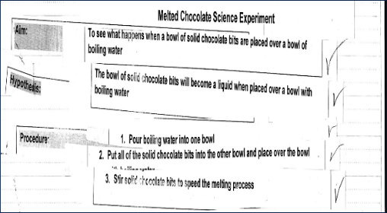  Analysis of student work  - Were the students able to complete the cloze using appropriate action verbs?  Cloze Activity (Figure 6)  Melting Chocolate  Aim: ……………….when a bowl of solid chocolate bits is …. over a bowl of boiling water.  Hypothesis: That the bowl of solid chocolate bits … …. a liquid when …. over a bowl with boiling water.  Procedure:  Equipment and materials  - two bowls  - a packet of solid chocolate baking chips  - boiling water  - large spoon  Steps  - …. boiling water into one bowl.  - …. all of the solid chocolate bits into  the other bowl and … over the bowl with boiling water  - … chocolate bits …. the melting process.  placed Stir Put Pour  placed will become To see what happens when
Whole Class  Focus on grammar of text – Noun/participant – Title, Aim, Hypothesis Procedure stages  - Discuss with students – What is the action being done to? Highlight together the Noun/participant, – Specific/General (technical) in red at each of the stages (Figure 7)  - Class list of noun/ participants commenced and added to in an ongoing way throughout the unit  - Students highlight noun/participants in ‘Dancing Raisins’ and ‘Colour Changing’ texts  EAL Focus Group ‘Melting Chocolate’  - Highlight as a group the Noun/participants in ‘Melting Chocolate’ text  Focus on grammar of text – Adverbial/circumstances (time/place/manner) – Title, Aim, Hypothesis Procedure stages.  - Discuss with students – Where, when or how did the action happen? Highlight together – Adverbial/circumstances (time/place/manner) in blue at each of the stages (Figure8)  - Class list of Adverbial/ circumstances commenced and added to in an ongoing way throughout the unit  - Students highlight Adverbial/ circumstances in ‘Dancing Raisins’ and ‘Colour Changing’ texts  EAL Focus Group ‘Melting Chocolate’  - Highlight as a group the Adverbial circumstances in ‘Melting Chocolate’ text | Linguistic Features  Noun/participant (Figure 7)  Linguistic Structure Linguistic Features  Title Popping Corn Noun/participant, – Specific/General (technical)  Aim To see what happens when popcorn kernels are heated in a pan.  Hypothesis That the popcorn kernels will expand when heated in a hot pan.  Procedure Equipment and materials - pan with lid - oil - half a bag of popcorn kernels Steps - Pour the oil into the hot pan - Add half a bag of popcorn kernels to the hot pan - Place the lid on top of the pan - Remove the lid from the pan after 5 minutes - Serve the expanded popcorn kernels with salt and melted butter  Adverbial/circumstances – time/place/manner (Figure 8)  Linguistic Structure Linguistic Features  Title Popping Corn Adverbial/circumstances (time/place/manner)  Aim To see what happens when popcorn kernels are heated in a pan.  Hypothesis That the popcorn kernels will expand when heated in a hot pan.  Procedure Equipment and materials - pan with lid - oil - half a bag of popcorn kernels Steps - Pour the oil into the hot pan - Add half a bag of popcorn kernels to the hot pan - Place the lid on top of the pan - Remove the lid from the pan after 5 minutes - Serve the expanded popcorn kernels with salt and melted butter | Observation  - Are the students able to identify the noun/ participants with teacher guided support and questioning?  - Are the students able to identify the noun/ participants without teacher guidance e.g. highlighting?  Observation  - Were the students able to identify the adverbial/circumstances with teacher guided support and questioning?  - Are the students able to identify the adverbial/circumstances without teacher guidance e.g. highlighting?
Joint Construction
In the ‘joint construction’ stage the teacher and students work together collaboratively to construct a science experiment report. They draw on shared understandings about the topic and metalanguage learned through explicit instruction of a science experiment report text. As the text is being constructed.
The teacher:
- Acts as scribe
- Scaffolds the students through questions, thinking aloud, retelling etc.

Whole Class  Science experiment report frame  - Students with teacher jointly construct the key words (Title, Aim, Hypothesis, Procedure) as the first stages of a science experiment report frame for students to use as a scaffold when writing a science experiment report. | Functions  - Identifying purpose of a science experiment report  - Identifying text structure (Title, Aim, Hypothesis, Procedure)  Linguistic Structure  Title  Aim  Hypothesis  Procedure
Jointly construct a text similar to mentor text  - Jointly plan a report on the ‘Dancing Raisins’ experiment undertaken in the Building the Field stage, using the ‘Science Experiment Report Frame’ constructed in the previous lesson.  - Teacher acts as a scribe, modelling and encouraging students to use the metalanguage they have learnt about science experiment report texts.  Sample Joint Construction text  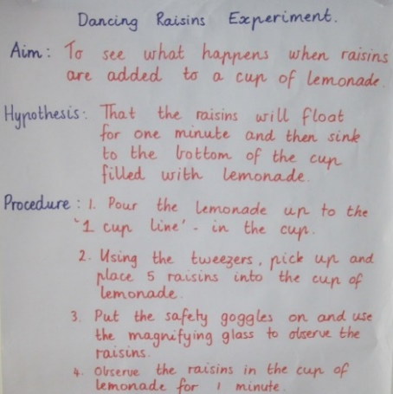 | Linguistic Features  Verb/process – Action verbs e.g. see, are added, sink...  Action verbs as commands/imperatives, e.g. pour, pick up, place, observe...  Noun/participant, – Specific/General (technical) e.g. raisins, a cup of lemonade, the safety goggles, the magnifying glass...  Adverbial/circumstances – (time/place/manner), e.g. into the cup of lemonade, for 1 minute,  Future tense – Aim and hypothesise, e.g.to predict an unknown outcome e.g. to see what happens when, will float  Present tense – Steps e.g. pour, observe... | Observation  - Observe students as they contribute their ideas to the jointly constructed text.  - Are they able to use the metalanguage to identify and describe the stages in the text?  - Are they able to use the linguistic features such as appropriate tense, action verbs, nouns and adverbials of time, place and manner?
Whole Class  Guided writing in pairs.  - Students with a partner use the ‘Science experiment report frame’ and sentence starters to jointly construct the report text on the ‘Changing Colours’ experiment (Figure 9).  EAL Focus Group – ‘Melting Chocolate’  - Teacher and students jointly construct a report on the ‘Melting Chocolate’ experiment using the ‘Science Experiment Report Frame’. Teacher acts as a scribe, modelling and encouraging students to use the metalanguage they have learnt about science experiment report texts.  - Students in pairs jointly construct the report using the guided scaffold (Figure 10).  Melting chocolate (Figure 10)  Melting Chocolate  Aim: To see what happens when…  Hypothesis: That the bowl of chocolate chips will …  Procedure:  Equipment and materials  - ……..  - ……..  - ……..  - ………  Steps  - Pour ….  - Put ….  - Stir …. | Linguistic Structure  Changing colours (Figure 9)  Title: Colour changing  Aim: To see what happens when two primary colours (yellow & blue) are….  Hypothesis: That the two colours will ……  Procedure:  Equipment and materials  - large test tube with lid  - eye dropper  - flask  - funnel  - blue and yellow food colouring  - water  Steps  - Fill….  - Add….  - Add…  - Place…  - Pour…  Linguistic Features  Verb/process – Action verbs  Future tense – Aim and hypothesise  Present tense – Steps  Noun/participant, – Specific/General (technical)  Adverbial/circumstances – (time/place/manner) | Analysis of student writing  - Observe how the students in pairs jointly construct the science experiment report using the guided scaffold.  - Are they able to use the linguistic features such as appropriate tense, action verbs, nouns and adverbials of time, place and manner?

Whole Class  Modelling and deconstruction of Description and Conclusion  - Students reread ‘Popping Corn’ text and identify final stages to be added to the science experiment report frame.  Title  Aim  Hypothesis  Procedure  Description  Observation  - Students discuss what they observed happened to the popcorn after they carried out the procedure. View visual results on DVD and students describe in more detail their observations.  - Revisit Mentor text ‘Popping Corn’ text and read Description and Conclusion (Figure 11)  - Focus on grammar of text – Highlight linguistic features of the Description and Conclusion stage – (Figure 11)  - Verb/process/past tense – includes action, relating and sensing verbs  - Noun/participant, – Specific – More descriptive – a popping noise  - Noun/general (technical) – Increased use e.g.an irregular shape, a gas, the hypothesis…  - Adverbial/circumstances (time/place/manner), e.g. after two minutes, to the hot pan, to a white colour  - Past tense | Function  - Observing what happened  - Analysing and interpreting  - Expressing cause and effect  - Checking against the hypothesis as the end of the experiment  Linguistic Structure  Description – Observation: What did we see happen?  Conclusion – Generalisation: What did we find out?  Linguistic Features  Verb/process – Action verbs e.g. stopped popping, had expanded...  Sensing/perceiving verbs, e.g. was supported  Relating verbs, e.g. had  Past tense  Noun/participant, Specific e.g., a popping noise, the white colour General (technical), an irregular shape, a gas, the hypothesis…  Adverbial/circumstances, (time/place/manner), e.g. after two minutes, to the hot pan, to a white colour…  Popping Corn’ – Description and Conclusion (Figure 11)  Description Observation What did we see happen? When the popcorn kernels were added to the hot pan they began to expand and made a popping noise after two minutes. The popcorn kernels stopped popping after five minutes. When the lid was taken off the hot pan, all of the popcorn kernels had expanded and had changed to a white colour. The popcorn had an irregular shape and felt smooth on the outside. A gas was formed as the room filled with the smell of popcorn. Verb/process- Action verbs Sensing/perceiving verbs relating verbs Noun/participant, – Specific/General (technical) Adverbial/circumstances (time/place/manner) Past tense using some past passive voice (Description and Conclusion)  Conclusion Generalisation What did we find out? The hypothesis was supported because the popcorn kernels expanded when they were heated in a hot pan. This occurred because the water molecules inside the kernel moved faster as they were heated and turned into a gas. This made the kernel explode and turn inside out, into a fluffy piece of popcorn. |  | Observation, questioning and feedback  - Observe students participating in the class discussion. Teacher uses careful questioning and responses guiding students towards more scientific structures and vocabulary.  - Are they able to describe in detail their observations and conclusions of the ‘Popping Corn’ experiment?  - Observe students use of the past tense to describe what they saw happen and what they found out.  - Were the students able to identify the:  - Verb/process – Action verbs  - Sensing/perceiving verbs  - Relating verbs  - Past tense  - Noun/participant, – Specific/ General (technical)  - Adverbial/circumstances (time/place/manner)
Whole Class  Focus on grammar of text – Passive voice  - Teachers reads two different forms of the text – one written in the active voice and the other written in the passive voice. Ask students to explain which is the more formal text and why (Refer to examples opposite)  - Teacher explains:  - Text A the orientation to the person undertaking the experiment – the scientist – the doer of the action, e.g. we added, our hypothesis was supported…  - Text B the orientation is to the ‘science’ – the done-to of the action – the receiver, e.g. the popcorn kernels were added, the hypothesis was supported  - Teacher shows sentence strips of examples from experiments and students categorise according to active and passive voice, e.g. You pour the boiling water into the bowl (Active) The pan is placed on the stove (Passive)  - Students together change active statements into passive statements e.g. You place the solid chocolate chips into the bowl (Active). The chocolate chips are placed into the bowl (Passive).  - Students with a partner complete worksheet activity in which they complete active and passive statements.  EAL Focus Group  - Students revisit active and passive voice through categorising statements linked to their focus text “Melting Chocolate’ e.g. You stir the melting chocolate to speed the melting process (Active). The melting chocolate was stirred to speed the melting process. (Passive). | Passive voice – e.g. were added, was taken off…  Text examples:  Active voice: Text A: When we added the popcorn kernels to the hot pan we observed that they began to expand and they made a popping noise after two minutes. (orientation to the person undertaking the experiment – the scientist – the doer of the action)  Passive voice: Text B: When the popcorn kernels were added to the hot pan they began to expand and made a popping noise after two minutes. (orientation to the ‘science’ – the done-to of the action – the receiver) | Observation, questioning and feedback  - Observe students participating in the class discussion and categorising statements according to active and passive voice.  Analysis of student work  - Observe how the students in pairs jointly complete the worksheet activity.  - Are they able to complete the active and passive statements?  Sorting task  - Observe EAL students’ ability to categorise statements according to active and passive voice and their explanations as to why.
Whole Class  Joint construction of the Description and Conclusion  - Model writing the description and conclusion in the passive voice to add to the joint construction of the ‘Dancing Raisins’ text.  Sample Joint construction text  Guided writing in pairs.  - Students use the ‘Science experiment report frame’ and sentence starters to jointly construct the Description and Conclusion stage on the ‘Changing Colours’ experiment with a partner (Figure 12)  EAL Focus Group  - Jointly Construct Description and Conclusion on the ‘Changing Colours’ experiment together with teacher.  Sample Joint construction text  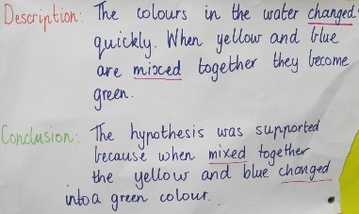 | Function  - Observing what happened  - Analysing and interpreting  - Expressing cause and effect  - Checking against the hypothesis as the end of the experiment  Linguistic Structure  Description – Observation. What did we see happen?  Conclusion – Generalisation. What did we find out?  Linguistic Features  Verb/process – Action verbs/sensing/perceiving/  relating verbs  Simple past tense  Noun/participant, – Specific/General (Technical)  Adverbial/circumstances (time/place/manner)  Passive voice | Observation  - Observe students as they contribute their ideas to the description and conclusion stage of the jointly constructed text.  - Are they able to use the metalanguage to identify and describe the stages in the text?  - Are they able to use the linguistic features such as:  - Simple past tense  - action, sensing and relating verbs,  - specific and technical nouns  - adverbials of time, place and manner  - passive voice?  Analysis of student work  - Observe how the students in pairs jointly construct the Description and Conclusion stage on the ‘Changing Colours’ experiment.  - Are they able to use the linguistic features correctly?  Colour changing (Figure 12)  Title: Colour changing  Aim: To see what happens when two primary colours (yellow & blue) are….  Hypothesis: That the two colours will ……  Procedure:  Equipment and materials  - ……..  - ……..  - ……..  - ………  Steps  - Fill….  - Add….  - Add…  - Place…  - Pour…  Description: The colours in the water changed…  Conclusion: The hypothesis was supported because…
EAL Focus Group  - Shared reading of science report ‘Melting Chocolate’ with Description and  Conclusion added (Figure 13). Melting Chocolate (Figure 13  Melting Chocolate  Aim:  To see what happens when a bowl of solid chocolate bits is placed over a bowl of boiling water  Hypothesis:  The bowl of solid chocolate bits will become a liquid when placed over a bowl with boiling water  Procedure:  Equipment and materials  - two bowls  - a packet of solid chocolate baking bits  - boiling water  - large spoon  Steps  Pour boiling water into one bowl  Put all of the solid chocolate bits into the other bowl and place over the bowl with boiling water  Stir solid chocolate bits to speed the melting process  Description  Once the bowl of solid chocolate bits was placed over the bowl with boiling water the chocolate bits became a liquid. The chocolate bits slowly melted after five minutes. It started as a solid and became a liquid.  Conclusion  When solid chocolate bits were put into a bowl and then placed over another bowl of boiling water, it changed from a solid to a liquid. This occurred because the molecules inside the chocolate moved faster and were not as tightly packed as they were heated and therefore it turned into a liquid. When melted chocolate was placed in a refrigerator for twenty-four hours it became a solid because the molecules slowed right down and it kept its shape.  - Students sequencing cut up text using the complete structures of science experiment report text – Title, Aim, Hypothesis, Procedure, Description, Conclusion  - Teacher and students jointly construct complete science experiment report text, ‘Melting Chocolate’. | Function  - Observing what happened  - Analysing and interpreting  - Expressing cause and effect  - Checking against the hypothesis as the end of the experiment  Linguistic Structure  Description – Observation. What did we see happen?  Conclusion – Generalisation. What did we find out?  Linguistic Features  Verb/process – Action verbs/sensing/perceiving/relating verbs  Simple past tense  Noun/participant, – Specific e.g., a popping noise, the white colour General (technical) – an irregular shape, a gas, the hypothesis…  Adverbial/circumstances – (time/place/manner), e.g. after two minutes, to the hot pan, to a white colour…  Passive voice – e.g. were added, was taken off… | Analysis of student work  - Sequencing task: Were the students able to sequencing cut up text with a focus on structure  Observation  - Observe students as they contribute their ideas to the jointly constructed text.  - Are they able to use the metalanguage to identify and describe the stages in the text?  - Are they able to use the linguistic features such as appropriate tense, verbs, nouns, adverbials of time, place and manner and passive voice?
Independent Construction
In the ‘independent construction’ stage the students plan and construct their own science experiment report text applying newly acquired knowledge. The students then present this orally to an audience as the summative task for this topic.
The teacher supports and guides students in:
- Applying new understandings of topic and science experiment report text
- Provides explicit feedback on how to improve the text.

Whole Class  Independently write a science experiment report and present this as a spoken text to peers at school science expo  - Students research an experiment which demonstrates change in matter to present at science expo  Written text:  - Discuss Rubric: Self and Peer feedback of written Science Experiment Report (Figure 14). (Elicit ideas for success criteria from students or provide criteria but ensure that students understand each point in the criteria).  - Individually students plan, draft, revise and edit text using the rubric  - Peer allocated to revise and edit their text using the rubric  - Student uses feedback to redraft text  - Student publishes their written text  EAL Focus Group  - Students write their science experiment report on ‘Melting Chocolate’ which they will present at the school science expo.  An example of an EAL student’s written published text  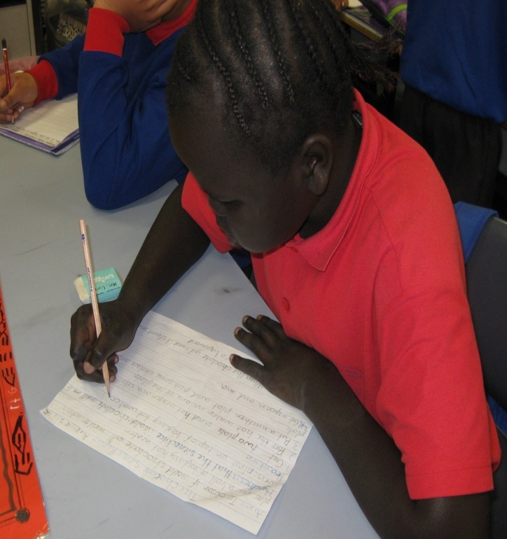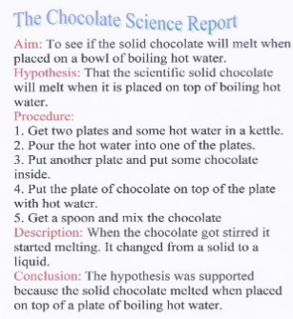 | Linguistic structure  Title – Name of investigation/experiment  Aim – Investigative question.  Hypothesis – Prediction  Procedure – Steps  Description – Observation  Conclusion – Generalisation  Linguistic features  Verb/process, Action verbs, sensing/perceiving verbs, relating verb  Present tense/Imperatives (Procedure)  Future tense (Prediction and developing a Hypothesis)  Past tense using some passive voice (Description and Conclusion)  Noun/participant – Specific/General  Adverbial circumstances – Time/place/manner  Self and Peer Feedback for written Science experiment report (Figure 14)  Yes No Comments  Authorial  I/You have included the Title of the experiment  I/You have included an Aim and began the Aim with ‘To see…’  - Use of future tense verbs  I/You have included a Hypothesis and began the Hypothesis with ‘That the…’  - Use of future tense verbs  I/You have included a Procedure of the experiment step by step, e.g. ‘Pour the water into the cup.’  - Commences each step with an action verb in the present tense  I/You have included a Description of what happened during the science experiment.  - Use of past tense verbs  - Use of technical nouns  - Use of passive voice  I/You have included a Conclusion which includes whether the Hypothesis was correct or not.  - Use of past tense verbs  - Use of technical nouns  - Use of passive voice  Secretarial  I/You have included full stops  I/You have included capital letters.  I/You have checked the spelling  I/You have started each part of the science report on a new line on the page, e.g.  - Title:  - Aim:  - Hypothesis:  - Procedure:  - Description:  - Conclusion:  Editing process  I/You used self-reflection, peer feedback and teacher feedback to improve my/your work  Two things I liked about my/your science experiment report  One thing you could do to improve your science experiment report | Peer and self-assessment – Written Science experiment report  - Students self-assess their writing using the success criteria  - Peer buddy provides feedback on their writing using the success criteria  - Teacher observe students as they work together in providing verbal feedback on the written texts.  Analysis of work Teacher/student conference  - Teacher discusses with student their written text using criteria sheet. Teacher provides feedback to the student on what they are managing well in their writing, and the next step in improving their writing and how.  Portfolio  - Students publish their text after revising and editing it from feedback given. Work samples are then retained in their learning portfolios.
Oral text  - Discuss Rubric: Self and peer feedback of oral science experiment report (Figure 15). (Elicit ideas for success criteria from students or provide criteria but ensure that students understand each point in the criteria).  - Students plan and practice their presentation.  - Students present their experiment at the school Science Expo and peer chosen to assess their presentation. | Self and peer feedback of oral science experiment Report (Figure 15)  Yes No Comments  Communication  I/You had good eye contact  I/You spoke clearly and loudly  I/You used body language and gestures well to communicate with the audience  Content  My/Your presentation was well organised  I/You shared the Aim of the experiment and began the Aim with ‘To see…’  I/You shared the shared the Hypothesis and began the Hypothesis with ‘That the…’  I/You shared the procedure of the experiment clearly, step by step, e.g.  - Pour the water into the cup  - Place a piece of cardboard on top of the cup  I/You shared the description of what happened during the science experiment.  I/You shared the conclusion which included whether the Hypothesis was correct or not.  Two things I liked about my/your presentation  One thing you could do to improve your presentation | Peer and self-assessment and teacher feedback – Oral Science experiment report  - Teacher videos EAL students’ presentations.  - Students self-assess their oral presentation using the success criteria  - Peer buddy provides feedback on the student’s oral presentation using the success criteria  - Observe students as they work together in providing verbal feedback on the oral presentations.  - Note how well students demonstrate their understanding of the experiment as they respond to questions and sequence ideas and explain what happened  - Note how accurately the students use the linguistic features to explain the process of the experiment.  - Question and provide immediate, on the spot verbal feedback as necessary.  Analysis of work Planned Observation – Oral language analysis (post-test).  Teacher/student conference.  - Teacher discusses with student their oral presentation text using criteria sheet and video.  - Teacher provides feedback to the student on their strengths and the next step in how they can improve their oral presentation.  Reflection on Learning intentions  - Ask students to reflect on the learning intentions at the commencement of the unit and to share what they feel they have achieved.

Unit evaluation: Unit name: Date:
General evaluation  Were the students interested in the topic?  Did planned activities need to be modified for EAL students? Why?  Which teaching strategies were particularly successful for mainstream and EAL students? | The students enjoyed the topic and the overall engagement level was very high. Many of students worked at home conducting their own experiments and writing experiment science reports. They requested a website to be created by the teachers, so they could ask questions, make requests for science experiments that had not been conducted at school and revisit experiments undertaken in class.  The whole class benefitted from explicit teaching of scientific vocabulary and terms.  The teachers identified the need to develop a series of DVD’s and accompanying written texts based on scientific experiments as they had difficulty locating appropriate texts which matched both the structure of the hybrid text, and the age and stage of the students. The linguistic structure and features were constantly recycled throughout each lesson and this enabled all students to independently write and present their own science experiment text at the expo.  The targeted EAL group received extra scaffolding, participating in small group EAL focus sessions, which provided greater exposure to visuals and hands on activities, repetition of vocabulary and linguistic structures and features to enhance understanding. They also constantly revisited the key mentor text ‘Melting Chocolate’, as they were presenting this report at the expo.
Content learning goals  Were the topic goals achieved?  Did the topic lead to worthwhile learning? | The students confidently and independently wrote and presented a science experiment report, using technical language and demonstrating an understanding of the key concepts about matter and the changes that occur during science experiments. The students high level of motivation was evidenced by their desire to conduct further science experiments at home, sharing their knowledge with their peers. and posting questions on the website.
English language learning goals  Were general English language learning needs highlighted by the unit?  Was there a balance between written and spoken texts? | Students’ literacy needs were identified and assessed through formal and informal assessment data, which included pre-and post-oral and written pieces. Teaching the structure and linguistic features of the hybrid text was a challenge, as it comprised several different text types and tenses. This was achieved by explicitly planning and scaffolding activities around the Teaching and Learning Framework.  The students demonstrated in their final written and oral presentations that they were able to use the correct structure and linguistic features. The transfer of knowledge was evidenced later in the year, when students were directed to write a science experiment report or selected to do so in free choice/writer’s notebook sessions.
EAL considerations  How successfully did the unit involve the EAL students?  Which English language needs were identified as a priority for future units? | The science experiment report was considered to be a high challenge task for the EAL students. The ‘hands on’ approach enabled the EAL students to successfully participate. The specific EAL literacy needs were determined by placing the students on the Victorian ‘EAL Developmental Continuum P-10’. Following the whole class activities, the classroom teacher provided additional scaffolded activities for the EAL focus group. These highlighted, reinforced and explicitly taught the linguistic structures and features of a science experiment report. On reflection, explicitly teaching oral language presentation skills to EAL students would be a priority for future units
Ideas for further units/activities  What language focuses need to be targeted again in future units?  What further topics will complement this unit? | Specific content vocabulary, tenses, passive voice, verb/process, adverbial circumstances  Many topics complement the unit given the nature of the hybrid text.
Assessment for learning strategies  Did the chosen assessment strategies ensure students achieved the unit learning goals? Did the assessment feed into planning and teaching?  Were students involved in the assessment process?  Were the success criteria for the focused analysis assessment tasks clear?  Were students able to use criteria to provide feedback to their peers?  Were students able to use feedback from assessment to improve their learning? | Students had the opportunity to complete rubrics and give peer feedback.  The assessment, as well as student work samples, gave the teacher a clear indication of the learning needs and this was addressed in small groups.  Students were able to use the assessments to improve their own learning.  The teachers developed the assessment rubrics and on reflection decided it would have been better to develop these with the students.

