Theme name: Marvellous Melbourne
Topic for this unit: Aboriginals in Melbourne in the past
Through-line of topic: Change, Continuity, Time – Over time some aspects of life in communities change and some remain constant. Major events often result in changes in local, national and global communities. When people understand historical and societal change it helps them to understand their world and contribute to creating preferred futures.

Student Year level/EAL Stage/s:
This unit was written for a Year 3 class. Most students were at standard on the Australian Curriculum and one student was assessed against the EAL continuum. All students participated in the whole class focus activities, with the EAL student participated in extra small focus groups. The EAL student was assessed on the continuum for the following:
- B2 – Writing
- B2 – Reading
- B3 – Speaking and Listening

Victorian Curriculum content links – Year 3:
Strand: Humanities
Domain: Geography
Dimensions: Geographical knowledge
Content Descriptors:
Representation of Australia as states and territories, and Australia’s major natural and human characteristics (VCGGK079)
The many Countries/Places of Aboriginal and Torres Strait Islander peoples throughout Australia, and the custodial responsibility they have for Country/Place, and how this influences views about sustainability (VCGGK080)
The many Countries/Places of Aboriginal and Torres Strait Islander peoples throughout Australia, and the custodial responsibility they have for Country/Place, and how this influences views about sustainability (VCGGK080)

Strand: Mathematics
Dimensions: Data and Information
Content Descriptors:
Collect and record relevant geographical data and information from the field and other sources (VCGGC074)

Strand: Humanities
Domain: History
Dimensions: Historical Concepts and Skills, Historical Sources as evidence
Identify the origin and content features of primary sources when describing the significance of people, places and events (VCHHC067)

Strand: Humanities
Domain: History
Dimensions: Historical Knowledge, Community, remembrances, celebrations
Content Descriptors:
The significance of Country and Place to Aboriginal and Torres Strait Islander peoples who belong to a local area (VCHHK072)
A significant example of change and a significant example of continuity over time in the local community, region or state/territory (VCHHK073)
The role that people of diverse backgrounds have played in the development and character of the local community and/or other societies (VCHHK074)

First Contacts
Content Descriptors:
The diversity and longevity of Australia’s first peoples and the significant ways Aboriginal and Torres Strait Islander peoples are connected to Country and Place (land, sea, waterways and skies) and the effects on their daily lives (VCHHK078)

Strand: Humanities
Domain: Civics and Citizenships
Dimensions: Citizenship, Diversity and Identity
Content Descriptors:
Describe the different cultural, religious and/or social groups to which they and others in the community may belong (VCCCC007)

Strand: English
Domain: Writing
Dimensions: Literature (Text structure and organisation)
Content Descriptors:
- Understand that paragraphs are a key organisational feature of written texts (VCELA259)

(Expressing and Developing ideas)
Content Descriptors:
- Understand that verbs represent different processes (doing, thinking, saying, and relating) and that these processes are anchored in time through tense (VCELA262)

Dimensions: Literature
(Creating Literature)
Content Descriptors:
- Create texts that adapt language features and patterns encountered in literary texts (VCELT265)
(Creating Texts)
Content Descriptors:
- Plan, draft and publish imaginative, informative and persuasive texts demonstrating increasing control over text structures and language features and selecting print and multimodal elements appropriate to the audience and purpose (VCELY266)
- Reread and edit texts for meaning, appropriate structure, grammatical choices and punctuation(VCELY267)

Class description:
The unit was designed for a mainstream class of 23 students (13 girls and 10 boys). The majority of the students were assessed as being at standard across the Australian Curriculum.
The unit included modified activities for an EAL student, aged 9, with a Vietnamese background. The EAL student was assessed at Stage B2 for Reading and Writing and B3 for Speaking and listening. The EAL student participated three times a week in an additional reading program (TOTEM).
The main idea from this unit derived from students’ interests and questions after a class visit to the Melbourne Museum. They developed an interest in Aboriginal history, and this interest was bolstered after viewing a mini-clip about John Batman and the Aboriginal people prior to European settlement. This prompted new interest and questions regarding the treatment of Aboriginal people since European arrival, and how Aboriginal people lived prior to European settlement.

Main genre focus:
To write an information report on Melbourne and the Aboriginal tribes that had settled there. Students will write an information report based on the Aboriginal culture and how they used to belong to particular areas in the local community. They will look changes in location and changes in time as well as the different Aboriginal tribes that resided in Melbourne in the past.

Specific EAL learning needs to be addressed in this unit:
- Tense – Use of common past tense verbs
- Writing using a genre framework
- Spelling unfamiliar words
- Adverbs – describing actions
- Time connectives
- Topic/key words
- Features of text types – information reports

Years: 3 & 4  Level 3/4  EAL Stages B2 B3 |  | Unit name: Marvellous Melbourne  Sub unit name: Aboriginals in Melbourne in the past. |  |  |  |  |  |  |  |  | Time allocation:
Topic focus | Learning Area / content objectives / cultural understandings  Develop the understanding that:  - Aboriginals lived in Australia (Melbourne) for thousands of years before European arrival 1788.  - Aboriginal people had their own names for places and locations in this area  - Aboriginal people used to hunt and what they hunted. |  |  | Main text focus: Information Report
 |  |  |  | Text-type and mode | Listened to | Spoken |  |  | Read | Written |  |  | Viewed | Produced
 |  |  |  | Narrative | √ |  |  |  | √
 |  |  |  | Recount
 |  |  |  | Procedure
Topic specific vocabulary  Nouns - Melbourne, Aborigines, Aboriginal tribes, canoes, shields,(aboriginal artefacts)  Collective nouns - tribes, bands  Action verbs – hunting, fished, hunted, bound, gathered  Time connectives - around, until, first  Topic Specialised vocabulary- shell middens, estuaries, harbours, inhabitants, archaeologist  Locations – Melbourne, Bellarine Peninsula, Great Dividing Range, Mansfield, Port Phillip Bay, Mordialloc Creek  Aboriginal tribal names – Kulin, Jarra, Boon Wurrung, Taungrong. |  |  | Text structure focus  Report  - Headings to identify the topic  - Structure:  Opening to introduce topic or give a classification  Main paragraphs to include description, features and characteristics of the topic.  Conclusion including a concluding statement or a summary paragraph.  - Information grouped into topic specific paragraphs. | Report | √ | √ |  |  | √ | √ |  |  | √ | √
 |  |  |  | Explanation
 |  |  |  | Discussion | √ | √
 |  |  |  | Argument/ exposition
 |  |  |  | Other:
 |  |  |  | Functions
Assessment types used
Teacher led  - Informal observation  - Planned observation  - Questioning/discussion  - Focused analysis of student work | Self and peer  - Self-reflection  - Peer discussion  - Peer observation

 |  |  |  | Classroom learning  - arguing  - classifying  - establishing limits  - evaluating  - hypothesising  - identifying  - judging  - persuading  - planning  - predicting  - requesting  - sequencing |  |  | Getting things done  - comparing  - clarifying  - describing  - explaining  - instructing  - inquiring  - justifying  - questioning  - reporting  - suggesting  - brainstorming |  |  |  |  | Maintaining communication  Expressing:  - appreciation  - approval  - certainty  - concern  - frustration  - indifference  - intention  - needs/wants  - preferences  - probability  - regret
Grammatical features focus
- Questioning
- Adjectives- describing actions and movement
- Nouns- Identifying names, groups, collections
- Connectives – naming a place, time
- Past tense
- Use of plural forms

Resources
Reading resources:
Website outlining a timeline of Aboriginal History (Creative Spirits, 1999).
Website outlining the timeline history of Melbourne (Musuem Victoria, 2009)
Video clips of Aboriginals practicing day to day activities in their traditional culture (National Film and Sound Archive, 2015)
Interactive site explore the tribes and history of Aboriginals in Melbourne (Catholic Education Melbourne, 2010)
My Place, by Nadia Wheatley, illustrated by Donna Rawlins, Walker Books, 1988
Online non-fiction aboriginal stories (Sunshine Online, 2015)

Level 3/4/Stages B2/B3: Ideas for activities

These activity suggestions are linked to the aspects of language in the EAL Developmental Continuum at Stages B2 and B3. The shaded activities types are included in this unit.

Listening and speaking | Reading | Writing
Text/Communication  To participate in different learning contexts and explore a range of oral text-types:  - take part in conversations and discussions about personal experiences and interests  - discuss topics related to the KLAs  - take part in listening to, preparing and delivering a formal talk to others, e.g. debates, explanations  - take part in listening to, preparing and presenting performances, e.g. stories, plays, poems, wordplay. | Text/Communication  To read and view a wide range of texts for a range of purposes:  - read and research texts for information  - read and reflect on novels, poems, short stories, viewed texts  - follow written instructions and directions  - obtain information from advertisements, posters, signs, captions, etc.  - obtain information from diagrams, tables, maps, plans, graphs, etc. | Text/Communication  To introduce students to writing various texts for a range of purposes:  - write a range of factual texts to fulfil particular purposes  - write a range of fictional texts to fulfil particular purposes  - give information in graphic form, e.g. maps, diagrams, graphs  - give information through signs, captions, tables, etc.  - share and talk about their own writing.
Contextual understanding  To develop awareness and skills in using the oral text-types appropriate to particular purposes and audiences:  - compare the effectiveness of spoken texts in serving particular purposes, e.g. reports, explanations  - identify the characteristics of a variety of text-types  - use non-verbal language in drama and role-play  - compare how spoken texts change, depending on the formality of the situation. | Contextual understanding  To interpret the information in factual and fictional texts according to purpose and context:  - discuss how texts change according to purpose and audience  - talk about the best way to present information and why formats vary, e.g. table, graph, written text  - talk about the reasons for different opinions about the meaning of a text. | Contextual understanding  To recognise that particular text-types have particular features that will be affected by the writer’s purpose and audience:  - talk about the purposes and audiences they are writing for  - discuss the importance of vocabulary choice and writing style when writing for different audiences  - talk about the most purposeful and useful ways of presenting information, e.g. a table, a graph, written text.
Linguistic structures and features  To use the structures and features of a variety of common spoken texts:  - discuss the impact of, and develop a vocabulary to discuss aspects of, spoken texts, e.g. pace, intonation  - talk about the cohesive devices used in spoken texts, e.g. sequencing, pronoun referencing, use of topic sentences  - learn the specialised language of particular topic areas. | Linguistic structures and features  To focus on text structures and features to assist in reading a wide range of texts:  - recognise the characteristic features of particular texts, e.g. choice of vocabulary, cohesion, topic sentences  - use book organisation features to access information, e.g. contents page, index, headings  - discuss how additional features of texts assist or affect interpretation, e.g. layout, illustrations, diagrams. | Linguistic structures and features  To use knowledge of the characteristic structures and features of common texts to write appropriately for a range of purposes:  - compare texts written for a range of purposes and identify patterns in texts  - identify the features that make one text more effective than another  - learn and use appropriate vocabulary  - talk about and use punctuation in their writing  - use layout to assist in the presentation of their writing.
Strategies  To reflect on and use effective oral communication strategies with teachers and other students:  - identify and practise effective small-group communicative strategies  - listen for information and respond appropriately  - plan for, rehearse and modify own spoken texts. | Strategies  To practise strategies that assist in reading for enjoyment, interpretation and information:  - talk about and use strategies for effective reading, e.g. skimming and scanning text  - select texts for own purposes  - read silently and aloud  - use a range of strategies when reading and finding out the meaning of new words  - research a topic and find appropriate information. | Strategies  To develop a range of strategies and resources for planning, reviewing and ensuring the appropriateness of their writing:  - observe and practise strategies for writing, e.g. planning, topic selection, gathering information, note taking  - use models to write texts for particular purposes  - review writing to identify aspects that may be improved, e.g. handwriting, presentation, spelling, sentence linking  - use different resources to check and confirm spelling.

Teaching and learning activities | Linguistic focus | Assessment for learning ideas
Building the field:  1. Pre-assessment  Students independently write an information report based on their knowledge of Melbourne and Aboriginal people residing in Melbourne. |  | Pre-assessment – Independent writing of an information report.  Assess students work for inclusion of common text structure features, Introduction, how information is organised, conclusion.
2. Brainstorming  In preparation for the excursion to Melbourne Museum, Bunjilaka exhibition, students in pairs, brainstorm and record individual wonderings/questions around headings, ‘Melbourne’, ‘History’, and ‘Aboriginals’.  Whole class share and questions are classified under categories, and students write their questions to take to the museum. | Questioning: using the 5 w’s  I wonder what…, I wonder who…,  I wonder when…, I wonder where…,  I wonder why…  (See Appendix 1)
3. Whole class immersion day – Excursion to Melbourne Museum (Bunjilaka exhibition)  Students take copies of their questions to try to find answers to some of their questions at the exhibition, and record them. |  | Reflection on excursion – strategic use of questioning to identify their understanding and the knowledge they have gained from the excursion.  Revisit some of the questions posed before the excursion. Did students find any answers?
4. Word Wall  Whole class- Students view photos from the excursion and work in pairs to record associated words.  Example of words from the class word wall:  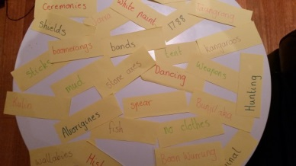  Examples of the images used:  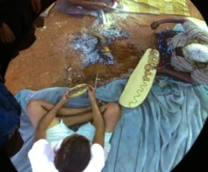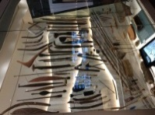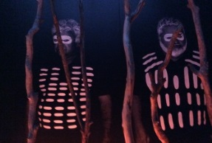 | Questions, 5 w’s e.g.:  What was it used for?  Why was it made out of that?  Where did the aboriginals live?  What were their tribes/groups called?  Using nouns, verbs, adjectives, to identify and describe what they see in the photos.  EAL focus:  Topic specific nouns and verbs – shields, ceremonies, hunting, dancing  Use of past tense:  I wondered whether …  I found out that …
5. Barrier Games with pictures of old and new Melbourne  Students work in pairs with images of Aboriginal people in Melbourne pre-1835. Students describe what they see and what they think is happening in their image. Students ask questions in order to find out more information.  Activity to be repeated so that students have an opportunity to describe many scenes. Repeat activity using images from Melbourne post 2006. | Adjectives and nouns to identify and describe the images, e.g.: grassy bank of river, small tents, no clothes, big campfire.  Questioning:  What are the people doing in the picture?  Are there animals in the picture?  Do the men have clothes?  Do they have wooden items in their hands? | Questioning: Ask questions to check students’ understanding of pictures.
6. Making a timeline  Talk to students about how long aboriginal people lived around Melbourne, and how long since Melbourne was first settled by Europeans.  Draw a timeline to show the last 250 years, and help students to mark on it key dates that they know, such as the year most of them were born, when their parents were born, when Melbourne was settled, other key dates they are aware of.  Show them how long a thousand years would be on the timeline. Then ask them to estimate how long the timeline would need to be to represent the time that Aborigines have been living around Melbourne – at least 40,000 years. |  | Do students understand the concept of a timeline, can they estimate how long many thousands of years would look, for example by pacing out the length?
7. Whole class reading –My Place by Nadia Wheatley  Before-reading activities  Predicting – Students to look at the image/text and make predictions.  During-reading activities:  Students use skimming and scanning techniques and record key information in a table.  Names Clothes/body decorations Home Food Children Adults Hunting  After reading activities  Students summarise the text, answering questions and making further predictions/wonderings. | Predicting: Possible nouns, verbs and adjectives.  e.g. The Aboriginal boy will be hunting.  Time connectives:  In the past: back then, prior to 1935, before, once, used to  The present time: now, these days, today  EAL focus: basic time connectives – then/now, used to, now, once  Identifying nouns and verbs:  Aboriginals, Melbourne, hunting, gathering, playing, watching,  Describing adjectives:  old, worn, dirty, beige, ripped, empty | Questioning: Ask questions to ensure students understanding of topic.
8. Grammar Lesson – Past tense  Whole Class- Look at sentences that are written incorrectly. e.g.: I jump on the trampoline yesterday. Students identify and discuss the errors. Students complete activity in small groups. | Past tense/verbs:  jump/jumped, hunt/hunted, eat/ate, fish/fished. | Verbal Instant Teacher Feedback – Teacher to give 2 stars and wish. Two things the student has done well, one thing they can practice and improve on.
9. Whole class reading of Mentor Text – Life in Melbourne before 1788 (see Appendix  Whole class read mentor text ‘Life in Melbourne before 1788’ Students explore the text and identify factual information. Information and key words will be gathered and added to word wall.  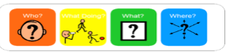  EAL student rereads text in small reading group, highlighting and colour coding nouns, verbs, and time connectives using colourful semantics cards. | Nouns: Melbourne, Aboriginals, Bellarine Peninsula  Action verbs: fishing, hunting, gathering  Past tense/time connectives: moved, around, first

Modelled/ deconstruction: Teaching and learning activities | Linguistic focus | Assessment for learning ideas
10. Re-read Mentor Text  Whole class re-read mentor text. Students to identify information, grammar and text structure.  EAL student reads through and highlights nouns, verbs and past tense recording them in a chart.  Nouns Action Verbs Past Tense Time Connectives  Aboriginals Melbourne Fish chewed fished chew – chewed fish – fished was were | Nouns: Melbourne, Aboriginals, Bellarine Peninsula  Action verbs: fishing, hunting, gathering  Past Tense/time connectives: moved, around, first
11. Whole Class Reading  Whole class re-reads and identifies the text structure. Teacher explicitly teaches the structure; headings, general classification, topic specific paragraphs, conclusion.  EAL student to work with Teacher developing a deeper understanding of the text structure and organization of an information report. | Features of an information report: heading, general classification, topic specific paragraphs, and conclusion. | Observations/ Checklist  Students ability to identify the features of the text and sequence them.
12. Text Reconstruction (see Appendix 3)  Students cut up and sequence mentor text under text structure headings. Students to discuss and justify their order and sequencing to their peers.  EAL student to work with Teacher and sequence larger piece of texts with text structure headings as support. Students to discuss and justify their choice of order to their peers. | Reconstruction sequencing of text.  Justifying order through discussion of nouns, time connectives and sentence starters. | Observations/Anecdotal notes: Teacher to record the success of students’ ability to sequence and reconstruct text.  Teacher to observe and record students’ responses and justification of sequencing choices.
13.Cloze Activities (see Appendix 4)  Students complete different cloze activities.  EAL student to work in pairs and complete cloze activities. Share their work with the Teacher, re-reading the text to discuss word choices. | Nouns: Aboriginals, Aboriginal women, fish, canoe, Melbourne,  Action verbs: hunted, fished, carried, gathered  Possible actions verbs:  e.g. …they munched on the fish or shellfish and coughed it back into the water around the canoe to attract the fish around their lines. The men chased animals with a barbed spear. | Identification of Vocabulary – Students correctly identify nouns and verbs in the corresponding sentences. Students to be able to discuss their choices and reasoning with the teacher.
14. Whole Group Grammar – Past Tense  Students are given a list of present tense words and identify and discuss the corresponding present tense. Discuss the effectiveness and fluency with each set of words.  EAL: Student given the text with incorrect past tense They are to read, highlight and write the correct alternative. | Identifying and suggesting correct past tense words: chew - chewed  fish – fished  move – moved
15. Writing Sentences  Students to work in small groups and rewrite sentences from the text substituting the action verbs and building their understanding of noun groups. Students discuss their choice of words and possible alternative sentence starters. | Substituting action verbs.  e.g. chewed – munched, ate  hunted – looked for, tracked, preyed on | Verbal Instant Teacher Feedback – Teacher to give ‘2 stars and a wish’. Stars for 2 things the students have done well, one thing they can practice and improve on.
Joint Construction: Teaching and learning activities | Linguistic focus | Assessment for learning ideas
16. Whole class discussion of the research process. | Discussing the sequence and research process.
17. Whole Class joint construction of an Information Text (3-4 sessions)  Teacher to model the planning tool. Students are to research and record facts to assist with their writing.  Whole Class jointly construct an information report.  Activity to be modelled with each text feature having an individual lesson focus.  EAL student to jointly complete planning tool with a partner. Activity to explicitly modelling the introduction, topic paragraphs and conclusion in separate lessons. | Planning and brainstorm the ideas, key words and information needed for an Information text.  Identifying the text structure:  - Heading, opening statements  - Topic paragraphs on Aboriginals, their tribes, hunting techniques, where they are today  - Identifying nouns, adjectives from our class word wall, e.g.: Aboriginals lived along the beautiful coastline. | Anecdotal Notes – Teacher to note and record student input and responses during whole class focuses.
18. Small Group joint construction of Text (3-4 sessions)  In small groups/ pairs students construct an Information report based on their notes from the planning tool.  EAL student to work with a partner and follow structure of an information report to write sentences. Opening sentence statements to be given as prompts. | Time connectives/past tense:  was, were, hunted, lived.  Action verbs: fished, carried, built  Sentence starters:  In the past…  In 1788, Aboriginals who lived many years ago…  Sequencing the order of an information text | Peer Feedback –Students to use prompts  ‘I like when you….’  ‘I like how you….’  ‘Next time you could…’  ‘How would you feel about changing/adding…’
19. Reflection of joint construction  Students to review their own information text using the assessment rubrics. (see Appendix 5)  EAL student to work with Teacher and discuss progress using the assessment rubric. Student to self-assess using two stars and a wish. Teacher to explicitly re-teach any missing elements. | Discussing assessment rubric.  Brainstorming changes and additions of nouns, adjectives and topic words that could be added during independent construction. | Self-reflection -Students to independently reflect on the information text using the assessment rubrics and two stars and a wish.

Independent Construction: Teaching and learning activities | Linguistic focus | Assessment for learning ideas
20. Independent Writing (see Appendix 6)  Students independently plan, write, edit and publish an information text based on the topic Aboriginals in Melbourne before 1788.  EAL student to plan with a partner using the modelled planning tool  Students to use sentence starters from previous lesson to assist with writing topic sentences where necessary.  (see Appendix 7) | Planning the structure of an information text: heading, general classification, topic specific paragraphs, and conclusion.  Brainstorming factual information gathered from planning tool and class word wall.  Sequencing the structure of an information text using varying sentence starters.  Identifying nouns, adjectives from our class word wall. e.g.: Aboriginal women fish along the beautiful coastline, while Aboriginal men go hunting for animals with wooden spears.  Time connectives/past tense:  e.g.: Before 1788 Aboriginals were living in Australia. They used to live all along the coast line. They hunted for animals and made canoes to go fishing. | Joint construction of goals- Teacher and student to jointly construct a goal for the student to work towards in their writing.  Self/Peer reflection – Students give two stars and a wish to their own writing, and then explain to a partner why they gave these assessments. Their partner says why they agree or disagree with this assessment.  Reflection on rubrics – Students identify where their writing sits on the given rubrics, and name two or three goals for their future writing.  Presentation to audience: Students to read and present to a Year 2 student.

Unit evaluation: Unit name: Marvellous Melbourne
General evaluation  Were the students interested in the topic?  Did planned activities need to be modified? Why?  Which teaching strategies were particularly successful? | The students were interested in topic as it was created from their individual questioning and wonderings. They were interested in the historical aspect as well as learning about people that they had little or no knowledge of prior to this unit.  On reflection, some of the past tense grammar activities require repetition or modifications. These were due to limited time and rushed modelling. The repetition of cloze activities was successful as it created lots of classroom talk, discussion and debates among students of all abilities. In future I would try to create more games-based language activities/opportunities.  Whilst some activities focused on reading and writing, the majority of the activities were scaffolded around oral language and classroom talk. Classroom talk was designed around think-pair-share, barrier games and partner/small group activities. In creating more small focus groups I was able to explicitly teach grammar functions and strategies, not only to the EAL student, but also many students at lower literacy levels. Integrating other learners into my small focus groups not only offered explicit teacher support, but allowed each student repetitive practice and exposure to areas of need, paired problem-solving opportunities and their own individual opportunities to become the expert of the group.
Content learning goals  Were the topic goals achieved?  Did the topic lead to worthwhile learning? | I credit the success of this unit to students' engagement and sustained interest in the topic. Students were continually questioning, discussing and justifying their knowledge and answers and were able to produce high quality work that had a purpose. The topic lead to worthwhile learning for the whole class.  The topic of Aboriginals living in Melbourne prior to 1788 was a complex one for the EAL student, as he had little knowledge and experience of Aboriginals, or the history of Melbourne. Through shared experiences and constant exposure to different texts and Aboriginal artefacts, the student was able to build up knowledge of the topic area, and now has extended his knowledge of how Aboriginals lived in Melbourne.
English language learning goals  Were general English language learning needs highlighted by the unit?  Was there a balance between written and spoken texts? | There was a balance of written and spoken texts highlighted throughout the unit. During the ‘Building of the field’ and ‘Modelling of text’, the majority of the activities focused on oral language and class talk discussion, whilst joint and individual construction focused on transferring his knowledge into written texts.
EAL considerations  How successfully did the unit involve the EAL students?  Which English language needs were identified as a priority for future units? | While most of the activities started off with a whole class focus, each one had an element where the EAL student could extend learning by participating in small teacher focus groups. When completing joint construction the EAL student was able to work with a mixture of similar and mix abilities to ensure he stayed on task, extended his learning and used classroom talk as a way to justify his choices and responses, as well attempt activities relating to past tense and time connectives necessary for writing his report. He was also able to display his new found grammar knowledge of past tense, adjectives and verbs during reading and writing sessions for the remainder of Year 3.
Ideas for further units/activities  What language focuses need to be targeted again in future units?  What further topics will complement this unit? | The needs and interests of the EAL student will depend on the targeted language focus. If focusing on Information reports many of the grammar and language features (as highlighted by the mentor text will stay the same).  For this particular EAL student, there will need to be a continued focus on past tense, verbs and topic specific language, in any unit they are learning. Further topics based around Melbourne, Australian History, Stolen Children, White European Settlement will all complement this unit. Genres such as information reports and information narratives would also complement this unit.
Assessment for learning strategies  Did the chosen assessment strategies ensure students achieved the unit learning goals?  Did the assessment feed into planning and teaching?  Were students involved in the assessment process?  Were the success criteria for the focused analysis assessment tasks clear and student friendly?  Were students able to use criteria to provide feedback to their peers?  Were students able to use feedback from assessment to improve their learning? | The chosen assessment strategies ensured that students worked towards achieving the units learning goals. They were explicitly discussed with the EAL student at the beginning of very lesson and there was time for verbal feedback or self-reflection. Through the students reflecting and creating their own learning goals, they were able to take ownership of their learning and aim for success.  Students were involved in the majority of the assessment, as it all focused around instant verbal feedback, peer and self-reflection. The use of two stars and a wish allowed for positive feedback as well as constructive feedback, to challenge their learning further.  The rubrics used for the written text was student friendly using ‘I can’ statements. There is room for this rubric to be simplified further, attempting to provide fewer statements (yet still covering all the language feature requirements of the text)  At the end of this unit, the EAL student still had some confusion with action verbs, often pronouncing or writing them in the incorrect tense. This student was able to revisit skills and prior knowledge when implementing work in Term 4. The student continually reflected upon goals, scaffolded around the area of past tense and verbs.

Appendix 1
This is an example of some of the ‘wonderings’ based on the headings – Melbourne, Aboriginals and History. Students worked in mixed ability groups, with the more able students recording their wonderings and questions.

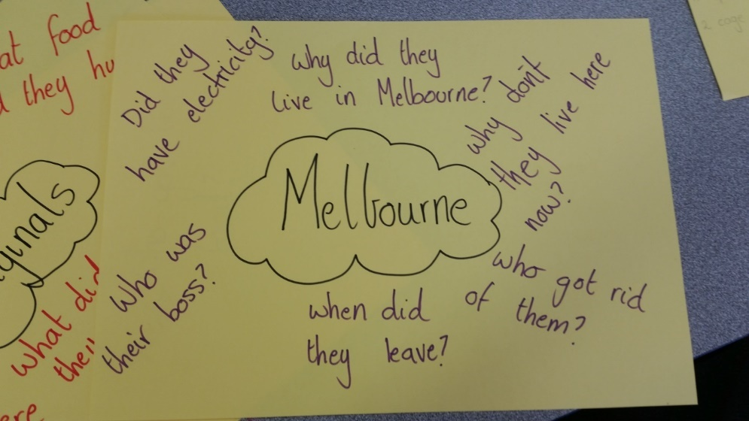
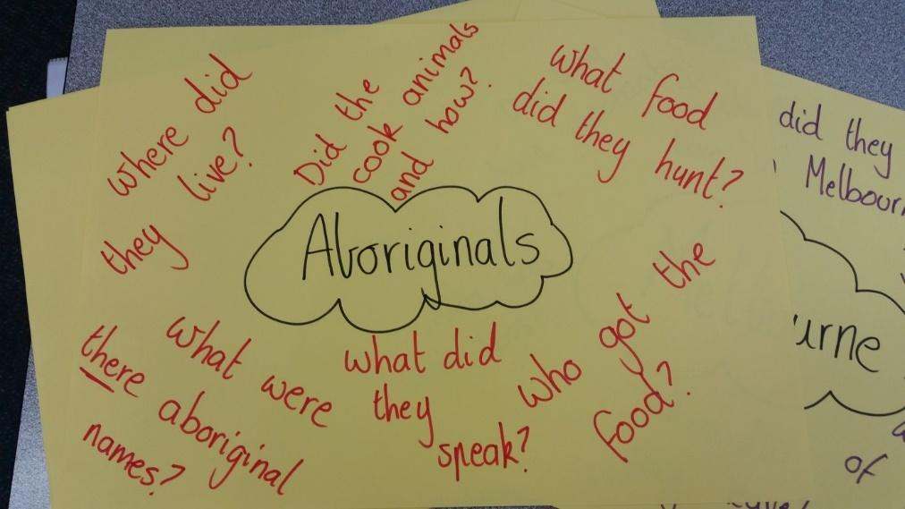

Appendix 2
This is an example of the mentor text ‘Life in Melbourne Prior to 1788’. This is to primarily be used during the Modelled/ Deconstruction and Joint Construction stages of the Teaching and Learning Cycle.
Text Structure | Purpose: To write an information text about the Aboriginals life in Australia.  Intended Audience: Teacher, students in Year 3. | Language Features
Headings to signify structure, sections and content of the text.  A general opening statement to introduce the topic or give a classification.  The main body of the report includes a description of the aspects, features or characteristics  - Where they lived.  - How they hunted.  - What they used to hunt?  Information grouped in paragraphs.  Concluding information or a summary paragraph. | Life in Melbourne before 1788  Aborigines have lived in the Melbourne area for at about 40, 000 years. Evidence of their occupation in the area is still visible today. Shell middens (waste piles which contain remnants of meals and other discarded materials of daily Aboriginal life) can be found along shores of the coast estuaries, and in national parks and reserves there are axe sharpening grooves and rock engravings.  The Aboriginals lead a nomadic life. They moved from place to place depending on the season and their hunting or food needs. They lived in bands of thirty to fifty people. Many bands shared the same language, ceremonies, customs and Dreaming Stories and often intermarried. These bands are known as tribes.  When Europeans first settled around the Melbourne region it was already occupied by five Aboriginal tribes. These tribes spoke a related language and were part of the KULIN (Koolin) nation of peoples. The Jarra tribe lived in Central/Western Victoria. The Wathaurong tribe lived in the Bellarine Peninsula along the coastline between Werribee and Lorne. The Taungrong tribe occupied the lands north of the Great Dividing Range to the south-east of Mansfield. The Boon Wurrung territory extended south of the Mordialloc Creek and with a small coastal strip around the top of Port Phillip Bay.  Aboriginal women fished with a hook and line from a canoe in sheltered bays, harbours and estuaries along the coast. Fish hooks were filed and chipped from bone. They looked shiny in the water and would lure the fish. Instead of bate they chewed fish or shellfish and spat it into the water around the canoe to attract the fish around their lines. The men fished with a barbed spear. They had to lie quietly with their faces underwater until a fish came close enough to spear! Further inland Aboriginal men hunted kangaroos, possums and wallabies while the women gathered edible roots and berries.  Bark was a valuable resource. Canoes were made from sheets of bark which were bound into a bunch at each end. Water and food was carried in vessels made in much the same way. Slabs of bark leaning against a frame of saplings and branches served as a hut. Ovals of heavy iron bark were used as shields. Wooden and bark utensils were shaped with stone axes.  Today, you can still see the grooves on the sandstone outcrops near creeks and streams where these stones axed heads were quarried and sharpened. However sandstone wears away at a faster rate than most other rocks. Much of the evidence of Aboriginal life may disappear archaeologists have time to learn more about the first inhabitants of the Melbourne area. | Topic Specialised vocabulary  Written in the third person  Brackets to explain, clarify or add extra information  Action verbs  Past Tense  Noun Groups – relating the adjective to the noun  Topic/ collective Nouns  Verb Agreement  Nouns  Connectives- space and place, time, contract connectives  - Sentences containing one or more facts  - Variety of sentence types  - Generalisations that apply to a general class of things.  - Definitions of uncommon or subject specific terms.

This is an example of the mentor text being used as a re-read/identifying grammar activity during the modelling/deconstruction stage. Each student had their own version. A class model was displayed around the room.

Nouns Action Verbs Past Tense Time connectives/ past tense

Life in Melbourne before 1788
Aborigines have lived in the Melbourne area for at about 40, 000 years. Evidence of their occupation in the area is still visible today. Shell middens (waste piles which contain remnants of meals and other discarded materials of daily Aboriginal life) can be found along shores of the coast estuaries, and in national parks and reserves there are axe sharpening grooves and rock engravings.
The Aboriginals lead a nomadic life. They moved from place to place depending on the season and their hunting or food needs. They lived in bands of thirty to fifty people. Many bands shared the same language, ceremonies, customs and Dreaming Stories and often intermarried. These bands are known as tribes.
When Europeans first settled around the Melbourne region it was already occupied by five Aboriginal tribes. These tribes spoke a related language and were part of the KULIN (Koolin) nation of peoples. The Jarra tribe lived in Central/Western Victoria. The Wathaurong tribe lived in the Bellarine Peninsula along the coastline between Werribee and Lorne. The Taungrong tribe occupied the lands north of the Great Dividing Range to the south-east of Mansfield. The Boon Wurrung territory extended south of the Mordialloc Creek and with a small coastal strip around the top of Port Phillip Bay.
Aboriginal women fished with a hook and line from a canoe in sheltered bays, harbours and estuaries along the coast. Fish hooks were filed and chipped from bone. They looked shiny in the water and would lure the fish. Instead of bate they chewed fish or shellfish and spat it into the water around the canoe to attract the fish around their lines. The men fished with a barbed spear. They had to lie quietly with their faces underwater until a fish came close enough to spear! Further inland Aboriginal men hunted kangaroos, possums and wallabies while the women gathered edible roots and berries.
Bark was a valuable resource. Canoes were made from sheets of bark which were bound into a bunch at each end. Water and food was carried in vessels made in much the same way. Slabs of bark leaning against a frame of saplings and branches served as a hut. Ovals of heavy iron bark were used as shields. Wooden and bark utensils were shaped with stone axes.
Today, you can still see the grooves on the sandstone outcrops near creeks and streams where these stones axed heads were quarried and sharpened. However sandstone wears away at a faster rate than most other rocks. Much of the evidence of Aboriginal life may disappear archaeologists have time to learn more about the first inhabitants of the Melbourne area.

Appendix 3
This is an example of the text structure headings and text pieces created for the sequencing activity during the joint construction stage. The EAL student was supported by the teacher using appropriate text structure headings. Other students were given smaller pieces of text and had to identify the text structure themselves.
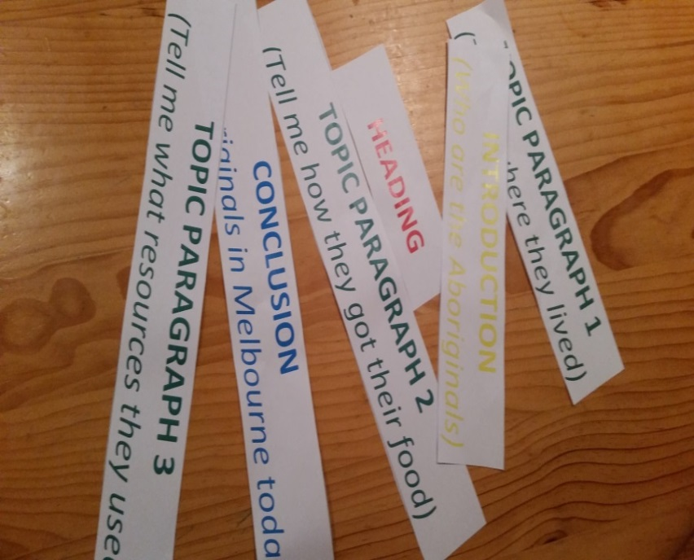
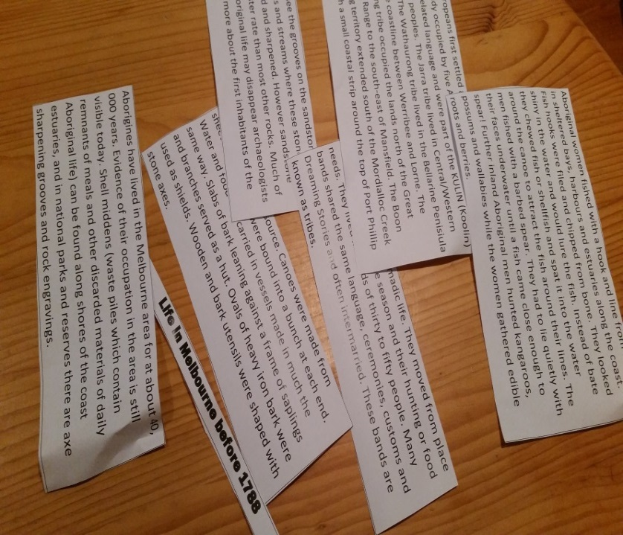

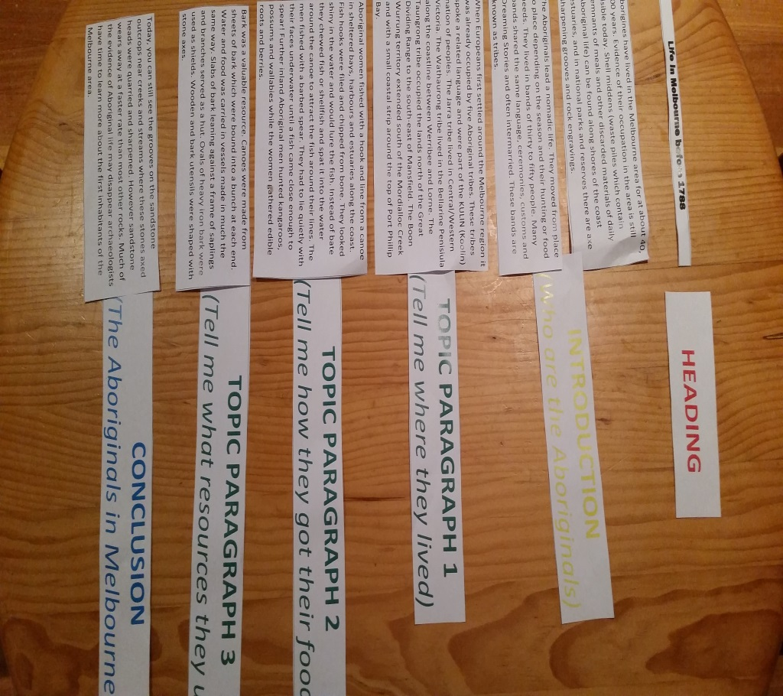
Appendix 4
These are modified versions of the cloze activity used in the modelling/deconstruction stage. Students were asked to read the information report and fill in the gaps for the missing nouns or action verbs. All students received their copies in larger font on an A3 piece of paper. The EAL student was given the word prompts to assist in the completion of this task.

Name: _______________ Date:_______________

CLOZE ACTIVITY

LO: We are learning to read an information report and write in the missing NOUNS.

Life in Melbourne before 1788

_____________have lived in the _____________area for at about 40, 000 years. Evidence of their occupation in the area is still visible today. Shell middens (waste piles which contain remnants of meals and other discarded materials of daily Aboriginal life) can be found along shores of the coast estuaries, and in national parks and reserves there are axe sharpening grooves and rock engravings.
The ______________lead a nomadic life. They moved from place to place depending on the season and their hunting or food needs. They lived in bands of thirty to fifty people. Many bands shared the same language, ceremonies, customs and Dreaming Stories and often intermarried. These bands are known as tribes.
When_______________ first settled around the Melbourne region it was already occupied by five Aboriginal tribes. These tribes spoke a related language and were part of the________(Koolin) nation of peoples. The Jarra _________lived in Central/Western Victoria. The Wathaurong tribe lived in the Bellarine Peninsula along the coastline between Werribee and______. The Taungrong tribe occupied the lands north of the Great Dividing Range to the south-east of Mansfield. The Boon Wurrung territory extended south of the Mordialloc Creek and with a small coastal strip around the top of ____________Bay.
____________fished with a hook and line from a canoe in sheltered bays, harbours and estuaries along the coast. Fish hooks were filed and chipped from bone. They looked shiny in the water and would lure the fish. Instead of bate they chewed_______ _or shellfish and spat it into the water around the canoe to attract the fish around their lines. The men fished with a barbed spear. They had to lie quietly with their faces underwater until a fish came close enough to spear! Further inland Aboriginal men hunted________ _, and while the women gathered edible roots and berries.
Bark was a valuable resource.___________ were made from sheets of bark which were bound into a bunch at each end. Water and food was carried in vessels made in much the same way. Slabs of bark leaning against a frame of saplings and branches served as a hut. Ovals of heavy iron bark were used as shields. Wooden and bark utensils were shaped with stone axes.
Today, you can still see the grooves on the sandstone outcrops near creeks and streams where these stones axed heads were quarried and sharpened. However sandstone wears away at a faster rate than most other rocks. Much of the evidence of Aboriginal life may disappear archaeologists have time to learn more about the first inhabitants of the ____________area.

Aborigines  Melbourne  Aboriginals  Europeans | Kulin  tribe  Lorne  Port Phillip | aboriginal women  fish  kangaroo  possum | wallabies  canoe  Melbourne

Name: _______________ Date:_______________
CLOZE ACTIVITY

LO: We are learning to read an information Text and place in the correct ACTION VERBS.

Life in Melbourne before 1788

Aborigines have lived in the Melbourne area for at about 40, 000 years. Evidence of their occupation in the area is still visible today. Shell middens (waste piles which contain remnants of meals and other discarded materials of daily Aboriginal life) can be found along shores of the coast estuaries, and in national parks and reserves there are axe sharpening grooves and rock engravings.
The Aboriginals lead a nomadic life. They _____________from place to place depending on the season and their ___________or food needs. They lived in bands of thirty to fifty people. Many bands shared the same language, ceremonies, customs and Dreaming Stories and often intermarried. These bands are known as tribes.
When Europeans first settled around the Melbourne region it was already occupied by five Aboriginal tribes. These tribes spoke a related language and were part of the KULIN (Koolin) nation of peoples. The Jarra tribe lived in Central/Western Victoria. The Wathaurong tribe lived in the Bellarine Peninsula along the coastline between Werribee and Lorne. The Taungrong tribe occupied the lands north of the Great Dividing Range to the south-east of Mansfield. The Boon Wurrung territory extended south of the Mordialloc Creek and with a small coastal strip around the top of Port Phillip Bay.
Aboriginal women _________with a hook and line from a canoe in sheltered bays, harbours and estuaries along the coast. Fish hooks were filed and chipped from bone. They looked shiny in the water and would lure the fish. Instead of bate they________ fish or shellfish and _______ it into the water around the canoe to attract the fish around their lines. The men ________ with a barbed spear. They had to lie quietly with their faces underwater until a fish came close enough to spear! Further inland Aboriginal men _____________kangaroos, possums and wallabies while the women _____________edible roots and berries.

Bark was a valuable resource. Canoes were made from sheets of bark which were bound into a bunch at each end. Water and food was _________in vessels made in much the same way. Slabs of bark _______leaning against a frame of saplings and branches served as a hut. Ovals of heavy iron bark were used as shields. Wooden and bark utensils were shaped with stone axes.

Today, you can still see the grooves on the sandstone outcrops near creeks and streams where these stones axed heads were quarried and sharpened. However sandstone wears away at a faster rate than most other rocks. Much of the evidence of Aboriginal life may disappear archaeologists have time to learn more about the first inhabitants of the Melbourne area.
moved  hunting  fishing | spat  fished  hunted | gathered  carried  leaning

Appendix 5
This is an example of the planning tool used for the information report. Some initial guiding questions were supplied to the EAL student by the Teacher. The EAL student worked with the teacher aide the majority of the research time in order to finding and recording key words and facts.

LO: We are learning how to plan an Information Report
My Topic:_______________________________
Questions I want to find answers to:  - What Aboriginal tribes lived in Melbourne in 1788?  - What did the Aboriginal women do to find food?  - What did the Aboriginal women do to find food? |  | - ____________________________________________  - ____________________________________________  - ____________________________________________
Notes/ Key words: | Notes/ Key words: |  | Notes/ Key words:

Appendix 6
This is the rubric used for the assessment of the Information Text. The first in the whole class example, the second is a modified version for the EAL student.
Whole Class rubric
INFORMATION REPORT RUBRIC
Subject: Information Report Semester: 2 Term: 3 2015
Year Level: 3 AusVELS Level: Level 3
Achievement Standard: Their texts include writing and images to express and develop in some detail experiences, events, information, ideas and characters. They demonstrate understanding of grammar and choose vocabulary and punctuation appropriate to the purpose and context of their writing. They use knowledge of sounds and high-frequency words to spell words accurately, checking their work for meaning. They legibly write using consistently sized joined letters.
Task: To write an informative/ factual text
Context: Students are to use their knowledge of Melbourne from the Inquiry unit ‘Marvellous Melbourne’ and write an information report. These can be in the form of a newspaper or information report.
Elements of the task

Structure/ Features | INFORMATION REPORT  - I have included everything that makes up two stars.  - I have included 3 or more detailed paragraphs to give information about my topic.  - My conclusion answers the following question: How does this help us in our everyday life? | INFORMATION REPORT  - I have included an accurate title  - I have included a short opening sentence explaining what my report will be about.  - I have included 2-3 simple paragraphs to describe and add detail about my topic.  - I have included labelled diagrams.  - I have used headings and subheadings that match my topic.  - I have included the information with the same topic together.  - I have written in the third person.  - I have used facts rather than opinions. | INFORMATION REPORT  - I have included a title.  - I have tried to write in the third person.  - I have told the reader what my topic is and wrote some things about it.  - I have listed my information in any order.  - I chose any picture to include in my report.
Language conventions and grammar | - My spelling is correct most of the time.  - I use my spelling strategies  - I use capital letters, talking marks, full stops and commas in the correct way all the time.  - My sentences are made up of two parts.  - I use the correct tense.  - I use paragraphs in my writing.  - I can join my handwriting. | - I spell common words correctly.  - I use my spelling strategies to try and spell words.  - I use capital letters, talking marks, full stops and commas in the correct way most of the time.  - I try to write sentences that include detail.  - I use the correct tense.  - I leave a line between my paragraphs.  - My letters are all the same size when I am writing | - I spell most common words correctly.  - I try to use capital letters and full stops.  - I use the correct tense most of the time.  - I try to write my letters so that they are all the same size
The writing process | - I following all parts of the Writing Process.  - I look at my plan and change it if I have new ideas as I am drafting.  - I think about my audience when I publish and share my writing. | - I can plan my writing by including information that will help me.  - I look at my plan when I write my draft.  - I can read my writing out aloud to see if it makes sense and then edit it.  - I can edit my work to make sure I have included the right spelling and punctuation.  - I can edit my work to make sure it makes sense.  - I present my writing clearly when I publish. | - I can plan my writing using a brainstorm.  - I can read my writing out aloud to see if it makes sense.  - I can find words in my writing that need their spelling fixed.
EAL version
INFORMATION TEXT RUBRIC
Subject: Information text Semester: 2 Term: 3 2015
Year Level: 3
Standard for B2 Writing
At Stage B2, students write for a range of purposes on familiar topics. They write simple organised texts demonstrating a developing use of specific vocabulary and simple sentence structures. Their writing demonstrates an understanding of purposes of common text types, and their structure and features. Their texts include basic information and detail. They use a number of common conjunctions to link ideas, using pronoun references with some noun/pronoun agreement, simple phrases to express basic comparisons, and some basic punctuation. Their attempts to spell new words are plausible, and based on known sound-letter relationships. They use a range of strategies for spelling words, checking word lists or keeping personal dictionaries. They base new sentences on known sentence structures. Students draw on a developing knowledge of the writing process to plan and write simple texts, and with support, redraft them.
Task: To write an informative/ factual text
Context: Students are to use their knowledge of Melbourne from the Inquiry unit ‘Marvellous Melbourne’ and write information/ factual text. These can be in the form of a newspaper or information report.
Elements of the task
Structure/ Features | INFORMATION REPORT  - I have included a title.  - I have put my information into different paragraphs.  - I have listed my information in the correct order – introduction, history, tribes, hunting, food, instruments, conclusion  - I chose a picture and included a caption in my report. | INFORMATION REPORT  - I have included a title.  - I included any information I know about the topic.  - I included at least 1 interesting fact about the topic.  - I have listed my information in any order.  - I included any picture
Language conventions and grammar | - I used capital letters for names and at the start of my sentences.  - I used full stops at the end of all of my sentences.  - I used past tense in my writing.  - I have written complete sentences.  - I used nouns correctly (capital letter and in the correct spot)  - I have used action verbs to describe what the aboriginals were doing.  - I used different sentences starters.  - I use topic words.  - I try to write my letters so that they are all the same size. | - I used some capital letters.  - I used a full stop at the end of a sentence.  - I used different tenses in my writing  - I attempted to write complete sentences.  - I used some nouns correctly.  - I attempted to describe what the aboriginals were doing.  - All my sentences start the same way.  - I attempted to use some topic words.  - I wrote as neat as I could.
The writing process | - I can plan my writing using the planning sheet.  - I can read my writing out aloud to see if it makes sense.  - I tried fixing my spelling by using my word chart.  - I edited my work using the rainbow edit checklist. | - I tried to plan my writing.  - I can read my writing out aloud to see if it makes sense.  - I can find words in my writing that need their spelling fixed.  - I edited my work only for full stops and capitals.

Appendix 7
This are the sentences starters given to the EAL student in the sentence writing activity. This was in the joint construction stage of the Teaching and Learning Cycle.

Aboriginals lived in Melbourne….
The Aboriginals were always moving homes because…
The Jarra Tribe…
The Wathaurong tribe…
The Taungrong tribe….
The Boon Wurrung tribe…
The Aboriginal women hunted food by….
The Aboriginal men hunted food by….
To hunt animals the Aboriginal people used.
Today in Melbourne…..

Appendix 8

This is a transcription of the original report written by the EAL student. The spelling errors have been left uncorrected.
Aboriginals in Melbourne
Abergnals live in Melbin. They have diff color skin. They was here befor otter people. They was hunted animels and people. Melbin is a big city. I been before and went to eye that goes around. My Uncel take me and my brother.
Abergnals lived differnet to me. No ipads, tv, music. They wore no clothes. The had no tv. They ate funny things.
They are black coloured skin like me but I am Vietnam. They wore different cloths. I wear sckool uniform.

This is the EAL student’s independently constructed information report based on Aboriginals in Melbourne before 1788. A typed up version has been provided. Some of the spelling errors have been left uncorrected, while some have been corrected in red.
Aboriginals in Melbourne before 1788
Aboriginals usd to live in Melborne before 1788. They have been around for many yeers. Some items that they used to use for eating and sleping can still be found near the water and under the ground.
The aboriginals were always moving homes (because) they had no food left or it got to hot or to (too) cold. A group of Aboriginals is called a tribe. A tribe is like a big group of peple.(people)
The Jara tribe lived in Victoria. The Wathaurong tribe lived near the coastline were (where) there are buttiful (beautiful) beeshes (beaches). These were all called Koolin people. The Boon Wurrung tirbe lived at creeks and water and the Taungrong tribe lived in the Great Dividing Range. They are called Koolin people to (too).
The Aboiginal womn hunted food by fishing. They fished using a hook and line and a boat. They would chew old fish in their mouth and then spit it out and ut (put) it on the hook. This made the fish come around the boat. The Aboriginal men fished to (too). They fished with a spear. They lied in water and shot the spear fast at (the) fish. The Aboriginal men hunted animals. They hunted kangaroo, possims, (possums) and wallibi (wallabies). They hunted them with spears. The Aboriginal women would get yummy (yummy) roots and beris (berries) eat.
To hunt animals and get food the used a boat called (called) canoo (canoe). They made this from bark. They made it by getting lots of bark together and they made it strong. It was round, dark bark. They also used it as a sheld (shield). This protect (protected) them from dangr (danger). They made sharp, shini (shiney)stone axs (axes).
Today in melbone (Melbourne) no Aboriginals live. Some still lived (live) here (but) not many. They dont (don’t) live in tents. They live in houses. Where they lived there is now new big billdings (buildings) and houses. A scians (science) man can still learn how they lived by digging and looking up the old things that they used to have.

